Voting results on U.N. General Assembly Resolution, "Programme budget for 2021," A/RES/75/254 A-C, December 31, 2020
https://digitallibrary.un.org/record/3897077?ln=en
http://webtv.un.org/search/general-assembly-resumed-48th-plenary-meeting-75th-session/6219507027001/?term=2020-12-31
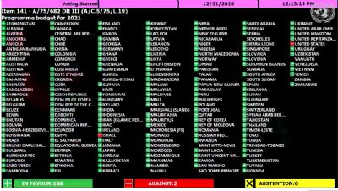
Vote: 168 in favor, 2 against, 0 abstentions
Against:
Israel, United States

In favor:
Afghanistan, Albania, Algeria, Andorra, Angola, Argentina, Armenia, Australia, Austria, Azerbaijan, Bahamas, Bahrain, Bangladesh, Barbados, Belarus, Belgium, Belize, Bhutan, Bolivia, Bosnia and Herzegovina, Botswana, Brazil, Brunei Darussalam, Bulgaria, Burundi, Cabo Verde, Cambodia, Cameroon, Canada, Chad, Chile, China, Colombia, Costa Rica, Cote d'Ivoire, Croatia, Cuba, Cyprus, Czechia, Democratic People's Republic Of Korea, Democratic Republic Of The Congo, Denmark, Djibouti, Dominica, Dominican Republic, Ecuador, Egypt, El Salvador, Equatorial Guinea, Eritrea, Estonia, Ethiopia, Fiji, Finland, France, Gambia, Georgia, Germany, Ghana, Greece, Grenada, Guatemala, Guyana, Honduras, Hungary, Iceland, India, Indonesia, Iran, Iraq, Ireland, Italy, Jamaica, Japan, Jordan, Kazakhstan, Kenya, Kiribati, Kuwait, Kyrgyzstan, Lao People's Democratic Republic, Latvia, Lebanon, Lesotho, Liberia, Libya, Liechtenstein, Lithuania, Luxembourg, Madagascar, Malawi, Malaysia, Maldives, Mali, Malta, Mauritania, Mauritius, Mexico, Monaco, Mongolia, Montenegro, Morocco, Mozambique, Myanmar, Namibia, Nepal, Netherlands, New Zealand, Nicaragua, Niger, Nigeria, North Macedonia, Norway, Oman, Pakistan, Panama, Papua New Guinea, Paraguay, Peru, Philippines, Poland, Portugal, Qatar, Republic of Korea, Republic of Moldova, Romania, Russian Federation, Rwanda, Saint Lucia, Saint Vincent And The Grenadines, Samoa, San Marino, Saudi Arabia, Senegal, Serbia, Sierra Leone, Singapore, Slovakia, Slovenia, Solomon Islands, South Africa, Spain, Sri Lanka, Sudan, Suriname, Sweden, Switzerland, Syrian Arab Republic, Tajikistan, Thailand, Timor-Leste, Togo, Tonga, Trinidad And Tobago, Tunisia, Turkey, Tuvalu, Uganda, Ukraine, United Arab Emirates, United Kingdom, United Republic Of Tanzania, Uruguay, Uzbekistan, Venezuela, Viet Nam, Yemen, Zimbabwe

