Voting result for U.N. General Assembly Resolution “A global call for concrete action for the elimination of racism, racial discrimination, xenophobia and related intolerance and the comprehensive implementation of and follow-up to the Durban Declaration and Programme of Action,” A/RES/75/237
December 31, 2020
https://digitallibrary.un.org/record/3896183?ln=en
https://undocs.org/A/75/PV.48%20(Resumption%201)
Vote results as recorded:
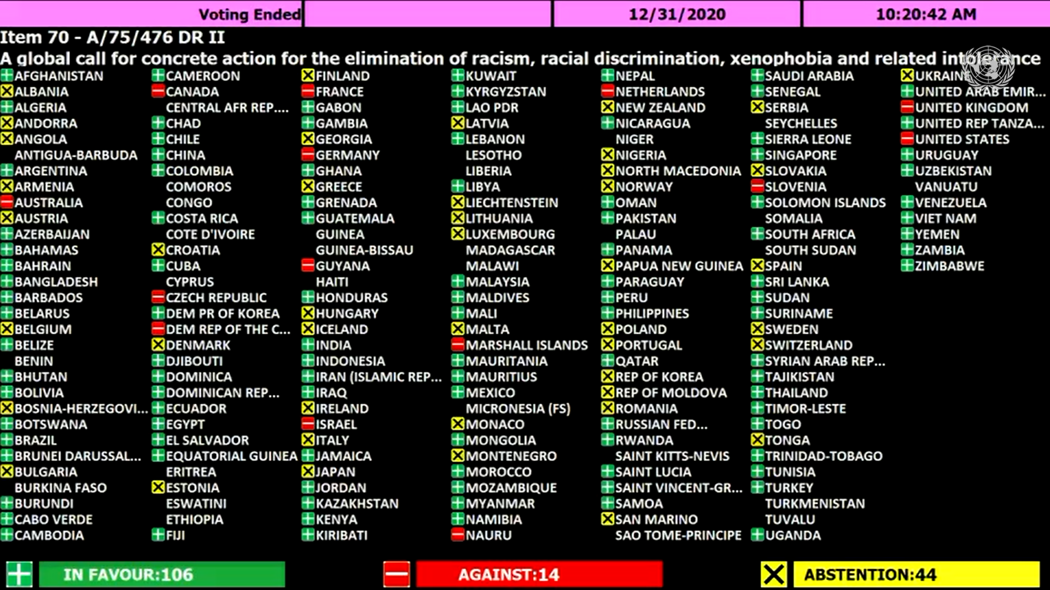
Vote totals: 106 in favor, 14 against, 44 abstentions

Against:
Australia, Canada, Czech Republic, Democratic Republic of The Congo, France, Germany, Guyana, Israel, Marshall Islands, Nauru, Netherlands, Slovenia, United Kingdom, United States

Abstentions:
Albania, Andorra, Angola, Armenia, Austria, Belgium, Bosnia Herzegovina, Bulgaria, Croatia, Denmark, Estonia, Finland, Georgia, Greece, Hungary, Iceland, Ireland, Italy, Japan, Latvia, Liechtenstein, Lithuania, Luxembourg, Malta, Monaco, Montenegro, New Zealand, Nigeria, North Macedonia, Norway, Papua New Guinea, Poland, Portugal, Republic of Korea, Republic of Moldova, Romania, San Marino, Serbia, Slovakia, Spain, Sweden, Switzerland, Tonga, Ukraine

In favor:
Afghanistan, Algeria, Argentina, Azerbaijan, Bahamas, Bahrain, Bangladesh, Barbados, Belarus, Belize, Bhutan, Bolivia, Botswana, Brazil, Brunei Darussalam, Burundi, Cabo Verde, Cambodia, Cameroon, Chad, Chile, China, Colombia, Costa Rica, Cuba, Democratic People's Republic of Korea, Djibouti, Dominica, Dominican Republic, Ecuador, Egypt, El Salvador, Equatorial Guinea, Fiji, Gabon, Gambia, Ghana, Grenada, Guatemala, Honduras, India, Indonesia, Iran, Iraq, Jamaica, Jordan, Kazakhstan, Kenya, Kiribati, Kuwait, Kyrgyzstan, Lao People's Democratic Republic, Lebanon, Libya, Malaysia, Maldives, Mali, Mauritania, Mauritius, Mexico, Mongolia, Morocco, Mozambique, Myanmar, Namibia, Nepal, Nicaragua, Oman, Pakistan, Panama, Paraguay, Peru, Philippines, Qatar, Russian Federation, Rwanda, Saint Lucia, Saint Vincent And The Grenadines, Samoa, Saudi Arabia, Senegal, Sierra Leone, Singapore, Solomon Islands, South Africa, Sri Lanka, Sudan, Suriname, Syrian Arab Republic, Tajikistan, Thailand, Timor-Leste, Togo, Trinidad And Tobago, Tunisia, Turkey, Uganda, United Arab Emirates, United Republic of Tanzania, Uruguay, Uzbekistan, Venezuela, Viet Nam, Yemen, Zambia, Zimbabwe

After the vote was completed, Guyana and Madagascar stated that they had intended to vote in favor the resolution; Hungary stated that it had intended to vote against the resolution; and Cyprus and the Netherlands stated that they had intended to abstain.
The vote results as intended:
108 in favor, 13 against, 45 abstentions

Against:
Australia, Canada, Czech Republic, Democratic Republic of The Congo, France, Germany, Hungary, Israel, Marshall Islands, Nauru, Slovenia, United Kingdom, United States

Abstentions:
Albania, Andorra, Angola, Armenia, Austria, Belgium, Bosnia Herzegovina, Bulgaria, Cyprus, Croatia, Denmark, Estonia, Finland, Georgia, Greece, Iceland, Ireland, Italy, Japan, Latvia, Liechtenstein, Lithuania, Luxembourg, Malta, Monaco, Montenegro, Netherlands, New Zealand, Nigeria, North Macedonia, Norway, Papua New Guinea, Poland, Portugal, Republic of Korea, Republic of Moldova, Romania, San Marino, Serbia, Slovakia, Spain, Sweden, Switzerland, Tonga, Ukraine

In favor:
Afghanistan, Algeria, Argentina, Azerbaijan, Bahamas, Bahrain, Bangladesh, Barbados, Belarus, Belize, Bhutan, Bolivia, Botswana, Brazil, Brunei Darussalam, Burundi, Cabo Verde, Cambodia, Cameroon, Chad, Chile, China, Colombia, Costa Rica, Cuba, Democratic People's Republic of Korea, Djibouti, Dominica, Dominican Republic, Ecuador, Egypt, El Salvador, Equatorial Guinea, Fiji, Gabon, Gambia, Ghana, Grenada, Guatemala, Guyana, Honduras, India, Indonesia, Iran, Iraq, Jamaica, Jordan, Kazakhstan, Kenya, Kiribati, Kuwait, Kyrgyzstan, Lao People's Democratic Republic, Lebanon, Libya, Madagascar, Malaysia, Maldives, Mali, Mauritania, Mauritius, Mexico, Mongolia, Morocco, Mozambique, Myanmar, Namibia, Nepal, Nicaragua, Oman, Pakistan, Panama, Paraguay, Peru, Philippines, Qatar, Russian Federation, Rwanda, Saint Lucia, Saint Vincent And The Grenadines, Samoa, Saudi Arabia, Senegal, Sierra Leone, Singapore, Solomon Islands, South Africa, Sri Lanka, Sudan, Suriname, Syrian Arab Republic, Tajikistan, Thailand, Timor-Leste, Togo, Trinidad And Tobago, Tunisia, Turkey, Uganda, United Arab Emirates, United Republic of Tanzania, Uruguay, Uzbekistan, Venezuela, Viet Nam, Yemen, Zambia, Zimbabwe

The official vote record on the UN General Assembly resolutions page and the UN Digital Library vote records page continue to record the vote totals as 106 in favor, 14 against, 44 abstentions.

