WATCH: New assault on Orthodox Jew in New York

January 1, 2020

World Israel News

https://worldisraelnews.com/watch-new-assault-on-orthodox-jew-in-new-york/

The New York Police Department tweeted a surveillance video on Wednesday of an Orthodox Jew being assaulted by a group of what appears to be black teens. It asked for help in identifying the assailants.

NYPD 71st Precinct
✔@NYPD71Pct

The NYPD is asking for help in identifying the individuals in connection to assault pattern in the 71 and 77 PCT Anyone with information please call the Crime Stoppers at 1-800-577-TIPS (8477) http://WWW.NYPDCRIMESTOPPERS.COM or Twitter@NYPDTips. All calls are strictly confidential

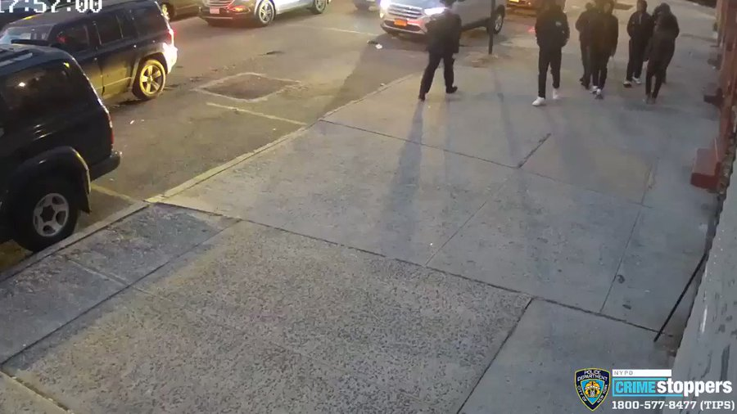

73
11:11 PM - Dec 31, 2019
Twitter Ads info and privacy

71 people are talking about this

