At UN, Three of Four Drop Opposition to Iran Sanctions Resolution, Indonesia Abstains
By Matthew Russell Lee
March 3, 2008
The Inner City Press
Original Source: http://www.innercitypress.com/sc3iran030308.html
UNITED NATIONS, March 3, 1:56 p.m. -- Monday's Security Council meeting about imposing sanctions on Iran stretched into and past the diplomats' lunch time, as pressure was brought to bear on prospective opponents or abstainers to the resolution. The Deputy Permanent Representative of Indonesia, on his way into the Council in the morning, said that his country was not at that time in support of the resolution. South Africa's Ambassador Dumisani Kumalo has for weeks been questioning the timing and substance of the resolution.
By the time the open meeting started, after a lengthy speech by Iran's Ambassador Khazaee, Amb. Kumalo said he would be supporting the resolution, out of respect for previous resolutions. Observers noted French President Sarkozy's talks with his South African counterpart Mbeki. Libya said that it too would associate itself with the Council's consensus. Viet Nam fell in line. At 1:50 p.m., the drum roll was for Indonesia, to which Sarkozy also reportedly reached out.
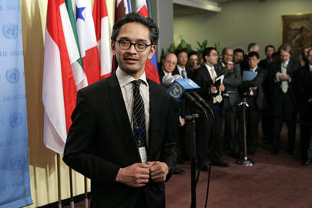
Indonesia's Ambassador at UN
At 1:56 p.m., Indonesia said, before the vote, that it would abstain. And it did. 14 for, none against, and one abstention. Developing.
At 2:30 p.m., while speeches continued inside the Council, Inner City Press asked Syria's Ambassador to explain Libya's vote in favor of the resolution. While he emphasized Libya's ambivalent statement about the resolution, the "why" of the affirmative votes remains.
At 3:20 p.m., after U.S. Ambassador Khalilzad pointedly took his first question in Farsi, from the BCC, and after the Ambassadors of the UK, France and Germany sung from the same hymnal, Inner City Press asked Russia's Vitaly Churkin, president of the Council for March, how long-term Russia's commitment to provide nuclear fuel to Iran is. Amb. Churkin called it a commercial deal, that may or may not have already been entirely fulfilled.
Moving on to other matters, Inner City Press asked Amb. Churkin if anyone has asked the Council to take up the Colombia - Ecuador matter. No, he said. As to why, watch this site.
The resolution directs particular vigilance at Bank Melli and Bank Saderat, and calls for inspections of Iran Air Cargo and Islamic Republic of Iran Shipping Line.

