Funding the Palestinians

By Daniel Pipes
December 18, 2007
FrontPageMagazine.com
Original Source: http://www.frontpagemag.com/Articles/Read.aspx?GUID=4282BF99-38AE-4241-AE92-E1DDC7E3D8E1
Lavishing funds on Mahmoud Abbas and the Palestinian Authority to achieve peace has been a mainstay of Western, including Israeli, policy since Hamas seized Gaza in June. But this open spigot has counterproductive results and urgently must be stopped.
Some background: Paul Morro of the Congressional Research Service reports that, in 2006, the European Union and its member states gave US$815 million to the Palestinian Authority, while the United States sent it $468 million. When other donors are included, the total receipts come to about $1.5 billion.
The windfall keeps growing. President George W. Bush requested a $410 million supplement in October, beyond a $77 million donation earlier in the year. The State Department justifies this lordly sum on the grounds that it "supports a critical and immediate need to support a new Palestinian Authority (PA) government that both the U.S. and Israel view as a true ally for peace." At a recent hearing, Gary Ackerman, chairman of the House Subcommittee on the Middle East and South Asia, endorsed the supplemental donation.
Not content with spending taxpayer money, Secretary of State Condoleezza Rice launched a "U.S.-Palestinian Public Private Partnership" on Dec. 3, involving financial heavyweights such as Sandy Weill and Lester Crown, to fund, as Rice put it, "projects that reach young Palestinians directly, that prepare them for responsibilities of citizenship and leadership can have an enormous, positive impact."
One report suggests the European Union has funneled nearly $2.5 billion to the Palestinians this year.
Looking ahead, Abbas announced a goal to collect pledges of $5.8 billion in aid for a three-year period, 2008-10, at the "Donors' Conference for the Palestinian Authority" attended by over ninety states on Monday in Paris. (Using the best population estimate of 1.35 million Palestinians on the West Bank, this comes to a staggering amount of money: per capita, over $1,400 per year, or about what an Egyptian earns annually.) Endorsed by the Israeli government, Abbas immediately raised nearly that amount for 2008 at the donors' conference.
Well, it's a bargain if it works, right? A few billion to end a dangerous, century-old conflict – it's actually a steal.
But innovative research by Steven Stotsky, a research analyst for the Committee for Accuracy in Middle East Reporting in America (CAMERA) finds that an influx of money to the Palestinians has had the opposite effect historically. Relying on World Bank, International Monetary Fund, and other official statistics, Stotsky compares two figures since 1999: budgetary support aid provided annually to the Palestinian Authority and the number of Palestinian homicides annually (including both criminal and terrorist activities, and both Israeli and Palestinian victims). Graphed together, the two figures show an uncanny echo:
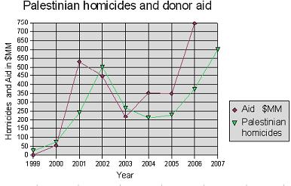
The correlation is even clearer when the aid of one year is superimposed on the homicides of a year later:
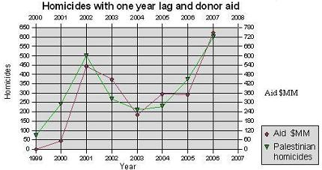
In brief, each $1.25 million or so of budgetary support aid translates into a death within the year. As Stotsky notes, "These statistics do not mean that foreign aid causes violence; but they do raise questions about the effectiveness of using foreign donations to promote moderation and combat terrorism."
The Palestinian record fits a broader pattern, as noted by Jean-Paul Azam and Alexandra Delacroix in a 2006 article, "Aid and the Delegated Fight Against Terrorism." They found "a pretty robust empirical result showing that the supply of terrorist activity by any country is positively correlated with the amount of foreign aid received by that country" – i.e., the more foreign aid, the more terrorism.
If these studies run exactly counter to the conventional supposition that poverty, unemployment, repression, "occupation," and malaise drive Palestinians to lethal violence, they do confirm my long-standing argument about Palestinian exhilaration being the problem. The better funded Palestinians are, the stronger they become, and the more inspired to take up arms.
A topsy-turvy understanding of war economics has prevailed in Israel since the Oslo negotiations began in 1993. Rather than deprive their Palestinian enemies of resources, Israelis have been following Shimon Peres's mystical musings, and especially his 1993 tome, The New Middle East, to empower them economically. As I wrote in 2001, this "is tantamount to sending the enemy resources while fighting is still under way – not a hugely bright idea."
Rather than further funding Palestinian bellicosity, Western states, starting with Israel, should cut off all funds to the Palestinian Authority.

