The Vile Antisemitism of Manal Tamimi

September 16, 2016
Israellycool
http://www.israellycool.com/2016/09/16/the-vile-antisemitism-of-manal-tamimi/

Manal Tamimi is a member of the infamous Tamimi clan, of which “Shirley Temper” is part. She has been lauded as a “human rights defender” and an “iconic activist” by extreme leftists and Israel haters, who engages in “non-violent popular resistance.”
She is also very much a part of Tamimi Press, the propaganda outlet run by “Shirley’s” father Bassem Tamimi, and as such, the disinformation campaign against Israel (aided and abetted by some in the mainstream media and smaller outfits like AMZ Productions of Oregon).
Much has already been written about her support for terror against Israelis. But what is perhaps less known is that she is an out-and-out Jew hater.
Her tweets include antisemitic memes to which we are already accustomed – genocidal wishes, denial of Jewish history and identity, Nazi-era imagery, mocking of Jews, co-opting the Holocaust, and outright libels demonizing the Jewish people.
Here’s a sample.
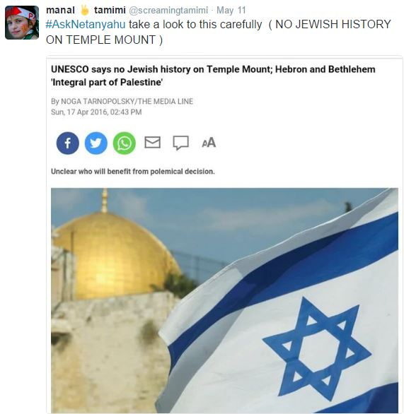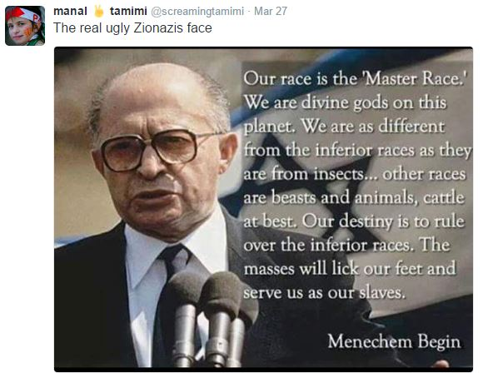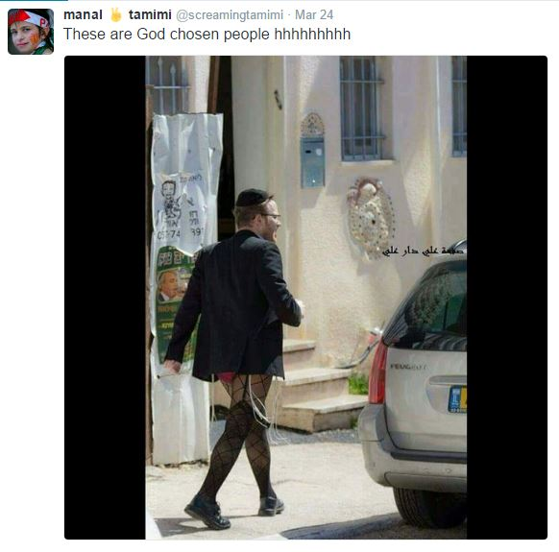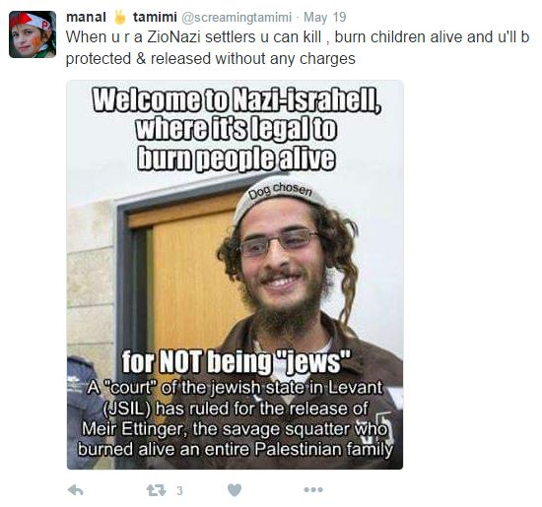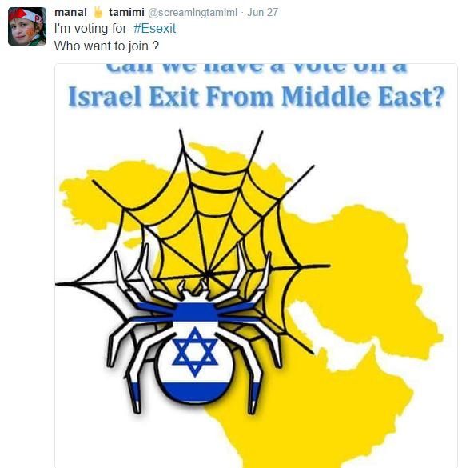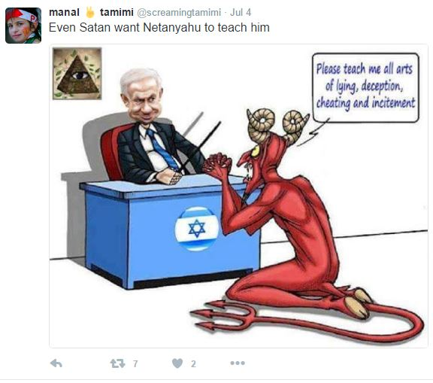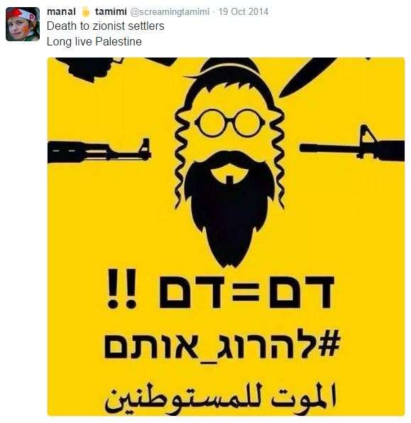
Of course, she brings out the tired, old “I’m anti-Zionist-not-antisemitic” refrain.
Did I mention Jewish Voice for Peace are working with this antisemite?
Of course, Manal is not alone as a Jew hater in the Tamimi clan.
Don’t fool yourselves. Tamimi’s hatred of Jews is endemic among those who oppose Israel. The palestinians could have had a state had they accepted a Jewish presence here – they simply can’t. And those who support the Tamimis and others like them are, in essence, supporting the ethnic cleansing of Jews from their indigenous lands.
Of course, in most cases, these supporters also hate Jews, so there’s that.

