Hamas manual on "Urban Warfare"
Israel Ministry of Foreign Affairs
August 5, 2014
https://mfa.gov.il/MFA/ForeignPolicy/Terrorism/Pages/Hamas-manual-on-Urban-Warfare.aspx

IDF forces in the Gaza Strip found a Hamas manual on "Urban Warfare", of the Shuja'iya Brigade of Hamas' military wing, the Al-Qassam Brigades. Hamas' callous use of the Gazan population was intentional and preplanned.

(IDF Blog)

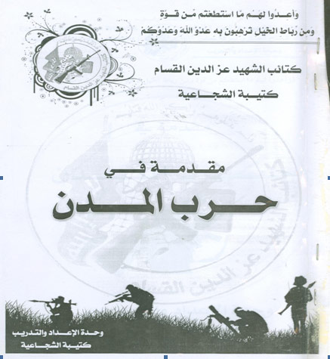
Hamas manual on Urban Warfare

IDF forces in the Gaza Strip found a Hamas manual on "Urban Warfare", of the Shuja'iya Brigade of Hamas' military wing, the Al-Qassam Brigades. The manual explains how the civilian population can be used against IDF forces. A reading of the manual demonstrates that Hamas' callous use of the Gazan population was both intentional and preplanned.

In a section entitled "Limiting the Use of Weapons," the manual explains that:

"The soldiers and commanders [of the IDF] must limit their use of weapons and tactics that lead to the harm and unnecessary loss of people and [destruction of] civilian facilities. It is difficult for them to get the most use out of their firearms, especially of supporting fire [e.g. artillery]."

Clearly Hamas knows the IDF will limit its use of weapons in order to avoid harming civilians, including refraining from using larger firepower in support of infantry forces.

The manual goes on to explain that the "presence of civilians are pockets of resistance" that cause three major problems for advancing troops:

"(1) Problems with opening fire
(2) Problems in controlling the civilian population during operations and afterward
(3) Assurance of supplying medical care to civilians who need it"

Lastly, the manual discusses the benefits for Hamas when civilian homes are destroyed:

"The destruction of civilian homes: This increases the hatred of the citizens towards the attackers [the IDF] and increases their gathering [support] around the city defenders (resistance forces[i.e. Hamas])."

It is clear that Hamas actually desires the destruction of homes and civilian infrastructure, knowing it will increase hatred for the IDF and enhance support for their operatives.

It is also of no small importance that this manual belongs to the Shuja’iya Brigade. The IDF fought a major battle in the neighborhood of Shuja’iya, which had been turned into a terrorist stronghold. The discovery of this manual suggests that the destruction to the civilian population of Shuja’iya was a part of Hamas’ plan.

Shuja’iya is a densely populated neighborhood in Gaza, close to the Karni Crossing and just over the border fence from Kibbutz Nahal Oz. Shuja’iya is saturated with Hamas terror sites and is home to a vast network of tunnels used for attacking Israel.

The UN recently published a map that marks areas of Shuja’iya damaged during IDF strikes. A comparison of the two maps clearly demonstrates that the areas targeted by the IDF are the same areas that the UN marked as damaged.

The conclusion: the IDF distinguishes between structures used for terror purposes and structures used only for civilian purposes.

