Hamas Terror: What Led to Operation Protective Edge?
IDF Blog
June 28, 2014
https://web.archive.org/web/20140711184537/http://www.idfblog.com/blog/2014/06/28/live-updates-gaza-terrorists-fire-rockets-israel

A dramatic escalation in Hamas rocket fire forced Israel to take action against terrorists in Gaza.
Gaza terrorists have fired more than 450 rockets at Israel since the beginning of the year. The attacks have sent thousands running into bomb shelters, threatening 3.5 million Israeli lives.
Since Israel withdrew from Gaza in 2005, terrorists from the strip have fired more than 8,000 rockets into Israel.
Although Israel’s Iron Dome Missile Defense system stops some of the attacks, most rockets are capable of reaching Israel’s biggest cities. More than half a million Israelis have less than 60 seconds to find shelter after a rocket is launched from Gaza into Israel. Many have only 15 seconds.

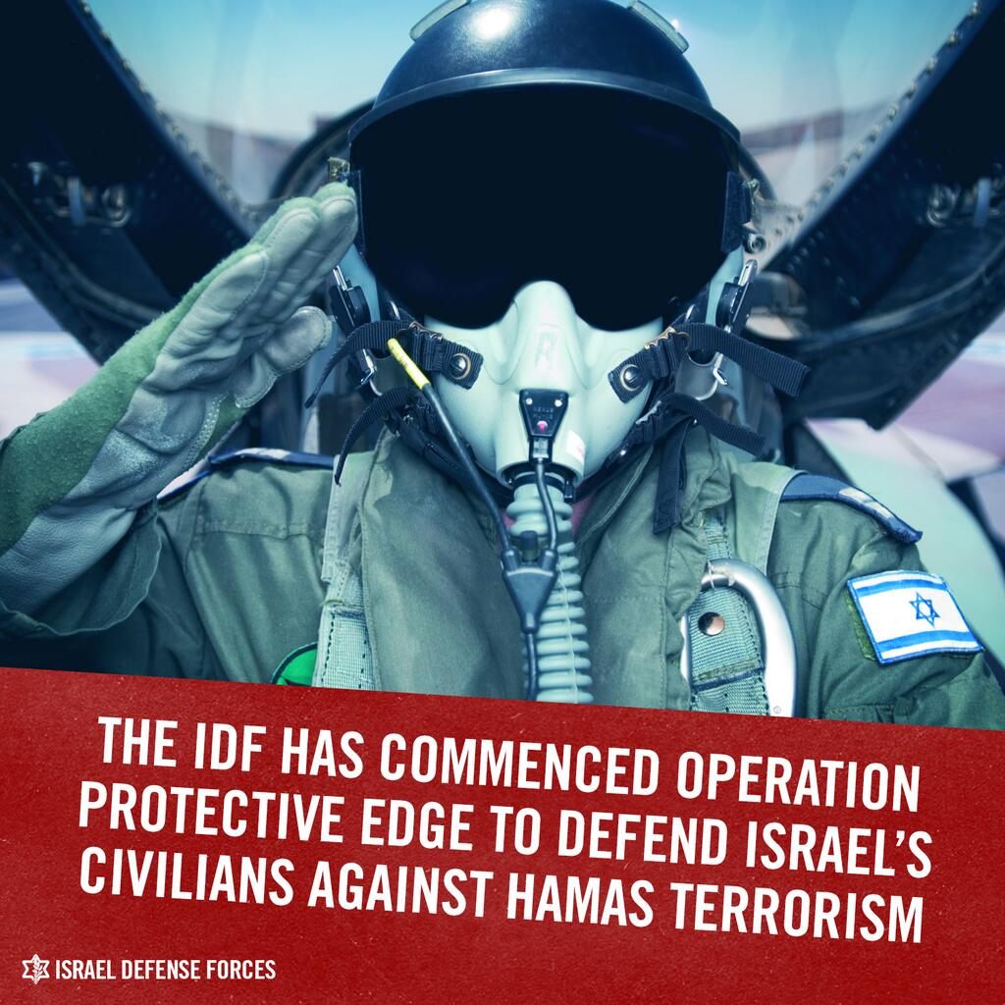

Updates: Rocket attacks against Israel

JULY 7
During the day more than 80 rockests have been fired from Gaza at Israel.
IDF aircraft targeted a Hamas terror tunnel, preventing an attack on Israelis.
Gaza terrorists fired a rocket a Be’er Sheva, the largest city in southern Israel. A short time later, terrorists attacked IDF soldiers patrolling Israel’s security fence along the southern Gaza border. Initial reports suggested that the attackers used firearms and an RPG anti-tank missile.

JULY 6
Gaza terrorists fired 15 rockets towards Israel.

JULY 5
Gaza terrorists fired 15 rockets at Israel. Two rockets caused a fire in the Eshkol Regional Council. The Iron Dome missile defense system intercepted a rocket fired at Be’er Sheva.
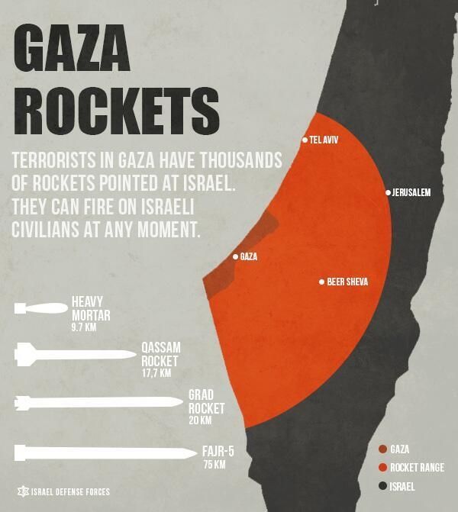

JULY 4
Gaza terrorists fired 16 rockets towards Israel. In response, the IDF targeted three Hamas terror sites in Gaza.

JULY 3
Gaza terrorists fired over 40 rockets at Israel. Two rockets directly stuck homes in Sderot. An additional two were intercepted by the Iron Dome missile defense system.
Shrapnel from a rocket attack wounded a soldier in Eshkol Regional Council.
In response to these attacks, the IDF targeted 15 terror sites in Gaza.
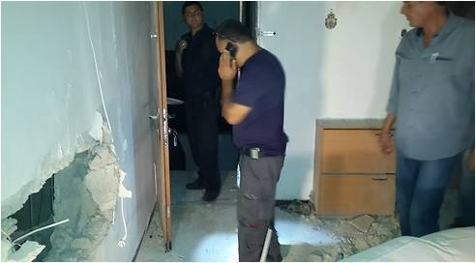

JULY 2
Gaza terrorists fired 10 rockets at Israel. Seven of them hit Eshkol Regional Council, and the Iron Dome system intercepted one of them above Ashkelon.
In response, the IDF targeted a rocket launching site in Gaza.

July 1
Gaza terrorists fired twelve rockets towards Israel. Two of them hit north of Sderot. Two others hit Eshkol Regional Council.
In response to these relentless attacks against Israelis, the IDF targeted 34 terror sites in Gaza.

Monday June 30
Three Gaza rockets struck Sdot Negev at about 9:50AM, damaging a home in the area. Less than two hours earlier, eight rockets hit populated areas throughout the south.

Sunday June 29
An IDF aircraft targeted terrorist​s ​in Gaza during​ their final preparations to launch rockets at communities of southern Israel.
Earlier Sunday evening, two rockets fired from Gaza were intercepted by the Iron Dome missile defense system. Simultaneously, terrorists opened fire at IDF soldiers adjacent to the security fence in the southern Gaza Strip. The force responded by firing at a suspect in the vicinity.

Saturday June 28
Gaza terrorists fired at least two rockets that struck an industrial factory in Sderot, causing a fire in the area. Emergency rescue teams rushed to the area following the terrorist attack.
In response to the rocket strikes and in order to prevent further attacks, an IAF aircraft targeted four terror activity sites, six concealed rocket launchers and two weapons manufacturing sites in Gaza.
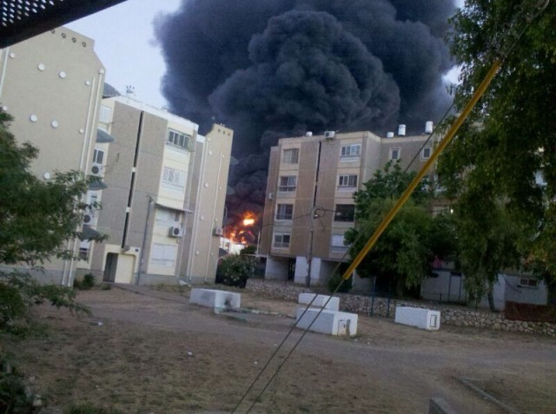
Plumes of smoke in Sderot following a rocket strike in the area
On Saturday evening, six rockets and two mortars fired at Israel. Three of the rockets hit the Eshkol Regional Council and an additional rocket hit the Hof Ashkelon Regional Council. Two of the rockets were intercepted by the Iron Dome missile defense system.
In response to these attacks, an IAF aircraft targeted two terror activity sites, a weapons-manufacturing facility and a weapons-storage facility in Gaza. Direct hits were confirmed.
Earlier Saturday, an explosive device was activated against forces working adjacent to the security fence in the northern Gaza Strip.
Eight explosive devices have been activated against IDF soldiers since the beginning of the year. Additionally, Gaza terrorists have fired over 50 rockets at southern Israel during the past two weeks alone.

Friday June 27
In less than an hour, Gaza terrorists fired five rockets at Israel on Friday evening. The Iron Dome system intercepted two of the rockets.
Earlier Friday, IAF aircraft targeted O​sama Ha​s​sumi and Mohammad Fatzih​, terror operative​s ​in northern Gaza. Hass​umi and Fatzih were involved in last week’s rocket fire at Israel, as well as several terror attacks over the past few years. The terrorists were planning further attacks against Israeli civilians before the IDF targeted them.
“​Militants like Hassumi and Fatzih, who attack Israel from Gaza, will not be free to plan, plot and operate [against Israel],” said IDF Spokesman Lt. Col. Peter Lerner. “We will continue to strike the instigators and agitators with patience, determination and precision. Gaza terrorism does not pay.”
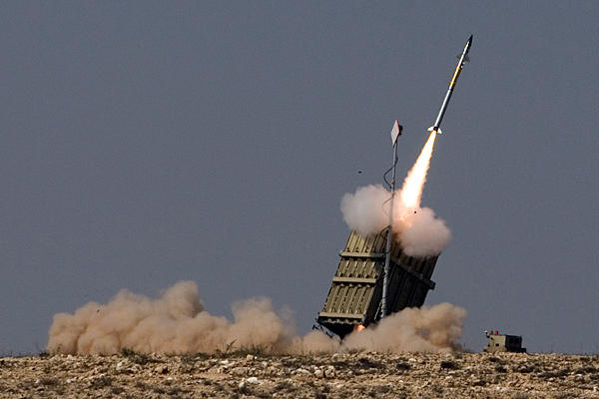
The Iron Dome system intercepted two of the rockets.

Tuesday June 24
Earlier this evening, five rockets were launched at Israeli civilians by Gaza terrorists. Two rockets were intercepted by the Iron Dome missile defense system, one hit an open area in the Sha’ar HaNegev regional council and the remaining two fell in Gaza.
In response to these attacks, an IAF aircraft targeted 5 concealed rocket launchers in northern Gaza, one terror activity site in central Gaza, and a weapon manufacturing facility in southern Gaza.

Sunday June 22
Terrorists fired two rockets fired at Israel. Both of them hit the Sha’ar Hanegev Regional Council.
In response: The IDF targeted four terror activity sites in Gaza.
Additionally, a terrorist carrying a hand grenade was arrested Sunday morning near Eshkol Regional Council. An initial investigation suggests he infiltrated Israel through the Gaza security fence.

Saturday June 21
Terrorists fired three rockets at Israel.
- One hit the Sha’ar Hanegev Regional Council
- One hit Hof Ashkelon Regional Council
- One fell short of its target and landed in Gaza

Friday June 20
Four rockets fired at Israel.
- One hit an open area near Sderot
- One intercepted by the Iron Dome missile defense system
- Two fell short of their target and landed in Palestinian teritory
In response: The IDF targeted three concealed rocket launchers and a weapons storage facility in Gaza.

Thursday June 19
Two rockets fired at Israel.
- One intercepted by the Iron Dome missile defense system
- One hit an open area near Sderot
In response: The IDF targeted a rocket-launching site and two terror activity sites in Gaza.

Wednesday June 18
Five rockets fired at Israel.
- Two hit the Sha’ar Hanegev Regional Council
- A house damaged by the explosion

Tuesday June 17
In response to rocket fire: The IDF targeted a terrorist activity site, a weapons factory and two weapon storage facilities in Gaza.

Monday June 16
One rocket fired at Israel.
In response: The IDF targeted two terrorist activity sites, three weapon storage facilities, and a weapons-manufacturing site in Gaza.

Sunday June 15
Multiple rockets fired at Israel.
Two intercepted by the Iron Dome missile defense system.
“We have repeatedly addressed the consequences facing those who seek to endanger the lives of innocent civilians,” IDF Spokesperson Lt. Col. Peter Lerner recently said in response to the attacks. “Iron Dome’s success does not change the absurd fact that Israelis have been living under continuous rocket threat for multiple years. We shall persist with our determination to combat terror elements and eliminate the pending threat to Israeli lives.”
