The Challenges of an Urban Battlefield
IDF Blog
July 18, 2014
https://web.archive.org/web/20140806021957/http://www.idfblog.com/blog/2014/07/18/challenges-urban-battlefield/

Urban warfare in Gaza presents a unique set of challenges: civilians are present, a tunnel network runs underneath the battlefield, and terrorists are familiar with the terrain.

The civilian population that lives within these urban areas is often exploited by Hamas, who who uses them as a human shield for military targets. The terrorist organization deliberately puts civilians in the line of fire in order to make it easier for their own terrorists to hide. They base command centers, weapons storage facilities and concealed rocket launchers inside civilian neighborhoods, sometimes even inside houses, knowing that the IDF is reluctant to strike densely populated areas.
Despite the various tactics used by Hamas, the IDF takes a number of measures to limit civilian casualties in Gaza. IDF soldiers go through special training [EDITOR’S NOTE: LINK GOES TO A SEPTEMBER 2, 2013 IDF BLOG ARTICLE ENTITLED “PHOTOS: Future IDF Infantry Officers Train for Complex Urban Warfare Scenarios”] that focuses on how to fight efficiently in urban areas.
“We know that the enemy – Hamas and other terror organizations – understands that the IDF is an ethical army [EDITOR’S NOTE: LINK GOES TO AN UNDATED IDF BLOG PAGE ENTITLED “IDF Code of Ethics”], and therefore they fight from within the civilian population in order to make our work more difficult,” explained Maj. Eyal Dror, Deputy Head of the Gaza CLA’s (Coordination and Liaison Administration) Operations Division. “The enemy wants us to shoot at hospitals and schools, and hurt innocent bystanders, in order to put international pressure on us.”
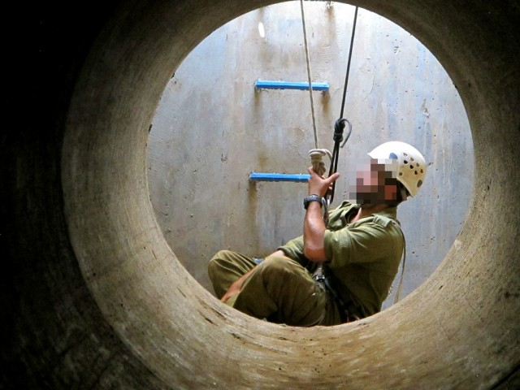
The elite Yahalom Unit in an exercise that involved climbing and sliding through tunnels and inside buildings.

During their urban warwafe training, the cadets encounter many of the possible challenges that they would need to deal with, including the presence of a terrorist network entrenched in a civilian area, [EDITOR’S NOTE: LINK GOES TO A FEBRUARY 3, 2014 IDF BLOG ARTICLE ENTITLED “Terror Underground: How Hamas Is Digging Tunnels and Building Rockets in Gaza”] booby-trapped homes, and kidnappings by enemy forces. “Every exercise we conduct is based on those which precede it,” said Colonel Odi Ben-Moha, former commander of the Kfir Brigade. “We always aspire to improve. We learn from our mistakes and work on being as efficient as possible on the battlefield.”
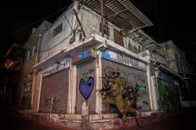
The Paratroopers Brigade simulate combat in urban territory at the Carmel Market in Tel Aviv
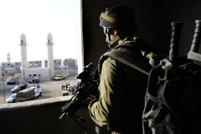
The Desert Reconnaissance Battalion conducts drill in the urban warfare center
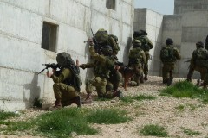
Kfir Brigade IDF Officers Practice Urban Warfare

