Special Report: The Deadly Rocket Arsenal of Hamas
IDF Blog
July 10, 2014
https://web.archive.org/web/20140806023434/http://www.idfblog.com/blog/2014/07/10/6-million-lives-in-danger-the-deadly-rocket-arsenal-of-hamas/

In response to the continued rocket fire into Israel from Gaza, the IDF has launched Operation Protective Edge. This is an analysis of the deadly weapons Hamas has in its possession that are responsible for the unbearable situation in Israel.
Hamas, the ruling entity of the Gaza Strip, is responsible for most of the attacks on Israeli population centers. Since Operation Pillar of Defense [EDITOR’S NOTE: LINK GOES TO A NOVEMBER 21, 2013 IDF BLOG ARTICLE ENTITLED: “8 Days, 8 Striking Photos that Tell the Story of Operation Pillar of Defense”] in 2012, the terrorist organization has increased the size and strength of its rocket arsenal. Terrorist organizations in the Gaza Strip currently possess around 10,000 rockets including long-range missiles such as the M-302. Hamas is in control of 6,000 of these rockets.
[EMBEDDED VIDEO: http://humanrightsvoices.org/site/documents/?d=21971&id=25255]
The following is a report from IDF intelligence on terrorist organizations rocket arsenals.

Hamas’ Rocket Arsenal
Short range (15-20 km)
- Over 1,000 units of self-produced rockets (15 km)
- Over 2,500 units of smuggled rockets (15 km)
- Approx. 200 units of self-produced Grad rockets (20 km)
- Approx. 200 units of smuggled Grad rockets (20 km)
Medium range (up to 45 km)
- Approx. 200 units of self-produced improved Grad rockets (45 km)
- Approx. 1,000 units of smuggled improved Grad rockets (45 km)
- Medium-Long range (up to 80 km)
- Over 400 units of self-produced medium range rockets
- Several dozens of rockets (80 km)
Long range (100-200 km)
- Tens of long-range rockets (100-200 km)
In Total: Approximately 6,000 rockets
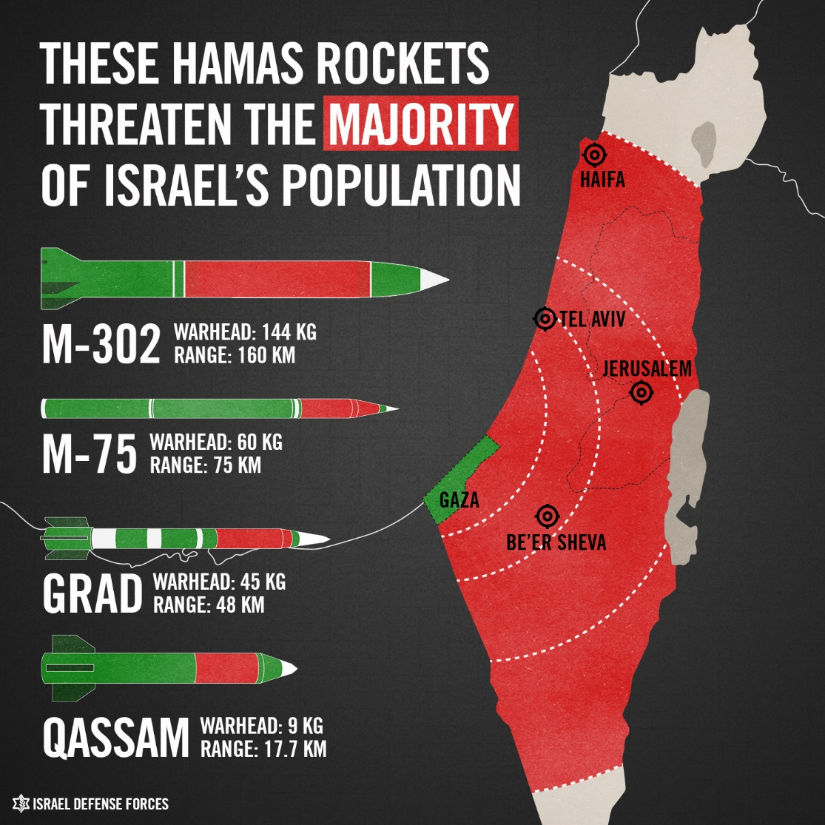

Palestinian Islamic Jihad’s Rocket Arsenal
The other main terrorist group in the Gaza Strip is the Palestinian Islamic Jihad [EDITOR’S NOTE: LINK GOES TO A JANUARY 19, 2014 IDF BLOG ARICLE ENTITLED “IDF Targets Palestinian Islamic Jihad Terrorist Ahmad Sa’ad”], who also have a formidable weapons arsenal.
Short range (15-20 km)
- Approx. 1,000 units of self-produced rockets (15 km)
- Approx. 1,000 units of smuggled rockets (15 km)
- Approx. 300 units of self-produced Grad rockets (20 km)
- Approx. 100 units of smuggled Grad rockets (20 km)
Medium range (up to 45 km)
- Approx. 200 units of self-produced improved Grad rockets (45 km)
- Approx. 600 units of smuggled improved Grad rockets (45 km)
Medium-Long range (up to 80 km)
- Over 100 units of self-produced medium range rockets
- Several medium-long range rockets (80 km)
In Total: Approximately 5,500 rockets
[EMBEDDED VIDEO: http://humanrightsvoices.org/site/documents/?d=21943&id=25227]

Other Terrorist Organizations
Short range (15-20 km)
- Hundreds of self-produced and smuggled rockets including Grad rockets (15 km)
Medium range (up to 45 km)
- Dozens of self-produced and smuggled improved Grad rockets (45 km)
Total number of rockets in the hands of Gaza terrorists: Approximately 10,000

Hamas Exploits Civilians
Hamas uses civilian infrastructure to store and hide these weapons. The terrorist group uses the densely packed civilian areas of the Gaza Strip to embed its weapons arsenal and command centers. In order to target these terror sites and limit civilian casualties, the IDF uses precision attacks and provides warnings of strikes in advance.
[EMBEDDED VIDEO: http://humanrightsvoices.org/site/documents/?d=21949&id=25233]

