Photo: Drivers take refuge from rockets in Tel-Aviv
IDF Blog
July 9, 2014
http://web.archive.org/web/20151119091735/https://www.idfblog.com/blog/2014/07/09/israel-fire-life-comes-halt/car0/

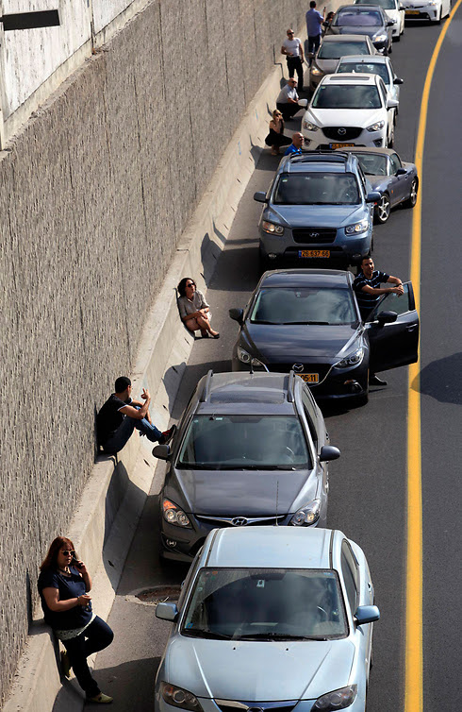
Drivers take refuge from rockets in Tel-Aviv.

