New Map Exposes Hamas’ Fortress in Shuja’iya
IDF Blog
August 4, 2014
http://web.archive.org/web/20140806021936/http://www.idfblog.com/blog/2014/08/04/map-exposes-hamas-fortress-shujaiya-neighborhood/

Hamas uses the residential neighborhood of Shuja’iya as a terrorist stronghold for its weapons, rockets, tunnels and command centers. This is why the IDF targeted multiple sites in Shuja’iya.
Shuja’iya is a densely populated neighborhood, close to the Karni Crossing and just over the border fence from the Israeli community of Kibbutz Nahal Oz. Shuja’iya is saturated with Hamas observation points and is home to a vast network of tunnels used for attacking Israel.
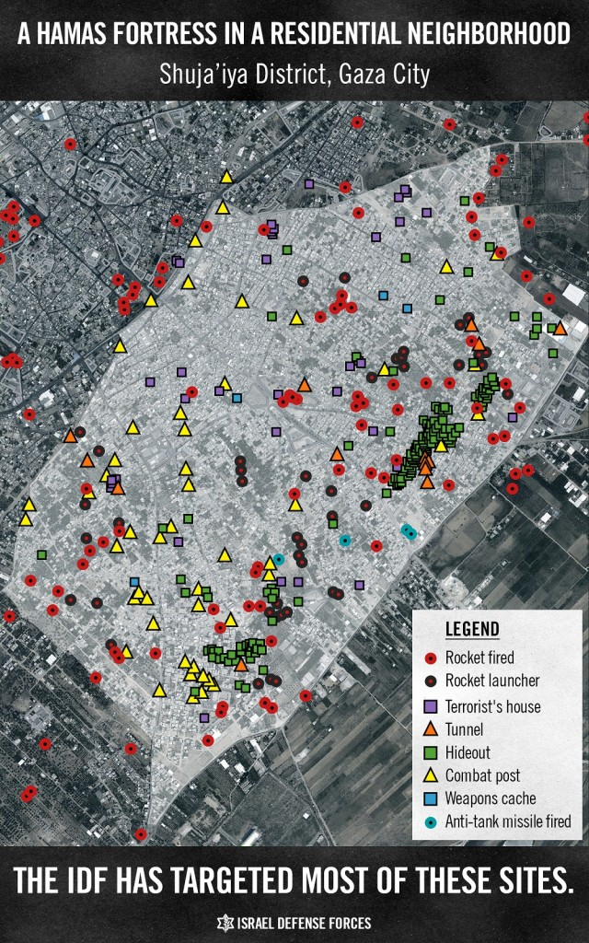
This map shows the many terror sites in Shuja’iya identified and targeted by the IDF. It confirms that the Shuja’iya neighborhood is a terrorist stronghold where Hamas uses residents as human shields.
The UN recently published a map that marks areas of Shuja’iya damaged during IDF strikes. A comparison of the two maps clearly demonstrates that the areas targeted by the IDF are the same areas that the UN marked as damaged. The conclusion: the IDF distinguishes between structures used for terror purposes and structures used only for civilian purposes.
