Live Updates: Gaza Terrorists Continue Rocket Fire
IDF Blog
July 18, 2014
http://web.archive.org/web/20140831110546/http://www.idfblog.com/blog/2014/07/18/live-updates-ground-operation-gaza/#

Following ten days of Hamas attacks against Israel and after repeated rejections of offers to deescalate the situation, the IDF started a new phase of Operation Protective Edge. A large IDF force entered the Gaza Strip. Their mission is to target Hamas’ tunnels that cross under the Israel-Gaza border and enable terrorists to infiltrate Israel and carry out attacks. The IDF intends to impair Hamas’ capability to attack Israel. Since the beginning of Operation Protective Edge more than 4,000 rockets have been fired from Gaza at Israel.

Wednesday, August 27
7:27 PM: A short while ago, an Israeli civilian was lightly injured as a result of errant fire from the internal fighting in Syria.
1:56 PM: In response to the errant fire from the internal fighting in Syria, which hit Israel earlier today and injured an IDF officer, the IDF just targeted two Syrian army positions in the Syrian Golan Heights. Hits were confirmed.
1:15 PM: Earlier today, an IDF officer was moderately injured as a result of errant fire from Syria. The officer was evacuated for medical treatment.

Tuesday, August 26
7:25 PM: An Israeli civilian was killed and several others were wounded after a mortar fired from Gaza hit Eshkol. Hours later, another civilian died from his wounds.
2:41 PM: Moments ago, a rocket fired from Gaza landed near a kindergarten in Ashdod.
6:46 AM: A house destroyed this morning in Ashkelon. Millions of Israelis began another day under Hamas’ rocket fire.
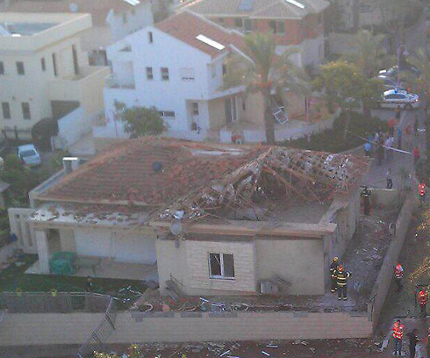
6:29 AM: At least one rocket was intercepted over the Tel Aviv metropolitan area.

Monday, August 25
11:17 PM: Earlier, 2 rockets were fired from Lebanon at northern Israel. IDF retaliated with artillery fire towards the source of the attack.
10:33 PM: At least one rocket fired from Lebanon hit the Upper Galilee.
7:59 PM: Sirens sounded across central Israel & explosions were hear.
3:56 PM: Moments ago, the IDF targeted a rocket launcher placed within a school in Shuja’iya. Earlier today, it was used to fire rockets at Israel.
8:22 AM: Rocket sirens in Tel Aviv.

Sunday, August 24
11:50 PM: Moments ago, 4 rockets were fired at Ashkelon from Gaza. In the last 24 hours terrorists fired 135 rockets at Israel.
11:18 PM: A short while ago, we struck the rocket launcher that fired at Jerusalem earlier this evening.
9:32 PM: Moments ago, a rocket fired from Gaza was intercepted above the Jerusalem area.
3:58 PM: Earlier today, we targeted Mohamed Al-Oul, the terrorist responsible for Hamas’ financial transactions.
2:33 PM: A short while ago, several rockets and more than 5 mortars hit the Erez crossing injuring 4 civilians; one of whom was moderately injured. In response, the IDF targeted the concealed rocket launcher from which the rockets were fired, located in the northern Gaza Strip.
12:19 PM: A rocket fired from Gaza was intercepted above Gan Yavne.
11:42 AM: Rocket sirens heard in southern Israel.
1:51 AM: At least five rockets fired from Syria hit different locations across the Golan Heights.

Saturday, August 23
10:48 PM: A rocket fired from Lebanon hit the Upper Galilee.
5:34 AM: Since midnight, about 60 rockets were fired at Israel.
1:37 AM: Today we’ve informed the residents of Gaza to distance themselves from any sites used by terrorists in light of impending IDF strikes.

Friday, August 22
10:30 PM: An Israeli civilian was severely injured by a rocket that hit Ashdod.
10:03 PM: A barrage of rockets from Gaza were launched at southern Israel, several were intercepted.
6:44 PM: 4-year-old Daniel Tragerman, an Israeli child, was killed in the Sdot Negev regional council after a mortar fired from Gaza exploded near a kindergarten. The mortar that killed him was fired from a school in Gaza maintained by Hamas authorities.
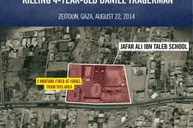

6:04 PM: Rocket sirens and explosions were heard in Tel Aviv area. One rocket was intercepted.
3:56 PM: A rocket fired from Gaza directly hit a synagogue in Ashdod, wounding two civilians.
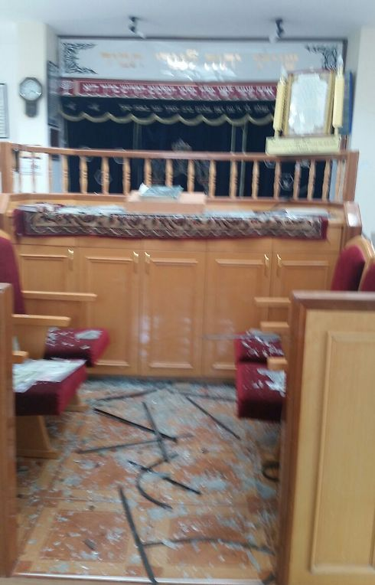
The synagogue in Ashdod
2:31 PM: A rocket just hit an open area near Tel Aviv.
12:35 PM: A civilian was moderatly wounded by a rocket hitting Be’er-Sheva. In addition, another civilian was lightly injured by a rocket in Sderot.
12:00 PM: 26 rocket launches from Gaza since midnight.

Thursday, August 21
12:00 PM: Approved for release- Further to this morning’s strike on senior Hamas terrorists, the IDF confirms that Muhamad Barhoum was also killed in this strike. Barhoum was a senior Hamas operative in the Rafah area who smuggled weapons to the Hamas terrorist infrastructure. Barhoum resided in Syria and Libya for several years in order to raise funds for Hamas and transfer them to the Gaza Strip.
11:21 AM: 6 Palestinian Islamic Jihad operatives who were in their final preparations to launch rockets were targeted. A hit was confirmed.
11:00 AM: In the past half hour, 12 rockets struck Nir Oz, an Israeli community near the Gaza border. A civilian was severely wounded.
9:50 AM: Confirmed- the IDF and Israeli security forces eliminated senior Hamas terrorists Raed Attar and Mohamed Abu Shamala in Gaza last night. Attar and Abu Shamala were high-ranking Hamas commanders responsible for major terror attacks against Israelis. Attar played a major role in tunnel infiltrations, terror attacks that killed Israelis, and the kidnapping of SFC Gilad Shalit. Abu Shamala, commander of Hamas forces in Southern Gaza, was directly involved in dozens of terror attacks, including the murders of IDF soldiers.

Wednesday, August 20
00:00 AM: In response to Hamas rocket fire, we struck 20 targets in Gaza during the night. Since Hamas breached the ceasefire, over 213 rockets were fired at Israel; 162 hit, 35 were intercepted and 16 landed short in the Gaza Strip
11:04 PM: The IDF targeted a terrorist who was responsible for the rocket barrages at southern Israel earlier this evening.
7:06 PM: The recent explosion heard in Tel Aviv was part of a barrage of 5 rockets fired at Israel in the past 30 minutes.
6:49 PM: Just now, an explosion was heard in the Tel Aviv area.
6:26 PM: Since Hamas broke the latest ceasefire, over 175 rockets have been fired at Israel.
2:50 PM: We targeted 2 terrorists who were responsible for firing rockets at Sderot this morning.
1:52 PM: A rocket was intercepted over Hashfela, in central Israel.
1:15 PM: 2 rockets were just intercepted over Ashdod.
1:10 PM: A rocket hit a civilian home in the Hof Ashkelon regional council. No injuries are currently reported. In addition, two rockets were intercepted above the Ashdod metropolitan area.
12:47 PM: 2 terrorists were targeted in the northern Gaza Strip. One of the terrorists took part in the rocket attack against Ashkelon earlier this morning, and the other was responsible for rocket launching at Israel earlier this morning and over the past few months. Hits were confirmed.
11:10 AM: Over 80 rockets were launched from the Gaza Strip since the breach of fire yesterday afternoon; the IDF is responding accordingly and targeting terror sites across the Gaza Strip. Since midnight over 30 rockets were launched at Israel; 6 were intercepted and 4 fell short in the Gaza Strip.
9:00 AM: More than 10 rockets were launched at Israel in the past hour. Since Gaza terrorists violated the latest ceasefire, they have fired about 70 rockets.

Tuesday, August 19
11:48 PM: Red alert sirens sound in Jerusalem.
10:55 PM: The IDF Home Front Command has furthered on previous instructions and ordered to open bomb shelters within the 40-80km range of the Gaza Strip.
10:49 PM: Sirens were just heard across central Israel. A rocket hit in the Tel Aviv Metropolitan Area.
9:58 PM: A rocket just hit Hof Ashkelon regional council.
8:30 PM: The IDF Home Front Command has issued orders to open bomber shelters within the 40km range of the Gaza Strip.
8:18 PM: A rocket hit an open area near Ashdod.
6:43 PM: 2 rockets were interecepted over Netivot in southern Israel.
4:35 PM: In response to the rocket fire, we have begun striking terror targets in the Gaza Strip.
3:55 PM: 3 rockets fired from Gaza hit Be’er Sheva and Netivot. Terrorists have violated the ceasefire.

Wednesday, August 11
Gaza terrorists fired 8 rockets at Israel, breaking the 72-hour ceasefire.

Sunday, August 10

Updates by the Hour
8:25 PM: Since the beginning of Operation Protective Edge, Hamas has fired 3,488 rockets at Israel.
4:43 PM: Three rockets fired from Gaza hit open areas in southern Israel.
3:14 PM: Goods regularly reach Gaza through our Kerem Shalom crossing. We’ve temporarily closed the crossing due to Hamas’ rocket fire over the area.
2:54 PM: Gaza terrorists fired two rockets over Sderot. The Iron Dome intercepted them.
2:35 PM: Two rockets hit the southern Israeli community of Kissufim.
2:15 PM: Three rockets fired from Gaza hit the Israeli city of Sderot.
7:21 AM: Two rockets fired from Gaza hit southern Israel.

Saturday, August 9

Updates by the Hour
11:18 PM: Earlier this evening, the IDF targeted four Hamas terrorists in the southern Gaza Strip. Hits were confirmed.
10:47 PM: Since the end of the ceasefire, Hamas fired approximately 100 rockets at Israel. In response, the IDF targeted some 120 terror sites and 9 terror operatives.
10:32 PM: Today, Hamas fired 30 rockets at Israel; of them 24 hit Israel and 5 landed short in Gaza.
10:36 AM: A few minutes ago, a rocket fired from Gaza hit southern Israel.
9:29 AM: Since midnight, the IDF has struck 33 terror targets in the Gaza Strip in response to continued attacks.

Friday, August 8

Updates by the Hour
11:10 PM: Since 8:00 AM, Gaza terrorists have fired 61 rockets at Israel. 43 rockets have hit Israel and the Iron Dome has intercepted 5 of them. In response to continuing attacks, the IDF has targeted 70 terror sites in Gaza.
8:30 PM: Since 8:00 AM, Gaza terrorists have fired 57 rockets at Israel. In response, IDF aircraft struck 51 terror sites and targeted three terrorists in the Gaza Strip.
11:45 AM: Gaza terrorists continue firing rockets, as sirens are heard in southern Israel.
10:45 AM: In response to the renewal of rocket fire by Gaza terrorists at Israel, the IDF is striking terror sites in Gaza.
10:35 AM: 1 rocket was intercepted over Sderot. 2 rockets hit open areas.
9:45 AM: Since 8:00 AM, over 18 rockets were launched from the Gaza Strip at Israel. 2 were intercepted above the Ashkelon metropolitan area, at least 14 hit open areas while 2 landed short in the Gaza Strip.
4:30 AM: 2 rockets fired from Gaza hit southern Israel. Terrorists have violated the cease-fire.

Tuesday, August 5

Updates by the Hour
8:00 AM: Starting now, the IDF will observe a ceasefire lasting 72 hours. During this time, forces will maintain defensive positions near the Gaza border.
1:16 AM: Moments ago, Iron Dome intercepted two rockets above Ashkelon.

Monday, August 4

Updates by the Hour
9:23 PM: So far today, 63 rockets fired from Gaza have hit Israel; an additional five rockets were intercepted by the Iron Dome.
5:38 PM: So far today, terrorists in Gaza have fired 53 rockets at Israel.
2:23 PM: The Iron Dome intercepted a rocket fired from Gaza above Ashdod.
7:15 AM: Moments ago, two rockets were fired at Israel. Iron Dome intercepted one rocket over Ashkelon; the second hit an open area.
2:25 AM: We have authorized a humanitarian window to take place in the Gaza Strip from 10:00 AM to 5:00 PM today. We will continue to neutralize Hamas’ tunnel network and will respond to any attempt to harm Israeli civilians or IDF soldiers.

Sunday, August 3

Updates by the Hour
11:15 PM: Today, Gaza terrorists fired 119 rockets at Israel. That’s 119 attempts to kill Israelis.
9:35 PM: We found motorcycles and weapons in a tunnel inside Israel. Hamas’ plan was to carry out a massive attack, abduct Israelis and rush back to Gaza with hostages.
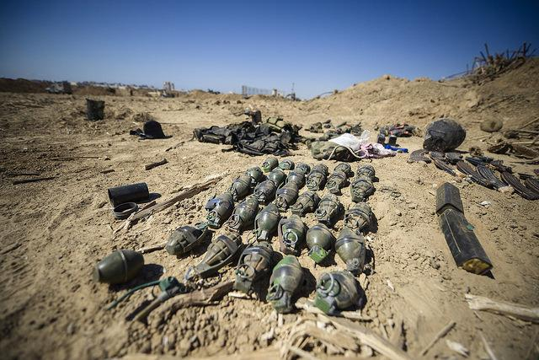
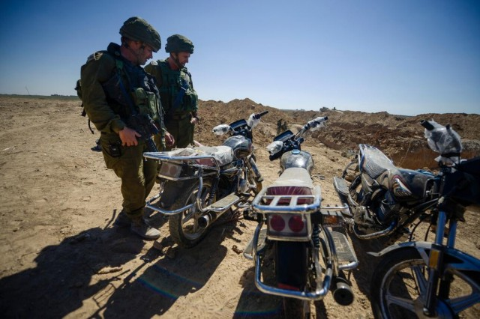
5:10 PM: One rocket was intercepted by the Iron Dome over Tel Aviv, and 3 rockets hit open areas in southern Israel.
5:03 PM: Sirens and booms heard in Tel Aviv and across central Israel.
3:00 PM: More than 55 rockets were fired at Israel since midnight.
In a second incident, forces operating to uncover shafts identified several terrorists emerging from one, and immediately opened fire at the squad, that attempted to flee to a nearby house. The force fired at the terrorists, and confirmed a hit. The forces detonated the tunnel’s route.
In addition, a paratrooper forces identified four terrorists preparing to launch an anti-tank missile from a house in the southern Gaza Strip. Armored corps opened fire at the target, identifying a hit.
Since midnight, The IDF struck some 40 terror targets in Gaza, as well as 8 terrorists.
Earlier today, special forces uncovered more than 150 mortars and a tunnel opening in Rafah, in southern Gaza. pic.twitter.com/e8G034wmrx
— IDF (@IDFSpokesperson) August 3, 2014
2:40 PM: As operation Protective Edge moves to the next stage, we are redeploying to enable combat against Hamas & continued defense from tunnels.
2:30 PM: So far today, Hamas terrorists from Gaza fired 13 rockets at Israel.
7:17 AM: We struck 108 terror targets in Gaza in the past 24 hours.
02:35 AM: Yesterday at 11:25 PM, a special committee led by the IDF Chief Rabbi announced the death of Lt. Hadar Goldin, 23, an infantry officer in the Givati Brigade who was killed in battle in the Gaza Strip on Friday. Medical, religious and other relevant factors were considered before making the official announcement. Lt. Goldin’s family was notified moments by Head of the IDF Personnel Directorate Maj. Gen. Orna Barbivai and Chief Military Rabbi Brig. Gen. Rafi Peretz.

Saturday, August 2

Updates by the Hour
3:43 PM: We have told Beit Lahia residents that they may return to their homes. We advised them to avoid explosives placed by Hamas across the area.
11:00 AM: Over the past 24 hours, the IDF struck 200 terror targets in the Gaza Strip, including tunnels, weapon manufacturing and storage facilities, and command and control centers. Among the targets was a Hamas military wing facility that was used for research and development of weapon manufacturing located within the Islamic University. In addition, weapon caches and Hamas command and training facilities concealed within five mosques were targeted. Earlier today, IAF aircraft targeted the launcher used to fire at Tel Aviv area earlier this morning.
Hamas has fired more than 3,000 rockets towards Israel since the beginning of Operation Protective Edge. RETWEET. pic.twitter.com/wfURPnTnYw — IDF (@IDFSpokesperson) August 2, 2014
6:21 AM: Moments ago Iron Dome intercepted two rockets over Tel Aviv and one over BeerSheba.
6:17 AM: Rocket sirens in Tel Aviv.

Friday, August 1

Updates by the Hour
8:51 PM: So far today, Palestinian terrorists in the Gaza Strip have fired 61 rockets at Israel.

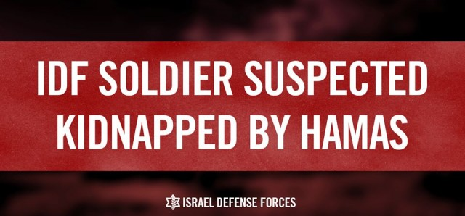
9:30 AM: in violation of the latest ceasefire, Hamas terrorists, including a suicide attacker, fired at our forces in southern Gaza. We suspect that Hamas kidnapped 2nd. Lt. Hadar Goldin, an IDF officer, during the exchange of fire and dragged him into a tunnel. The IDF is currently conducting extensive searches in order to locate the missing soldier. During the event, 2 IDF soldiers were killed by Hamas fire- Maj. Benaya Sarel, 26 and Staff Sgt. Liel Gidoni, 20.
12:45 PM: Eight rockets and mortars were fired at Israel, one was intercepted and seven hit open areas.
10:15 AM: The names of four of the five IDF soldiers killed last night by mortar fire are released: Staff Sgt. Noam Rosenthal, 20, Sgt. 1st Class (Res.) Daniel Marash, 22, Cpt. Omri Tal, 22, Staff Sgt. Shay Kushnir, 20 & Cpt. (res.) Liran Adir (Edry), 31. May their memory be blessed.
7:47 AM: Moments ago, six rockets fired from Gaza were intercepted by Iron Dome above southern Israel.
7:14 AM: At 8:00 AM, the IDF will cease fire for 72 hours in accordance with the government’s directive. We will continue to dismantle the tunnels.
5:10 AM: Yesterday, five IDF soldiers were killed by mortar fire during operational activity along the Gaza border.
1:30 AM: Moments ago, three rockets were fired from Gaza. Iron Dome intercepted one above central Israel.

Thursday, July 31

Updates by the Hour
10:38 PM: So far today, 73 rockets fired from Gaza have hit Israel; an additional 17 rockets were intercepted by the Iron Dome.
7:34 PM: A Hamas rocket fired from Gaza struck a home in Kiryat Gat.
6:26 PM: Moments ago, the Iron Dome intercepted a rocket above central Israel and three others above Kiryat Gat.
6:01 PM: Rocket sirens heard in Tel Aviv.
5:39 PM: The Iron Dome just intercepted two rockets above Ashkelon.
12:33 PM: Hamas terrorists fired 10 rockets at Sderot. Seven were intercepted by Iron Dome; three fell in open territory.
11:48 AM: Paratroopers identified a squad of five terrorists. Our aircraft targeted the squad and identified a hit.
10:04 AM: We struck 110 terror sites in Gaza in the past 24 hours, including five command centers.
9:06 AM: Moments ago, a rocket fired from Gaza hit southern Israel.
4:31 AM: 50 of the rockets fired from Gaza in the last 24 hours landed in Gaza.
3:36 AM: Gaza terrorists fired more than 140 rockets at Israel over the past 24 hours. That’s almost one rocket every 10 minutes.

Wednesday, July 30

Updates by the Hour
10:36 PM: The third soldier killed in combat in Gaza earlier today was Staff Sgt. Guy Algranati, 20. May his memory be blessed.
8:49 PM: Two of the soldiers killed in southern Gaza today were Staff Sgt. Matan Gotlib, 21 and Staff Sgt. Omer Hay, 21. May their memory be blessed.
7:10 PM: Three IDF soldiers were killed this afternoon during operational activity in the southern Gaza Strip.
7:00 PM: Since 3:00 PM, when the IDF authorized a humanitarian window in Gaza, 26 rockets have been fired at Israel, 2 of them were intercepted above Ashkelon and Netivot.
5:45 PM: This afternoon, an IDF elite unit operated in Gaza in order to uncover offensive tunnels, and indeed uncovered a tunnel opening inside a house in the southern Gaza Strip. Two explosive devices were detonated against the soldiers, one from within the tunnel and a second one that was concealed within the house. The explosion caused the residence to collapse and the injury of several soldiers.
3:00 PM: The IDF has opened a humanitarian window in Gaza from 3:00 to 7:00 PM. Window does not apply to areas where IDF soldiers are operating.
9:00 AM: In the past 24 hours, IDF infantry and engineering forces have detonated three tunnel routes within the Gaza Strip. Since midnight, the IDF targeted over 75 terror sites in Gaza. Overnight, the IAF targeted five mosques which were utilized for terror purposes, such as concealing weapons and housing tunnel access shafts.

Tuesday, July 29

Updates by the Hour
10:29 PM: A few minutes ago, two rockets fired from Gaza hit southern Israel. In addition, the Iron Dome intercepted one rocket over the Tel Aviv area.
10:24 PM: This map seized from a Hamas terrorist shows tunnel access points and rocket launchers in densely populated areas.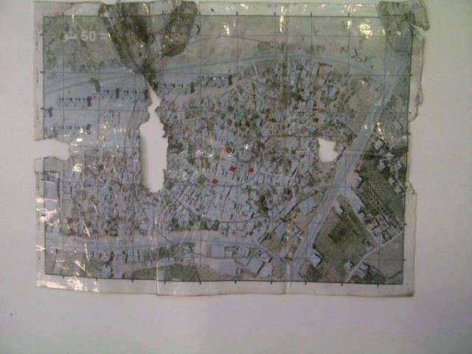
10:16 PM: Rocket sirens and blasts heard in central Israel.
8:41 PM: A few minutes ago, the Iron Dome intercepted a rocket over Beit Shemesh, a city west of Jerusalem.
1:06 PM: Last night, we struck four massive weapons caches that Hamas hid inside of mosques.
11:17 AM: In about three weeks, Hamas has fired over 2,600 rockets at Israel’s civilians.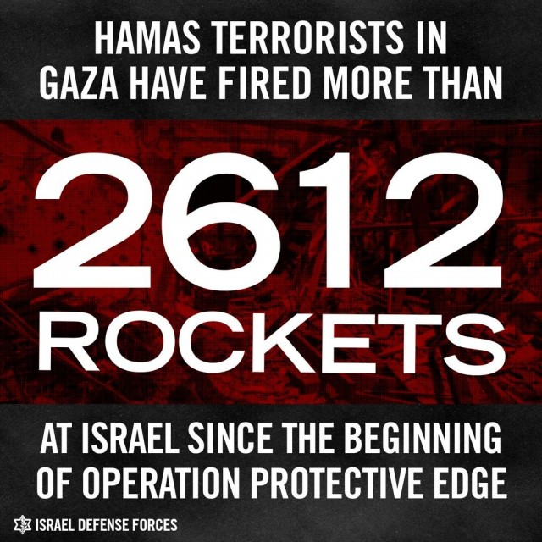
7:48 AM: The fifth soldier killed in combat yesterday during an attempted terrorist infiltration was Sgt. Nadav Raimond, 19. May his memory be blessed.
6:05 AM: Yesterday, five IDF soldiers were killed in combat when terrorists infiltrated Israel via a tunnel from Gaza and attempted to execute an attack. Among them: Sgt. Daniel Kedmi, 18; Sgt. Barkey Ishai Shor, 21; Sgt. Sagi Erez, 19; Sgt. Dor Dery, 18. May their memory be blessed.
3:11 AM: Moments ago, three rockets were fired from Gaza. Iron Dome intercepted one above Ashdod; two hit open areas in central Israel.
2:32 AM: Rocket sirens heard in Tel Aviv.
2:28 AM: Gaza terrorists fired rockets yesterday, hoping to kill Israelis. Instead, they hit a hospital and a refugee camp in Gaza.
Gaza terrorists fired rockets today, hoping to kill Israelis. Instead, they hit a hospital & a refugee camp in Gaza. pic.twitter.com/dXNhtCHTQc — IDF (@IDFSpokesperson) July 28, 2014
12:18 AM: The names of the soldiers killed yesterday as a result of mortar fire: Staff Sgt. Eliav Eliyahu Haim Kahlon, 22; Staff Sgt. Adi Briga, 23; Cpl. Meidan Maymon Biton, 20; Cpl. Niran Cohen, 20. May their memory be a blessing.

Monday, July 28

Updates by the Hour
9:55 PM: Staff Sgt. Moshe Davino, 20, from Jerusalem, was killed today in combat in the southern Gaza Strip. May his memory be blessed. In addition, four IDF soldiers were killed along the Gaza border today as a result of mortar fire. Their families have been notified.
9:37 PM: Confirmed: Terrorists infiltrated Israel via tunnel near Nahal Oz. IDF thwarted attack and killed one of the terrorists. Searches continue.
8:59 PM: Phone calls and text messages were sent to Beit Hanoun, Beit Lahia and Jabalia residents, warning them to evacuate immediately to central Gaza City.
8:11 PM: Initial reports that terrorists infiltrated Israel from Gaza in order to attack an Israeli community near the border. IDF forces responded.
7:23 PM: Phone calls were made and text messages were sent out to the civilian population of Shuja’iyya, Zeitoun and eastern Jabalia, calling them to evacuate themselves immediately towards central Gaza city.
6:09 PM: Al-Shifa Hospital and Al-Shati Refugee Camp were struck by failed rocket attacks launched by Gaza Terrorists.
12:12 PM: The IDF targeted 2 concealed rocket launchers and a weapon manufacturing site in the northern and central Gaza Strip.
9:30 AM: Following the rocket that hit Ashkelon earlier, the IDF retaliated towards Beit Lahyia area, from which the rocket was fired.
7:30 AM: Moments ago, a rocket hit open area in southern Israel.
7:20 AM: Rocket sirens sound in Ashkelon.

Sunday, July 27
Summary of the day:
- More than 71 rockets were fired from Gaza towards Israel.
- At least 50 rockets hit Israel.
- 9 rockets were intercepted by the Iron Dome missile defense system.
- The IDF struck over 40 terror targets in the Gaza Strip.
- 32 terror tunnels were uncovered by IDF forces since July 17.
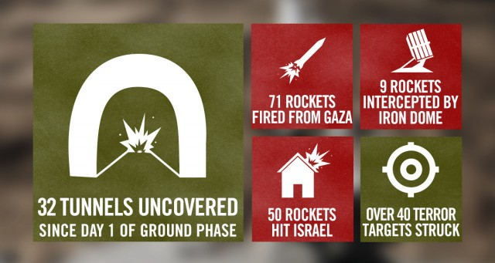

Updates by the Hour
6:28 PM: An Israeli woman was wounded earlier today by a rocket fired from the Gaza Strip.
5:32 PM: The Iron Dome just intercepted 4 rockets over Be’er Sheva.
4:57 PM: Five rockets were just fired from Gaza toward Kiryat Gat. The Iron Dome intercepted four of them; one hit an open area.
5 outgoing rockets from a populated area in Gaza a short time ago. Photo by reporter Nick Schifrin. pic.twitter.com/0Rm7g8WC5f — IDF (@IDFSpokesperson) July 27, 2014
4:47 PM: A few minutes ago, a rocket fired from Gaza struck a house in southern Israel.
2:20 PM: Two rockets fired from Gaza hit the Eshkol Regional Council in southern Israel.
12:36 PM: Earlier today, a car at the Beitar checkpoint, near Jerusalem, refused to stop. IDF forces searched it and found explosives, gas tanks and a switch.
10:12 AM: Due to Hamas’ incessant rocket fire during the humanitarian window, we are renewing our aerial, naval and ground activity in Gaza.
8:30 AM: Seven rockets were fired from Gaza. Iron Dome intercepted two and five hit southern Israel.
7:20 AM: Sgt. First Class (res.) Barak Refael Degorker, 27, was killed overnight by mortar fire from Gaza. May his memory be a blessing.
6:38 AM: Since midnight, three rockets fired from Gaza hit southern Israel.
2:10 AM: Hamas has fired more than 2,450 rockets at Israel since Operation Protective Edge began.
12:27 AM: Cpt. Liad Lavi, 22 and Chief Warrant Officer Rami Chalon, 39, both injured in battle, died of their wounds today. May their memory be blessed.

Saturday, July 26
Summary of the day:
      - More than 22 rockets were fired from Gaza towards Israel.
      - At least 16 rockets hit Israel.
      - 6 rockets were intercepted by the Iron Dome missile defense system.
      - The IDF struck over 40 terror targets in the Gaza Strip.
      - 31 terror tunnels were uncovered by IDF forces since July 17.
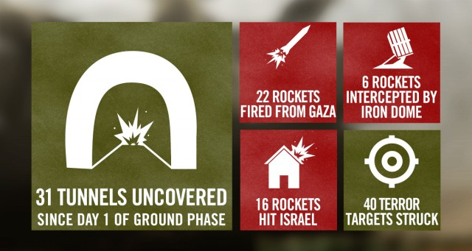

Updates by the Hour
10:21 PM: Iron Dome intercepted two rockets above Ashkelon.
9:49 PM: Rocket sirens heard in central Israel.
9:40 PM: Moments ago, three more rockets launched from Gaza hit Israel.
8:30 PM: During the day, we found four more tunnel shafts in Gaza.
8:10 PM: Three mortars fired from Gaza hit Israel.
Since last night, Staff Sgt. Amit Yeori, 20, Staff Sgt. Avraham Grintzvaig, 21, Staff Sgt. Gal Bason, 21 & Lt. Roy Peles, 21 fell in combat. — IDF (@IDFSpokesperson) יולי 26, 2014
5:44 AM: Last night, two IDF soldiers were killed on the battlefield in Gaza. One of the soldiers was Staff Sgt. Guy Boyland, 21, a combat engineer from the 7th Armored Brigade. May his memory be a blessing.
2:29 AM: From 8:00 AM to 8:00 PM, there will be a humanitarian window in Gaza. During this time, we’ll continue to locate & neutralize terror tunnels.
Gaza civilians who have been requested to vacate their residences are asked to refrain from returning. — IDF (@IDFSpokesperson) July 25, 2014

Friday, July 25

Updates by the Hour
9:27 PM: A short while ago, the Iron Dome intercepted one rocket over Gan Yavne and one rocket over Ramat Hasharon.
8:58 PM: At noon today, terrorists fired mortars & anti-tank missiles from near an UNRWA school in Gaza, killing IDF soldier taff Sgt. Guy Levy, 21, from Kfar Vradim. May his memory be a blessing.
6:34 PM: The Iron Dome just intercepted a rocket above Sderot.
5:00 PM: IDF paratroopers found a Hamas weapons cache containing many RPGs, grenades & suicide belts stuffed with shrapnel.
2:59 PM: IDF forces found anti-tank missiles and grenades today in a house in southern Gaza.
2:26 PM: A short while ago, the Iron Dome intercepted 3 rockets over the Ashkelon area.
2:22 PM: Master Sergeant (Res.) Yair Ashkenazy, 36, was killed today on the battlefield. May his memory be blessed.
1:22 PM: A rocket fired from Gaza hit an apartment building in the Israeli city of Ashkelon.
A rocket fired from Gaza hit an apartment building in the Israeli city of Ashkelon this morning. pic.twitter.com/WDiRbpeb5C — IDF (@IDFSpokesperson) July 25, 2014
12:05 PM: Two rockets were intercepted above central Israel in the last volley.
11:50 AM: Rocket sirens in Tel Aviv.
11:28 AM: Four rockets were fired from Gaza. Two were intercepted and two more landed in open areas.
9:59 AM: In central Gaza last night, the IDF found a civilian house containing explosives and loaded rocket launchers.

Thursday, July 24
Summary of the day:
        - More than 63 rockets were fired from Gaza towards Israel.
        - At least 43 rockets hit Israel.
        - 15 rockets were intercepted by the Iron Dome missile defense system.
        - The IDF struck over 90 terror targets in the Gaza Strip.
        - 31 terror tunnels were uncovered by IDF forces since July 17.
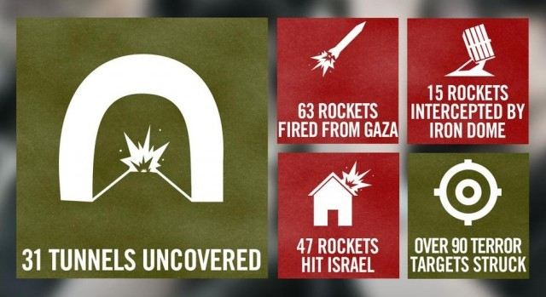

Updates by the Hour
10:36 PM: A short while ago, the Iron Dome intercepted a rocket above Eilat.
5:13 PM: IDF forces discovered a hidden weapons cache in a tunnel in Gaza.
11:33 AM: Three additional rockets were intercepted in central Israel. This makes five interceptions in central Israel in the past 10 minutes.
11:19 AM: Rocket siren and blasts heard in Tel Aviv.
11:12 AM: The Iron Dome just intercepted two rockets over Petah Tikva and Bat Yam.
11:02 AM: Rocket sirens heard in central Israel.
7:34 AM: The IDF struck 35 terror targets in Gaza overnight.

Wednesday, July 23
Summary of the day:
        - More than 98 rockets were fired from Gaza towards Israel.
        - At least 70 rockets hit Israel.
        - 25 rockets were intercepted by the Iron Dome missile defense system.
        - The IDF struck 160 terror targets in the Gaza Strip.
        - 31 terror tunnels were uncovered by IDF forces since July 17.
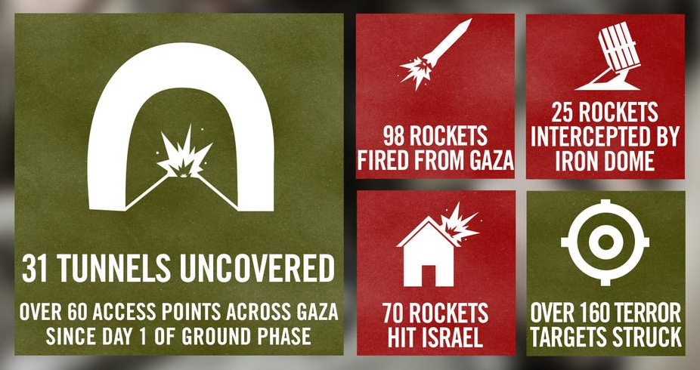

Updates by the Hour
9:23 PM: The Iron Dome intercepted five rockets over central Israel; one rocket hit southern Israel.
9:01 PM: Rocket sirens heard across central Israel.
8:15 PM: Lt. Paz Elyahu, 22, Staff Sgt. Li Mat, 19 and Staff Sgt. Shahar Dauber, 20, were killed today on the battlefield. May their memory be blessed.
6:22 PM: The Iron Dome just intercepted two rockets over Gedera.
3:32 PM: We found weapons, maps and IDF uniforms in a Hamas tunnel today. This suggests terrorists planned to infiltrate and attack Israel undetected.
2:53 PM: About an hour ago, a rocket fired from Gaza killed a civilian near Ashkelon.
1:31 PM: Because Hamas uses Wafa Hospital for military purposes, the IDF has targeted specific sites and terrorists within the hospital grounds.
1:01 PM: We have destroyed 30-40% of Hamas’ rockets since starting our operation in Gaza.
11:01 AM: Five rockets were just intercepted above Ashkelon.
10:51 AM: So far today, Hamas fired 16 rockets from Gaza at Israel.
8:40 AM: Since the beginning of Operation Protective Edge, more than 2160 rockets have been fired at Israel from Gaza.
Hamas has fired more than 2160 rockets at Israel since July 8. That’s more than 1 rocket every 10 minutes for 15 days pic.twitter.com/p97uK55HAn — IDF (@IDFSpokesperson) July 23, 2014
7:39 AM: Lt. Natan Cohen, 23, of the Armored Corps, was killed last night on the battlefield. May his memory be blessed.
5:45 AM: Two IDF soldiers were killed last night on the battlefield. One was Cpt. Dmitri Levitas, 26, of the Armored Corps. May his memory be blessed.
3:51 AM: The IDF continues to transfer goods into Gaza.
As Hamas continues to fire rockets at Israel’s civilians, the IDF continues to transfer tons of goods into Gaza pic.twitter.com/UCBkNqEpO8 — IDF (@IDFSpokesperson) July 23, 2014
1:08 AM: Over 90 rockets were fired from Gaza yesterday.

Tuesday, July 22
Summary of the day:
        - More than 90 rockets were fired from Gaza towards Israel.
        - At least 70 rockets hit Israel.
        - 18 rockets were intercepted by the Iron Dome missile defense system.
        - The IDF struck 260 terror targets in the Gaza Strip.
        - 30 terror tunnels were uncovered by IDF forces since July 17.
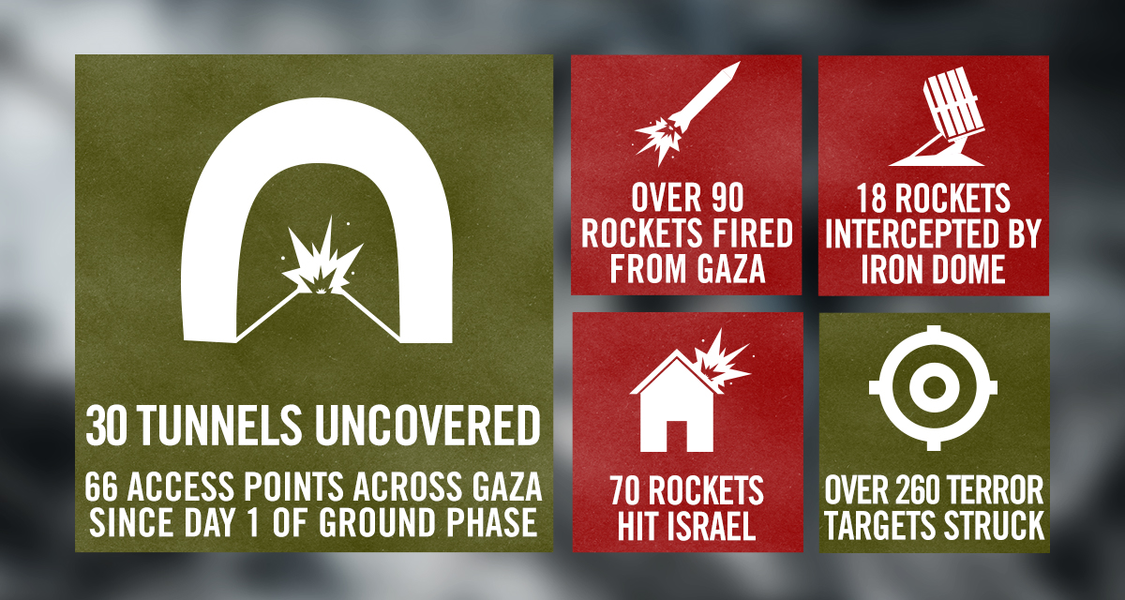

Updates by the Hour
11:37 PM: Today, Iron Dome shot down its 1,000th rocket.9:26 PM: Moments ago, two rockets fired from Gaza, one was intercepted by Iron Dome and the other hit the Ashdod area.
9:00 PM: Sirens heard across central Israel.
7:54 PM: For the second time in less than a week, UNRWA has said that it found rockets in one of its schools in Gaza.
7:13 PM: 41 rockets fired at Israel from Gaza today. 28 hit Israel, 11 were intercepted by the Iron Dome, and two fell short inside Gaza.
4:25 PM: Staff Sgt. Avitar Moshe Torjamin, 20, was killed today while fighting Hamas terrorists in Gaza. May his memory be blessed.
2:40 PM: 25 rockets fired at Israel from Gaza since midnight. 14 hit Israel, 10 were intercepted by the Iron Dome, and one fell short inside Gaza.
2:01 PM: The seventh soldier is Sgt. Oron Shaul, 21, from Poria. We are still working to identify his body.
12:01 PM: Master Sergeant Ohad Shemesh, 27, was killed yesterday while fighting Hamas terrorists in Gaza. May his memory be a blessing.
10:50 AM: A vehicle carrying seven soldiers was attacked on July 20. Six of their bodies have been identified and efforts to identify the seventh soldier are ongoing.
10:21 AM: The Iron Dome just intercepted a rocket above the Tel Aviv metropolitan area. Another rocket hit the city of Yehud in central Israel.
Hamas fired a rocket from Gaza and destroyed this house in Yehud today. pic.twitter.com/2CcReJkUlX — IDF (@IDFSpokesperson) July 22, 2014
10:02 AM: Rocket sirens in Tel Aviv.
9:25 AM: The Iron Dome missile defense system intercepted 7 rockets above Ashdod.
6:00 AM: The IDF confirms that yesterday, Sgt. First Class Oded Ben Sira was killed on the battlefield defending the citizens of Israel. May his memory be blessed.
3:28 AM: Four rockets were fired from Gaza towards Be’er Sheva. One was intercepted by Iron Dome and three hit open areas.
1:48 AM: A rocket fired from Gaza hit an open area near Kafr Qasim in central Israel, nearly 100 km from Gaza.
1:35 AM: A Palestinian terrorist shot and severely injured an Israeli civilian in Judea and Samaria. IDF Forces are searching the area.

Monday, July 21
Summary of the day:
        - More than 139 rockets were fired from Gaza towards Israel.
        - At least 116 rockets hit Israel.
        - 17 rockets were intercepted by the Iron Dome missile defense system.
        - The IDF struck 150 terror targets in the Gaza Strip.
        - 23 terror tunnels were uncovered by IDF forces since July 17.
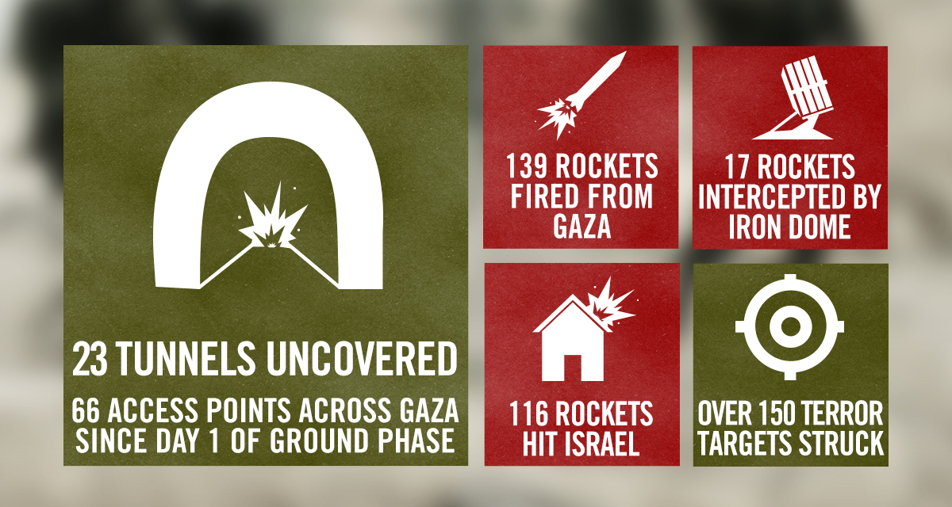

Updates by the Hour
11:58 PM: The following brave soldiers fell in battle over the past 48 hours. May their memory be blessed: Lt. Col. Dolev Keidar, 38, Staff Sgt. Tal Ifrach, 21, Sgt. Nadav Goldmacher, 23, Lt. Col. Dolev Keidar, 38, Staff Sgt. Tal Ifrach, 21, and Sgt. Nadav Goldmacher, 23.
10:16 PM: The Iron Dome just intercepted two rockets over the Ashdod area.
9:26 PM: A short while ago a rocket hit an empty kindergarten in southern Israel.
8:08 PM: One of the IDF soldiers who was killed in battle today was Staff Sgt.Yuval Dagan, 22, from Kfar Saba.
7:49 PM: In the past 24 hours, 7 IDF soldiers were killed while fighting Hamas terrorists in Gaza.
7:25 PM: IDF field hospital at Gaza border opened today. We are working with the Red Crescent to treat wounded Palestinians from Gaza.
IDF field hospital at Gaza border is open. We are working with Red Crescent to treat wounded Palestinians from Gaza. pic.twitter.com/yRujLUozrx — IDF (@IDFSpokesperson) July 21, 2014
3:41 PM: Hamas terrorists opened fire moments after IDF forces found the tunnel in Shuja’iya. Our soldiers killed 2 of the attackers.
3:40 PM: IDF forces exposed access points to a Hamas tunnel in Shuja’iya. Terrorists planned to use the tunnel to commit an attack in Israel.
1:58 PM: Iron Dome intercepted five rockets above Ashdod and three rockets above Ashkelon.
12:06 PM: A rocket fired from Gaza hit the Tel Aviv area.
11:41 AM: The Iron Dome missile defense system intercepted two rockets above the Tel Aviv metropolitan area.
11:40 AM: Hamas terrorists fired a barrage of rockets from Gaza into southern Israel.
8:55 AM: 2 terrorist squads infiltrated Israel through a tunnel from northern Gaza. An IDF aircraft struck 1 squad and other IDF forces killed 10 terrorists.
12:15 AM: Last night, 13 soldiers from the Golani Infantry Brigade fell protecting the people of Israel. Among them: Maj.Tzafrir Baror, 32, Cpt.Tsvi Kaplan, 28, Sgt.Gilad Rozenthal Yacoby, 21, Sgt.Oz Mendelovich, 21, Sgt.Nissim Sean Carmeli, 21.

Sunday, July 20
Summary of the day:
  - More than 87 rockets were fired from Gaza towards Israel.
  - At least 70 rockets hit Israel.
  - 16 rockets were intercepted by the Iron Dome missile defense system.
  - The IDF struck 187 terror targets in the Gaza Strip.
  - 13 terror tunnels were uncovered by IDF forces since July 17.
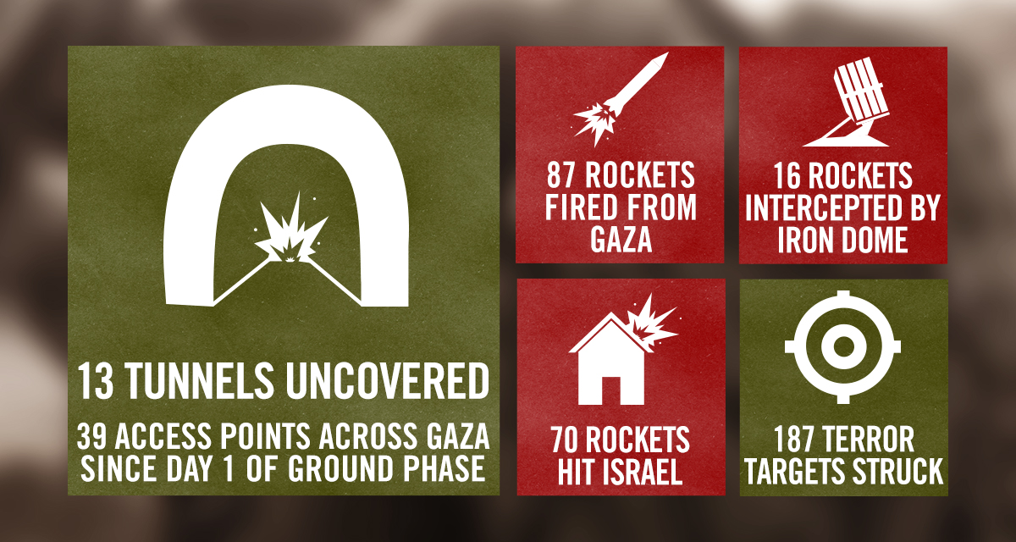

Updates by the Hour
9:32 PM: So far today, 70 rockets fired from Gaza have hit Israel; an additional 16 rockets were intercepted by the Iron Dome.
8:53 PM: Rocket sirens heard in Ashdod, Yavne and the surrounding area.
6:35 PM: Yesterday during the early hours of the morning, 13 soldiers from the IDF’s Golani Brigade were killed by terrorists in several separate incidents. In the first incident, terrorists detonated an explosive device on an armored vehicle, causing the death of seven soldiers. In the second, terrorists opened fire at two IDF soldiers in the northern Gaza Strip. The soldiers returned fire, but one was killed. Later, IDF soldiers were attacked by a terrorist squad in northern Gaza, leading to the death of two soldiers. Lastly, three IDF soldiers lost their lives when they became trapped in a burning building.
3:41 PM: Despite Hamas’ continuous fire, the IDF has agreed to hold fire in Shuja’iya for an additional hour.
In the last 2 hours, when we agreed to the Red Cross’ request for a ceasefire in Shuja’iya, Hamas opened fire from near Wafa Hospital. — IDF (@IDFSpokesperson) July 20, 2014
2:13 PM: Despite the IDF’s agreement to the Red Cross’ request for a cease fire in Shuja’iya until 15:30, Hamas has not stopped shooting from Shuja’iya.
1:30 PM: IDF agreed to the Red Cross’ request for a humanitarian window in Shuja’iya. We will hold our fire there from 13:30-15:30.
1:16 PM: Reports received that Hamas is preventing journalists in Gaza from leaving through the Erez crossing.
1:00 PM: This morning the IDF operated in Shuja’iya, Hamas’ terror fortress in the Gaza Strip.
Shuja’iya: Neighborhood for civilians, fortress for Hamas terrorists. pic.twitter.com/HUhAKvDuWN — IDF (@IDFSpokesperson) July 20, 2014

In Shuja’iya, our soldiers found 10 openings to tunnels used to terrorize Israel. — IDF (@IDFSpokesperson) July 20, 2014
11:40 AM: We are building a field hospital for Palestinians in Gaza. It will open tonight on Israel’s side of the Erez crossing.
After we fired a warning shot at this target, Hamas ordered civilians to form a human shield on the roof. pic.twitter.com/ZCBWmxr4wv — IDF (@IDFSpokesperson) July 20, 2014
10:00 AM: The Iron Dome intercepted a rocket above Ashkelon.
4:00 AM: Yesterday, we facilitated the transfer of approx. 20 tons of medical supplies into Gaza through Kerem Shalom Crossing. Watch here.
3:20 AM: 2nd Lt. Bar Rahav, 21, and Sgt. Bnaya Rubel, 20, were killed yesterday while fighting Hamas terrorists.
2:30 AM: We are currently expanding our ground operation against Hamas in Gaza.

Saturday, July 19
Summary of the day:
  - More than 111 rockets were fired from Gaza towards Israel.
  - At least 88 rockets hit Israel.
  - 18 rockets were intercepted by the Iron Dome missile defense system.
  - The IDF struck 140 terror targets in the Gaza Strip.
  - 13 terror tunnels were uncovered by IDF forces.
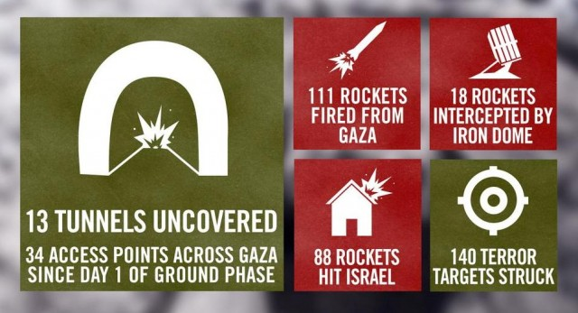

Updates by the Hour
11:12 PM: Today we facilitated the transfer of five trucks carrying 100 tons of medicine and supplies via the Erez crossing en route to hospitals in Gaza.
10:21 PM: Since IDF ground forces entered Gaza on July 17, they have killed 70 Hamas terrorists.
10:07 PM: Earlier today, IDF soldiers neutralized a terrorist in Gaza who was wearing an explosive belt. IDF found handcuffs and tranquilizers on site.
Weapons we found after Hamas terrorists infiltrated Israel today. What would have happened if we hadn’t stopped them? pic.twitter.com/iQ5B1Shn8o — IDF (@IDFSpokesperson) July 19, 2014
10:06 PM: Moments ago, a terrorist emerged from a concealed tunnel shaft in Gaza and fired at IDF forces. IDF troops responded, killing him.
9:57 PM: Revealed for publication: The Hamas terrorists who infiltrated Israel this morning and killed two IDF soldiers were wearing IDF uniforms.
8:37 PM: While searching a civilian house in Gaza today, IDF combat engineers found several rooms rigged with explosives.
7:46 PM: A short while ago, the Iron Dome intercepted a rocket over the Tel Aviv metropolitan area.
7:25 PM: Sgt. Adar Barsano, 20, and Maj. (res.) Amotz Greenberg, 45, were killed today while fighting Hamas terrorists.
6:18 PM: A few moments ago, the Iron Dome intercepted three rockets over Beer Sheva.
4:15 PM: A short time ago, two Hamas terrorists fired at IDF soldiers in Southern Gaza. We returned fire and killed the attackers. No harm to our forces.
2:28 PM: So far today, IDF forces operating in Gaza have uncovered three openings to Hamas’ vast tunnel network.
1:12 PM: Israeli civilian killed by Hamas rocket fire on southern Israel. Several others wounded.
12:50 PM: Hamas terrorists attempted to infiltrate Israel through an underground tunnel and massacre civilians in an Israeli community. IDF forces opened fire at the infiltrators. One terrorist was killed; the others escaped to Gaza. Two of our soldiers were wounded. The attack against Israeli civilians was thwarted.
Weapons used by Hamas terrorists in their attempted massacre of Israeli civilians today pic.twitter.com/irMX8pXwl7 — IDF (@IDFSpokesperson) July 19, 2014
10:16 AM: Yesterday, Hamas attacks Israeli soldiers with explosive donkey.
7:50 AM: Two IDF soldiers were lightly injured and one was severely injured overnight in a confrontation with Hamas terrorists in northern Gaza.
3:41 AM: A short time ago, five rockets were fired at southern Israel. Four were intercepted by the Iron Dome missile defense system, and one struck a residential area in Ashdod.

Friday, July 18
Summary of the day:
- More than 135 rockets were fired from Gaza towards Israel.
- At least 87 rockets hit Israel.
- 40 rockets were intercepted by the Iron Dome missile defense system.
- The IDF struck 240 terror targets in the Gaza Strip.
- 10 terror tunnels were uncovered by IDF forces.
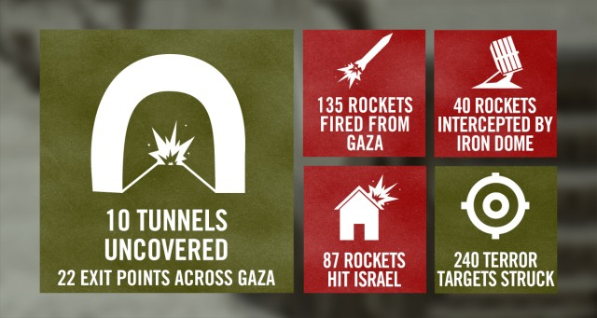

Updates by the Hour
10:31 PM: Since the beginning of Operation Protective Edge, more than 1,637 rockets were fired at Israel. Of them 1,228 of the rockets hit Israel and an additional 340 rockets were intercepted by Iron Dome. Furthermore, seven IDF soldiers have been injured and approximately 53,200 reserve soldiers have been recruited. Since the beginning of the ground phase of the operation, more than 135 rockets were launched at Israel, of them approximately 87 of the rockets hit Israel. One of them hit a kindergarten in Gan Yavne and another caused damage to a home in the Sha’ar HaNegev regional council. An additional 40 rockets were intercepted by the Iron Dome.
9:28 PM: For the second time today, the Iron Dome intercepted two rockets above the Tel Aviv metropolitan area.
9:15 PM: Rocket sirens sounded in the Tel Aviv metropolitan area. A number of explosions were heard.
6:33 PM: IDF uncovers more tunnels used for terror in the Gaza strip.
Photos from the field: More tunnels that we uncovered today in the southern Gaza Strip pic.twitter.com/88EdeojVNF — IDF (@IDFSpokesperson) July 18, 2014
6:05 PM: The Iron Dome intercepted two rockets over the Tel Aviv metropolitan area. Rocket sirens heard across southern Israel.
5:57 PM: Rocket sirens heard in Tel Aviv.
4:00 PM: An armored unit in Gaza saw two terrorists preparing to fire anti-tank missiles. IDF soldiers opened fire and identified hits.
4:00 PM: IDF uncovers tunnel used for terror in the Gaza Strip.
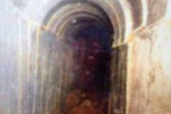
Gaza Terror Tunnel Uncovered
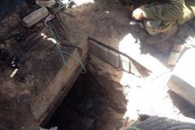
Gaza Terror Tunnel Uncovered

2:00 PM: Since last night, we have neutralized 17 terrorists. An additional thirteen terrorists surrendered to the IDF and were taken for questioning. We have also targeted 21 rocket launchers and four terror tunnels.
10:16 AM: Seven rockets were intercepted over Ashdod.
9:22 AM: Two rockets landed in open areas near Ashkelon and Netivot.
8:13 AM: Earlier, the IDF targeted a terror tunnel. As a result of the strike, a rocket was discharged – proving the malicious purposes of the tunnel.
7:45 AM: Overnight, we neutralized 14 terrorists, destroyed 20 rocket launchers, carried out 9 strikes on tunnels and hit a total of 103 terror targets. Furthermore, since last night, about 50 rockets were fired from Gaza. Of them, 25 hit Israel and 20 were intercepted by the Iron Dome missile defense system.
7:35 AM: An IDF soldier was killed in action during the ground operation in Gaza last night. His family has been notified.
Sgt. Eitan Barak, 20, from Herzliya, was killed overnight fighting Hamas terrorists in Gaza. pic.twitter.com/jo9CPlq3cV — IDF (@IDFSpokesperson) July 18, 2014
3:37 AM: Earlier, an anti-tank missile hit an IDF heavy bulldozer in the southern Gaza Strip, causing damage. No injuries reported.
12:19 AM: Following the approval of the government of Israel, the IDF will call up an additional 18,000 reservists.
12:10 AM: Our soldiers are preparing to enter Gaza.
From the Field: Our soldiers preparing to enter Gaza. The whole nation stands behind them. pic.twitter.com/qQw3Uzjhrt — IDF (@IDFSpokesperson) July 17, 2014

Thursday, July 17
10:41 PM: A large IDF force of infantry, tanks, artillery, combat engineers, and field intelligence is entering the Gaza Strip. The force is supported by the Israel Air Force, Navy, and other Israeli security agencies. A new phase of Operation Protective Edge has begun.