Israel's protection and Hamas' exploitation of civilians in Operation Protective Edge
Israel Ministry of Foreign Affairs
July 24, 2014
https://mfa.gov.il/MFA/ForeignPolicy/Issues/Pages/Israel-protection-and-Hamas-exploitation-of-civilians-in-Operation-Protective-Edge-July-2014.aspx

The main objective of Operation Protective Edge is to restore quiet to Israel's citizens. Israel's actions are intended solely to curtail Hamas' terrorist capabilities in Gaza and do not target the people of Gaza in any way.
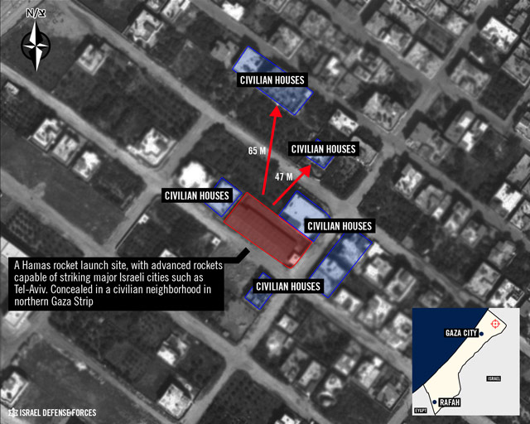
Hamas rocket launch site concealed in a civilian neighborhood in Gaza
Copyright: IDF Spokesperson
(Communicated by the Government Press Office)
Following the United Nations' Human Rights Council decision to establish an inquiry into alleged human rights violations in Gaza, the following document clarifies Israel's position.
Background
On 12 June 2014, the day Hamas terrorists abducted and murdered three Israeli teens in the West Bank, Hamas resumed launching rockets from Gaza on Israeli cities. For three weeks Israel showed great restraint and repeatedly indicated its desire to avoid further escalation, but Hamas' incessant missile attacks on Israeli communities continued, culminating in a barrage of 70 missiles fired on July 7th alone. Israel was left with no choice but to respond militarily to defend its civilian population.
In recent years, Hamas, designated as a terrorist organization around the world, including by the US, the EU and Canada, has invested heavily in a formidable terrorist infrastructure, including some 12,000 missiles capable of hitting most of Israel's territory. It has also built dozens of attack tunnels to infiltrate Israel for the purpose of killing and kidnapping Israeli civilians.
The main objective of Operation Protective Edge is to restore quiet to Israel's citizens. Israel's right to defend itself has been widely recognized by the international community, including most recently by EU foreign ministers on July 22nd. Israel's actions are intended solely to curtail Hamas' terrorist capabilities in Gaza and do not target the people of Gaza in any way.
Israel's efforts to protect civilians
In this context, the Israel Defense Forces (IDF) has been doing its utmost to minimize harm to non-combatant civilians. The IDF strictly abides by the principles of international law, including the law of armed conflict, which calls inter alia to distinguish at all times between civilians and military forces, to take precautions to minimize civilian casualties, and to carefully consider the expected military gain of any action, weighed against potential collateral damage (the principle of proportionality).
Among the measures taken by the IDF to minimize the risk to Palestinian civilians are announcements about impending attacks in the form of phone calls, pamphlets and warning shots. In many cases missions have been aborted because civilians were identified dangerously close to the targets.
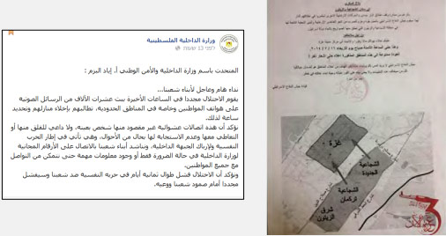
Flyer distributed by the IDF to warn the civilian population of Shuja'iya before an operation
Moreover, Israel’s commitment to international law is guaranteed by its strong democratic institutions, including an active and responsive legislature, efficient law enforcement mechanisms and an independent judiciary.

[EMBEDDED VIDEO: https://youtu.be/7yvQz3SQxGI]
IDF call to warn the population prior to attacking in the Gaza Strip

[MISSING VIDEO]

[EMBEDDED VIDEO: https://youtu.be/VTArVIHDelg]

Hamas gathers civilians on a rooftop, to serve as human shields, causing the IDF to avoid an attack

Hamas' efforts to harm and endanger civilians
Whereas Israel is conducting itself carefully so as not to harm civilians, Hamas acts in deliberate and flagrant violation of international law and with utter disregard for human life, whether Israeli or Palestinian. It has systematically been committing a double war crime, by deliberately targeting Israeli civilians while using the Palestinian civilian population for cover.
Indeed, Hamas appears to have perfected the "human shield" tactic, hiding weapons and terrorists in hospitals, schools, mosques and residential buildings. In at least two instances the United Nations Relief and Works Agency found missiles hidden in its schools. Journalists have reported witnessing Hamas leaders hiding in Shifa Hospital. In addition, Hamas has urged and even forced civilians to ignore repeated warnings by the IDF to evacuate areas where fighting is taking place and to remain in those locations.
The Hamas-affiliated Popular Committee of Palestinian Refugees issued similar instructions to the residents of Gaza, calling upon them to ignore IDF evacuation warnings while falsely assuring them that Hamas would protect them from danger. On July 15, the Hamas-run newspaper Al-Risalah (shown here) reported that Adnan Okal, the head of the Committee, called civilians who evacuated to UNRWA schools to return to their homes. He emphasized that the "resistance" will not cease to fight and neutralize any attempt at advance by the IDF.
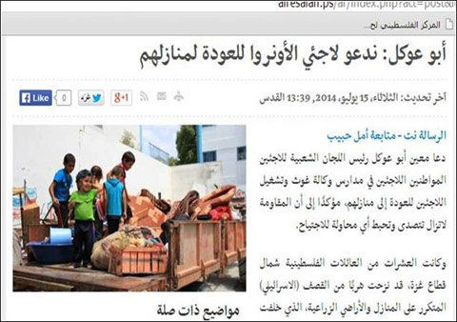
[EMBEDDED VIDEO: https://youtu.be/uzFgIhFKII8]
IDF video explaining the issue of human shields in Gaza, and placing civilians within the line of fire

[EMBEDDED VIDEO: https://youtu.be/TERz6YgOIGo]
Hamas Spokesman, Mushir El-Masri, calls civilian population not to leave their home s

[EMBEDDED VIDEO: https://youtu.be/P2lB76qTkQA]
Flyer by the Palestinian Ministry of the Interior calling civilians not to comply with IDF evacuation warnings

[EMBEDDED VIDEO: https://youtu.be/7O114V9PdmM]
Hamas uses an ambulance to help militants escape a battle area

[EMBEDDED VIDEO: https://youtu.be/u57yxd753f8]
Stockpile of ready-to-fire rockets hidden by Hamas next to a school in Gaza

[EMBEDDED VIDEO: https://youtu.be/rfbjO2WznEk]
Hamas militants shoot from residential homes

[EMBEDDED VIDEO: https://youtu.be/jOAVEpfusvQ]

Violations of international law by Hamas

Fire and cease-fire
Israel agreed to the Egyptian cease-fire proposal of July 15th; Hamas rejected it. Israel approved and honored two humanitarian breaks in the hostilities to ease the burden on the civilian population in Gaza and to allow the evacuation of injured civilians from combat areas;, Hamas rejected and violated these arrangements on both occasions.
Conclusion
For initiating and prolonging the hostilities, for its intentional and indiscriminate targeting of Israeli civilians and for deliberately putting Palestinian civilians in harm's way, Hamas is solely responsible for civilian casualties on both sides of the Israel-Gaza fence.

