Israel Under Fire: Life Comes to Halt
IDF Blog
July 9, 2014
http://web.archive.org/web/20150209092620/http://www.idfblog.com/blog/2014/07/09/israel-fire-life-comes-halt/

Incessant Hamas rocket fire is making daily life intolerable for Israeli civilians.
Most of the Israeli population is currently living under the threat of rocket fire. Life between sirens, in and out of bomb shelters, has become the daily reality for millions of Israelis.
Life under fire poses a serious threat to Israel’s civilians. On Monday, July 14, a rocket fired from Gaza hit Lakiya, located near Beer Sheva, and wounded two girls aged 11 and 13. One was seriously injured and the second was injured moderately. Earlier that day, a boy was lightly wounded from shrapnel after a rocket fired from Gaza struck Ashdod.
On Sunday, July 13, a rocket fired from Gaza hit Ashkelon and severely wounded an Israeli teenager. On Thursday, July 10, a house in Beer Sheva was hit by a rocket fired from Gaza. Later that night, a mortar fired from Gaza at southern Israel wounded two IDF soldiers, one lightly and one moderately. Additionally, a rocket hit a car in Ashdod.
This is an intolerable and dangerous reality for Israelis under fire, especially in the south of Israel where thousands of people have less than 15 seconds to run to a bomb shelter when an alarm goes off.
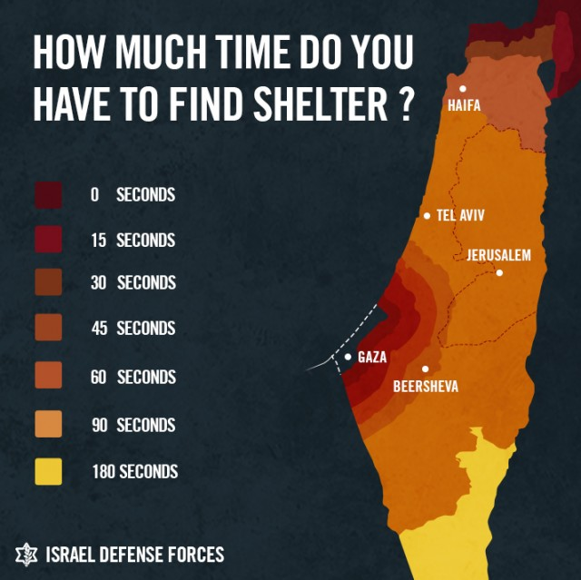
*Including the threat of rockets from Lebanon
Life under constant rocket fire has disrupted the daily routines of millions of Israelis. Summer camps for children have been canceled. Children are advised to be with their parents, in close proximity to bomb shelters. In many places, children remain in bomb shelters for the entire day in order to avoid being in open areas when the rocket siren sounds.
Transportation networks have been disrupted as train service in southern Israel has been canceled. Israelis are hesitant to drive in their cars because they do not want to be caught in the open when the rocket siren sounds. Public gatherings, such as concerts or festivals, have been canceled.
Businesses around the country, especially in the south, have suffered due to ongoing rocket fire. Many restaurants and shops have closed, as people prefer to be at home with their families near shelters.
Israeli civilians on the train during a Gaza rocket attack.
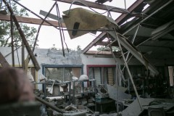
Building damaged by a rocket launched from Gaza

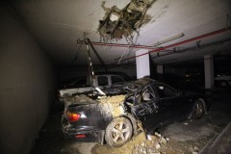
A parking lot in Ashdod, Israel, destroyed by Gaza rocket attacks.
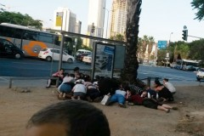
Civilians in Tel-Aviv lay on the ground in refuge of Gaza rocket attack

Israelis are well informed and prepared to cope with the constant rocket fire. When the rocket sirens go off, civilians must immediately run to the nearest protected area. Many Israelis have bomb shelters in their homes. Otherwise, staircases in the center of buildings are usually safe, as are rooms with concrete walls and minimum openings.
When outdoors, those who cannot run to a closed space should lie on the ground with their hands covering their heads. This method and others minimize the chances of getting hit by shrapnel during an attack.
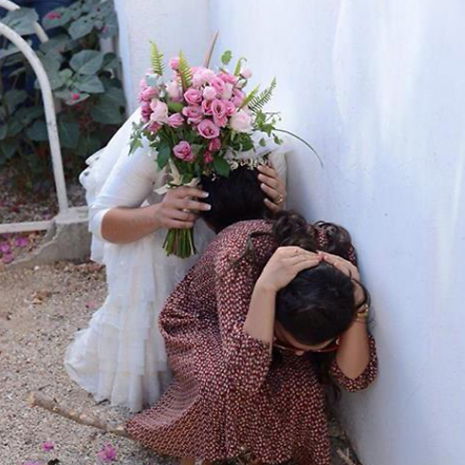
Photo credit: Avraham Rubenstien
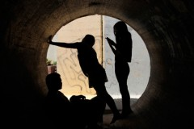
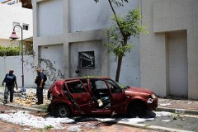
Photo credit: Reuters

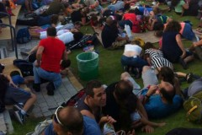
Israeli civilians lying on the ground in order to defend themselves against a rockets attack
[EMBEDDED VIDEO: https://youtu.be/x7qUlUEH5RE]

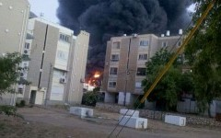
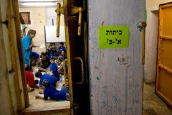
Summer camp in a bomb shelter

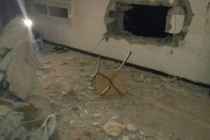
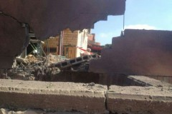

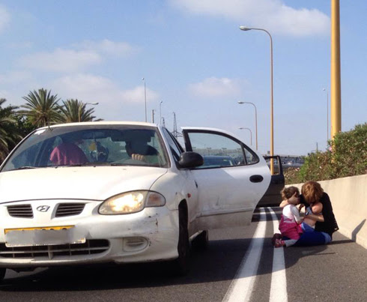
Drivers take refuge from rockets in Tel-Aviv. Credit: Michal Hurshi
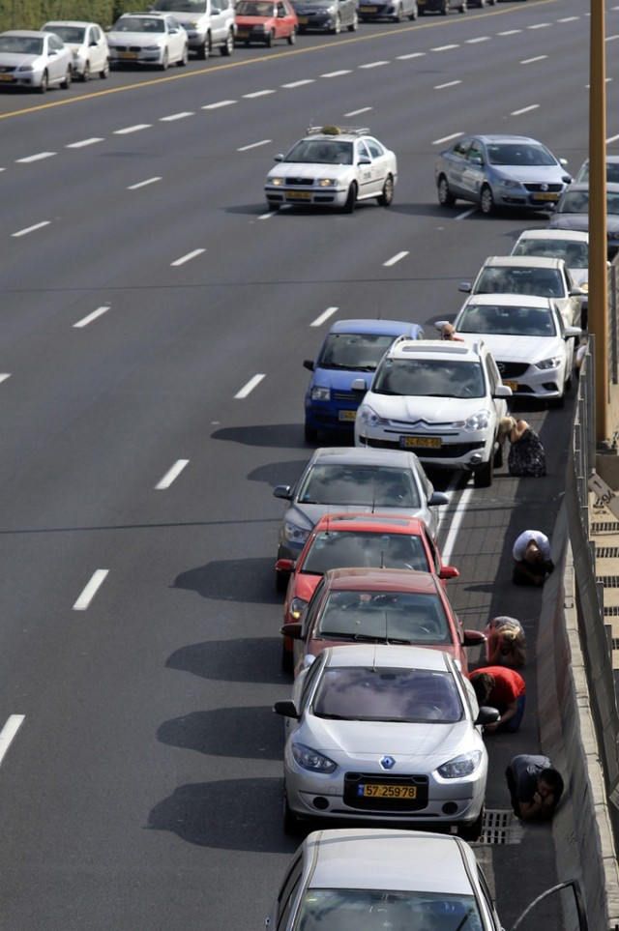
Drivers take refuge from rockets in Tel-Aviv.
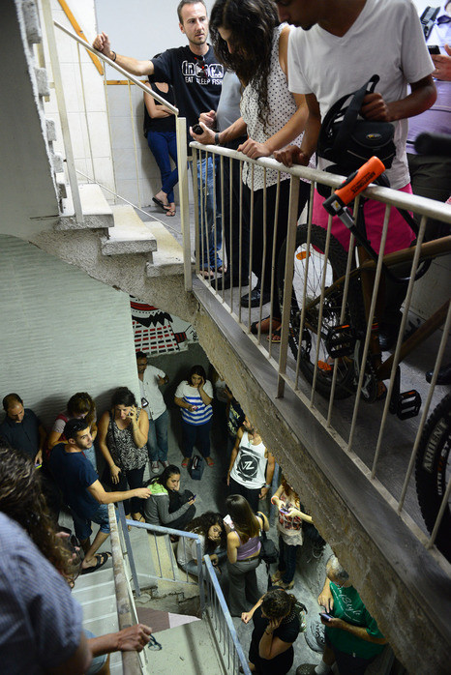
Israeli civilians taking refuge in the staircase during a rocket attack from Gaza

[EMBEDDED VIDEO: https://youtu.be/R4g4PW8zn_U]

The IDF launched Operation Protective Edge in order to restore quiet to the people of Israel. For updates on the operation, see our live blog updates.

