IDF thwarts terror attack via tunnel from Gaza
Israel Ministry of Foreign Affairs
July 17, 2014
https://mfa.gov.il/MFA/ForeignPolicy/Terrorism/Pages/IDF-thwarts-terror-attack-via-tunnel-from-Gaza-17-Jul-2014.aspx

Early this morning (July 17) IDF forces thwarted an attack by Hamas terrorists attempting to infiltrate Israel via a terror tunnel.

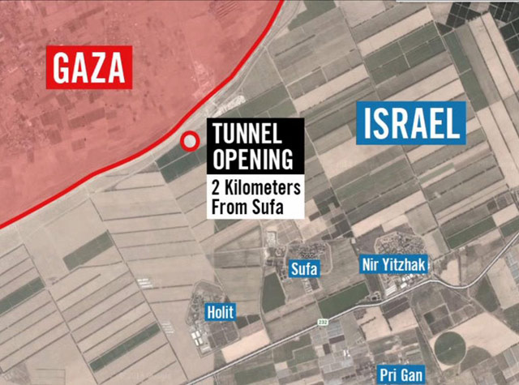
Terror tunnel from Gaza to southern Israel
Copyright: IDF Spokesperson

Just a few hours before the start of a humanitarian ceasefire, IDF forces identified approximately 13 terrorists attempting to infiltrate Israel through a terror tunnel constructed by Hamas. The tunnel led underground from the southern Gaza Strip towards Kibbutz Sufa, near the Kerem Shalom Crossing through which humanitarian aid enters Gaza. ​
IDF forces thwarted an impending terror attack, preventing the terrorists from attacking an Israeli kibbutz. The foiled attack could have had deadly and devastating consequences if carried out. No injuries were reported to IDF soldiers.
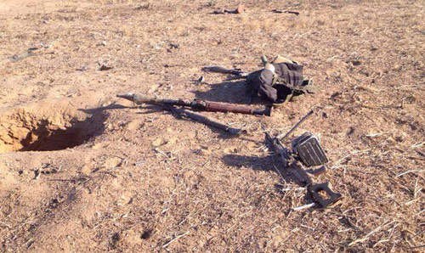
Tunnel opening and Hamas weapons at site
Copyright: IDF Spokesperson

IDF Spokesman Brig. Gen. Moti Almoz speaking on Israel TV Channel 2: "We knew specifically about this tunnel. We knew Hamas would try [to launch a terror attack] in any way it can. This attack was meant to be a killing spree in one of the villages nearby. The volley of rockets that hit central Israel in the last hour, just ahead of a humanitarian ceasefire beginning at 10 a.m., “was meant as an envelope for this attack."
On July 8th, another major terrorist attack was foiled when a massive terror tunnel was exposed and was blown up close to the Kerem Shalom crossing, where dozens of truckloads of goods enter Gaza every day.
Both these foiled terror attacks took place close to the land crossings between Israel and Gaza, which function as important lifelines for the civilian population of Gaza. Despite these repeated attacks, Israel will continue to operate the land crossings in order to allow for goods to enter the Gaza Strip.

[EMBEDDED VIDEO: https://youtu.be/SM6WUoel7xk]

