IDF Strikes Houses in Gaza Used for Military Purposes
IDF Blog
July 10, 2014
http://web.archive.org/web/20140711134954/http://www.idfblog.com/blog/2014/07/10/idf-strikes-houses-gaza-used-military-purposes/

When houses are used for military purposes, they may become legitimate military targets under international law.
On July 8, the IDF initiated Operation Protective Edge in order to restore security to Israel’s civilian population under constant rocket fire from the Gaza Strip. During the operation, the IDF has struck a number of houses throughout Gaza that were being used for military purposes.
Hamas conducts its military activities from deep within residential areas in Gaza. By doing so, it exploits the IDF’s desire and efforts to avoid harm to Palestinian civilians. In many cases, Hamas uses its commanders’ own homes, where their families and other civilians may be residing, for military purposes.
These houses may be used for weapons storage, command and control centers, or communications. The following video of an IDF strike provides clear evidence that Palestinian terrorists store weapons in residential areas. Following the initial IDF strike on the target, massive secondary blasts reveal that the IDF indeed struck a weapons cache located near Palestinian homes.
[EMBEDDED VIDEO: https://youtu.be/4ayyXgRVWHk]
When houses are used for military purposes, they may become legitimate military targets under international law. The IDF only aims its attacks against legitimate military targets as defined under the relevant rules of international law. In order to accurately determine military targets, the IDF employs advanced methods, including multiple levels of intelligence, the provision of legal advice, and extensive prior training provided to operational commanders.
Even when a house is considered a lawful military target, the IDF makes great efforts to minimize potential harm to the surrounding civilian population. For example, the IDF may use real-time visual coverage in order to assess the civilian presence at a target. The IDF also carefully chooses weaponry and ammunition that will help to minimize any harm to civilians. In certain instances, the IDF also provides advance warning before striking a target.
Many of the IDF’s efforts in this regard go beyond its legal obligations and the accepted practice of other militaries operating in urban areas. Unfortunately, Hamas exploits many of the IDF’s attempts to provide advance warning by using civilians as human shields in order to deter attacks.

[EMBEDDED VIDEO: https://youtu.be/UXZEzbT0H1s]

Furthermore, when an IDF commander determines that an attack is expected to cause collateral damage that would be excessive in relation to the military advantage anticipated, the attack will not be carried out.
When terrorist organizations such as Hamas deliberately use civilian homes for terrorist purposes, it is unavoidable that some civilians will be harmed when the IDF acts against these targets. Hamas exploits such instances to claim that the IDF deliberately seeks to harm the civilian population in Gaza, but fails to acknowledge that it has intentionally put these Palestinian civilians in grave danger by masking its terrorist activities behind a civilian facade.
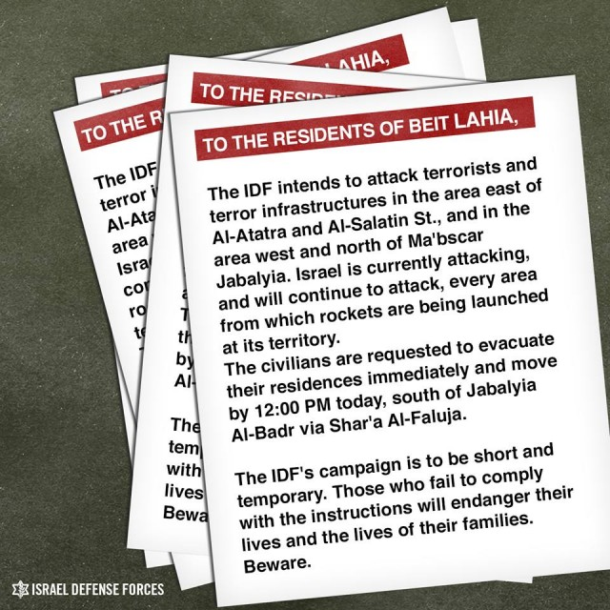
Translation of the leaflets dropped over northern Gaza.
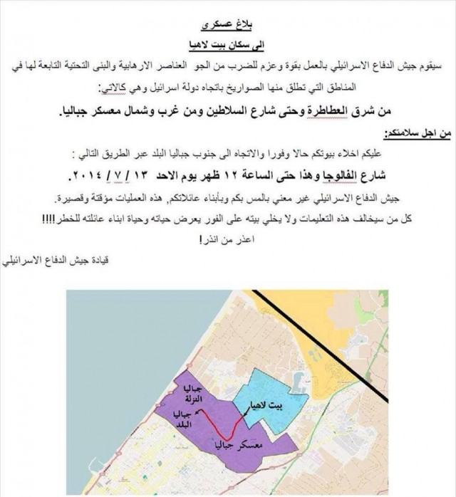
Photo of the leaflets dropped over Gaza.

The IDF will continue to conduct its operations in full accordance with international law, including by attacking only legitimate military targets, and will continue its efforts to minimize harm to Palestinian civilians.
In contrast, Hamas fires indiscriminately toward Israel’s civilian population, and celebrates when Israel’s civilians are harmed. These actions are war crimes. The IDF will continue to defend its citizens from such terrorist activity.

