Hamas' exploitation of civilian and medical facilities for terror
Israel Ministry of Foreign Affairs
August 24, 2014
https://mfa.gov.il/MFA/ForeignPolicy/Terrorism/Pages/Hamas-exploitation-of-civilian-and-medical-facilities-for-terror-24-Aug-2014.aspx

Since Hamas ended the ceasefire on August 19, over 570 rockets have been fired at Israel, some of them from various civilian facilities exploited by Hamas terrorists.

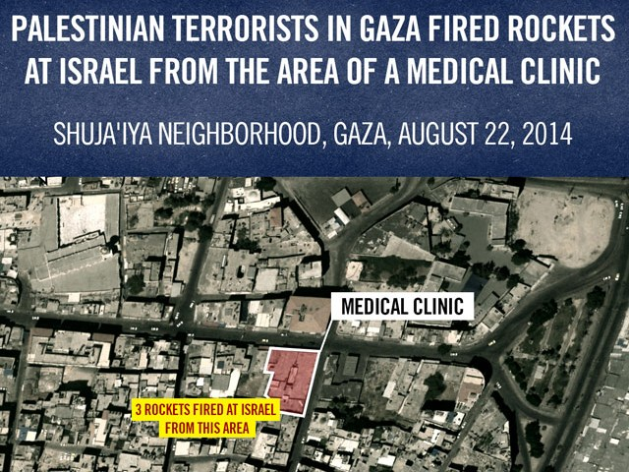
Terrorists fire from medical clinic in Gaza
Copyright: IDF Spokesperson

(IDF Spokesperson/Israel Security Agency)
Since Hamas ended the ceasefire on August 19, over 570 rockets have been fired at Israel, some of them from various civilian facilities exploited by Hamas terrorists. In the course of Operation Protective Edge, the IDF has revealed the systematic abuse of these facilities and registered more than 260 rockets that were launched from schools, more than 50 rockets from medical facilities and more than 130 rockets from cemeteries.
The IDF has documented the following incidents of abuse of the civilian environment over recent days:
- A launching site located adjacent to the Jafar Ali Ibn Taleb school in the Zeitoun neighborhood in Gaza City, from which rockets were fired at Kibbutz Nahal Oz in southern Israel, killing a 4 year old boy, Daniel Tragerman. This school currently serves as a shelter maintained by Hamas authorities in Gaza.

- Two school compounds in Shuja'iyya, from which rockets were fired at Israeli communities located near the Gaza Strip during the past two days. Over 36 rockets were fired at Israel during August from this compound.

- A medical facility in Shuja'iyya, from which rockets were fired in the past few days at Israeli communities.

- A cemetery in Zeitoun, from which rockets were fired in the past few days at Israeli communities.
Aerial photographs of the launching sites:

Hamas uses mosques, hospitals as cover for terrorist activity
(Communicated by the Israel Security Agency)
During Operation Protective Edge, various Hamas terrorists have been arrested and investigated by the Israel Security Agency (ISA). Their investigations have mainly served to gather information and warnings, which were passed on to the IDF, about launch sites, infiltration and attack tunnels, arsenals and booby-trapped access routes.
In addition, during the various investigations a disturbing picture was put together regarding Hamas's use of the civilian population and public buildings to carry out military actions on the assumption that Israel would refrain from attacking them.
In this context, prominent use was made of mosques and hospitals as meeting points and hideouts. Worse still was the digging of tunnels and launch sites, and the placing of arsenals, near kindergartens.
Following are outstanding examples:
I. Mosques as meeting places, training areas, for the concealment of war materiel, and for armed police activity
* Abdel Rahman Balousha from Khan Yunis said that the Alsafa and Alabra mosques in Khan Yunis serve as meeting and assembly points for Hamas terrorists. In the Alabra mosque, the assembly point is in an underground shelter.
* Muhammad Ala'a from Khan Yunis and Muwaz Abu Tim from Bani Suheila said that they were recruited for Hamas military activity at the Alabrar and Khaled Ben Alulid mosques in Khan Yunis and Bani Suheila, respectively, by Osama Altabesh.
* Iyad Abu Rida from Hazara said that the Hamas-affiliated Jamaat Asnad association is located on the second floor of the Altikva mosque in Hazara.
* Muhammad Ramadan from Khan Yunis said that his February 2014 training as an anti-tank fighter took place in a hall located beneath the Alshafi mosque in Khan Yunis. He added that the hall serves as an Izzadin Al-Kassam Brigades training and instruction facility and as such is closed to non-military personnel. He said that the Alatzlakh mosque in Khan Yunis serves as a meeting point for Izzadin Al-Kassam Brigade terrorists for military activity against the IDF, and that the Albana mosque serves as a meeting point for brigade terrorists who have been summoned for action in the attack tunnels.
* Muhammad Abu Daraz from Greater Ibsan said that Izzadin Al-Kassam Brigade terrorists monitor IDF movements from the Abad Alrahman mosque and added that two IEDs had been concealed in the Altoheid mosque.
* Muhammad Alqadra from Khan Yunis said that mosques in Khan Yunis serve as sites to conceal war materiel such as RPGs, heavy PKC machine guns and AK-47s. He said that the Hamas members responsible for the mosques use them as they please. He added that local schools and hospitals, including, the Nasser and Halal hospitals, are as arsenals.
* Khatem Abu Rida from Hazara said that the Altikva mosque in Hazara is used as a lookout from which orders are passed along to terrorists regarding where to plant IEDs and added that the Altoheid mosque is used as a center for armed police activity.
* Abdel Rahman Balousha from Khan Yunis said that armed police activity was carried out adjacent to the Uthman ibn Ifan and Abdallah ibn Masoud mosques in the Alkheif junction area.
* Ibrahim Abu Shawish from Khan Yunis said that armed police activity is carried out adjacent to the Hassan Albana and Abu Dir mosques and the Haroun Alrashid school.
II. Tunnels in proximity to kindergartens and mosques
* Afif Jerakh and Amad Jerakh from Beit lahiya said that an attack tunnel had been dug close to a kindergarten.
* Muhammad Abu Daraz from Greater Ibsan said a tunnel in which he worked was begun next to the Alfukhari clinic adjacent to the Abu Daka family home. He said that in the area in Hazara in which he was arrested there is a kindergarten, next to a clinic, to which he was to bring prisoners in the event of a successful kidnapping.
* Isa Khalil Muhammad Najar from Hazara said that he knew of a tunnel in the area of the Saalh E-Din mosque.
* Iyad Abu Rida from Hazara said that he heard that in the 2013 winter a tunnel – used to launch rockets at Israel – collapsed adjacent to the Salah E-Din mosque.
III. Hospitals as hideouts
Muhammad Alqadra from Khan Yunis said that it was well known that senior Hamas leaders and their armed bodyguards, usually in police uniforms, openly hide in hospitals. He said that guards are stationed at the admission department in the Nasser hospital in Khan Yunis and added that it was his assessment that the Hamas leadership in the Gaza Strip, including Ismail Haniye, is hiding in Shifa hospital in Gaza City, in an area that is not accessible to civilians, accompanied by plainclothes armed bodyguards.
* Samir Abu Luli from Rafiah said that since the start of fighting many armed policemen at Alnajar hospital in Rafiah have been blocking off certain sections of the hospital and not allowing anyone, including members of patients' families to enter.
* Nafez Salouf from Rafiah said he knows that Hamas and other terrorists are hiding in the Alnajar hospital. He asserted that on 31 July 2013 he was at the site and saw many terrorists in a three-storey hospital building, adding that civilians needing medical treatment had been put into the street.
* Marad Amr from Khan yunis said that before he was arrested he saw a Hamas Toyota military jeep blocking the entrance to the European hospital in Khan Yunis.
* Muaman Najar from Hazara said that during the fighting he delivered food to his brother Muhammad, who serves in the financial office of a local terrorist organization, while the latter was hiding in Nasser hospital.
It is clear from the foregoing that Hamas knowingly and intentionally operates in and adjacent to civilian areas, including kindergartens, hospitals and mosques in order to carry out military activity. Hamas thus endangers the civilian population even in times of calm given that munitions are liable to go off and put lives at risk. During fighting, Hamas deliberately operates in these locales, thus turning the civilian population into human shields on the assumption that Israel will be blamed for any injury and loss of life.

