Hamas Tweet: “Death For Allah is Our Most Exalted Wish”
IDF Blog
August 20, 2014
http://web.archive.org/web/20140822075943/http://www.idfblog.com/blog/2014/08/20/hamas-tweet-death-allah-exalted-wish/

Hamas’ Military Wing, the Al Qassam Brigades, recently published a tweet that exposes the fundamentalist and radical Islamist ideology of Hamas:
We are continuing our struggle. ALLAH IS OUR GOAL, THE PROPHET IS OUR LEADER, JIHAD IS OUR WAY, AND DEATH FOR ALLAH IS OUR MOST EXALTED WISH
— Al-Qassam Brigades (@Qassam_English) August 16, 2014
This tweet, published on August 16th, is taken nearly word for word from the terror group’s infamous charter, [EDITOR’S NOTE: LINK GOES TO A JANUARY 21, 2012 IDF BLOG ARTICLE ENTITLED “Antisemitism in the Hamas Charter”] which was written in 1998.
In Article 8 of the charter, under the title “The Slogan of the Islamic Resistance Movement,” it is written:
Allah is its target, the Prophet is its model, the Koran its constitution: Jihad is its path and death for the sake of Allah is the loftiest of its wishes.” (Translation Yale Law School) [EDITOR’S NOTE: LINK GOES TO A AVALAN PROJECT TRANSLATION OF THE 1988 HAMAS COVENANT]
This recent tweet serves as a reminder of Hamas’ radical Islamist nature [EDITOR’S NOTE: LINK GOES TO A DECEMBER 14, 2013 IDF BLOG ARTICLE ENTITLED “26 years later, Hamas stays true to its fundamentalist roots”] so enshrined in the terror group’s charter.
Hamas leaders have made many past statements saying that Hamas seeks death as the Israelis seek life, such as in the commander of Hamas’ military wing Muhammad Dief’s July 30th speech. As seen by Hamas’ wanton use of civilian infrastructure during Operation Protective Edge, endangering the residents of the Gaza Strip, these are not just empty words.

[EMBEDDED VIDEO: http://humanrightsvoices.org/site/documents/?d=22058]

Moreover, though this recent tweet is quoted nearly verbatim in Hamas’ charter [EDITOR’S NOTE: LINK GOES TO A JANUARY 21, 2012 IDF BLOG ARTICLE ENTITLED “Hamas History & Ideology”], it has a much earlier source. The words “Allah is its target, the Prophet is its model, the Koran its constitution: Jihad is its path and death for the sake of Allah is the loftiest of its wishes” is the slogan of the Muslim Brotherhood–the transnational Islamist organization founded in 1928 in Egypt.
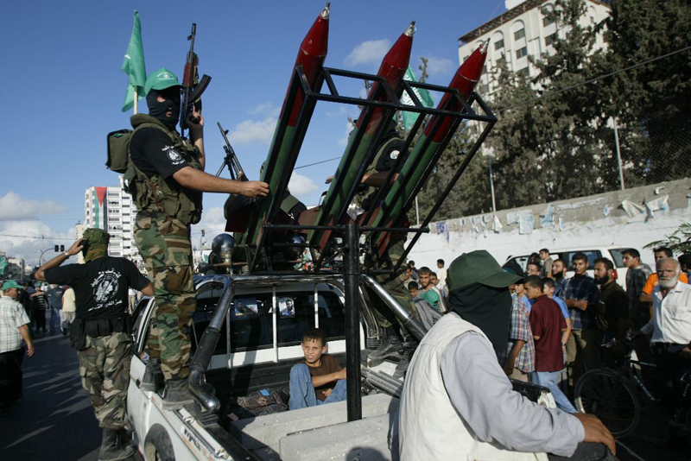
Therefore, this recent Al Qassam Brigades tweet also serves as a reminder that Hamas is a political satellite of the Muslim Brotherhood. However, though the Muslim Brotherhood’s top leader renounced violence many years ago, violence, such as kidnappings and indiscriminate rocket fire continues to be the modus operandi of Hamas.

