Hamas Social Media Rules: Describe Terrorists as Innocent Civilians
IDF Blog
July 21, 2014
http://web.archive.org/web/20140806022337/http://www.idfblog.com/blog/2014/07/21/hamas-teaches-gazas-facebook-users-secret-spinning-terror/

Hamas is employing a new tactic to conceal its true terrorist nature from the world. It has begun asking Gaza’s social media users to disseminate lies throughout the West and the Arab world.
This news will come as no surprise to those familiar with the radical Islamist organization’s usual methods. However, now mainstream media outlets will have to think twice before blindly quoting reports from Hamas about what’s really happening in Gaza.
The Middle East Media Research (MEMRI) published Thursday a translation of a new Hamas internet campaign to provide guidelines for Gaza’s social media users. According to MEMRI, the Hamas Interior Ministry has instructed Gazans to use Facebook and Twitter to “play their part in strengthening the home front and properly convey information worldwide.” The guidelines in fact instruct social media users to mislead the public and propagate disinformation worldwide.
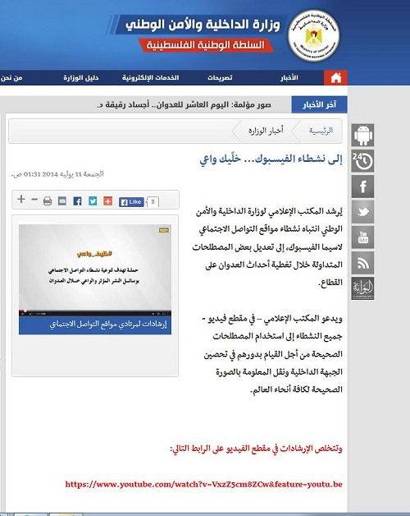
Hamas Interior Ministry’s Message to Facebook Users
The interior ministry’s “Be Aware – Social Media Activist Awareness Campaign” centers around an instructional video and posters published on the ministry’s Facebook and Twitter pages. Gazans are taught, first and foremost, to refer to all terrorists as innocent civilians.
“Anyone killed or martyred is to be called a civilian from Gaza or Palestine, before we talk about his status in jihad or his military rank,” the guidelines state. “Don’t forget to always add ‘innocent civilian’ or ‘innocent citizen’ in your description of those killed in Israeli attacks on Gaza.” Mainstream media outlets would do well to remember this when quoting distorted reports from Gaza of civilian casualties.
The guidelines go on to tell Facebook and Twitter users how to spin Hamas terrorist activity aimed at harming Israeli civilians to appear legitimate.
“Begin [your reports of] news of resistance actions with the phrase ‘In response to the cruel Israeli attack,’ and conclude with the phrase ‘This many people have been martyred since Israel launched its aggression against Gaza.’ Be sure to always perpetuate the principle of ‘the role of the occupation is attack, and we in Palestine are fulfilling [the role of] the reaction.”
Social media users in Gaza are instructed not to mention Hamas’ exploitation of civilians as human shields. Nor the fact that it urges civilians to ignore the IDF’s warnings about impending strikes.
“Avoid publishing pictures of rockets fired into Israel from city centers. This [would] provide a pretext for attacking residential areas in the Gaza Strip. Do not publish or share photos or video clips showing rocket launching sites or the movement of resistance [forces] in Gaza.”
[EMBEDDED VIDEO: https://youtu.be/uzFgIhFKII8]

“Narrative of Life vs. Narrative of Blood”
Hamas’ interior ministry also published a series of suggestions for navigating the cultural differences that its supporters may encounter when communicating with those in the West.
“Avoid entering into a political argument with a Westerner aimed at convincing him that the Holocaust is a lie and deceit; instead, equate it with Israel’s crimes against Palestinian civilians.”
Ultimately, Hamas reminds its supporters to remember that Westerners will not identify with the glorification of martyrdom, and to adjust their messaging accordingly. It calls this “the narrative of life vs. the narrative of blood.”
“[When speaking] to an Arab friend, start with the number of martyrs. [But when speaking] to a Western friend, start with the number of wounded and dead.”

