Everything You Need to Know About Hamas’ Underground City of Terror
IDF Blog
July 31, 2014
https://web.archive.org/web/20140806021952/http://www.idfblog.com/blog/2014/07/31/everything-need-know-hamas-underground-city-terror/

Since the beginning of Operation Protective Edge, the IDF has uncovered dozens of terror tunnels in Gaza. The threat that these tunnels pose to Israel’s civilian population would not be tolerated by any other nation. Here are answers to the most important questions about these tunnels.

1. What exactly is the “tunnel threat”?
Hamas’ tunnel network is in fact a vast underground city with dozens of access points located throughout Gaza. Hamas uses these tunnels as weapons caches, bunkers, command centers and a concealed transportation artery for terrorists and weapons, including rocket launchers.
Some of these tunnels lead directly from Gaza to Israeli communities [EDITOR’S NOTE: LINK GOES TO A JANUARY 15, 2013 IDF BLOG ARTICLE ENTITLED “IDF Discovers Gaza-Made Tunnel With Exit in Israeli Territory”] near the border, enabling terrorists to infiltrate, kidnap and attack Israeli civilians. The residents of southern Israel live in constant fear knowing that, at any time, a terrorist could emerge from a tunnel near their house and abduct or murder their neighbors or children.

[EMBEDDED VIDEO: http://humanrightsvoices.org/site/documents/?d=21897]

2. Where does Hamas build these tunnels?
Hamas exploits the Palestinian population of Gaza by building tunnels beneath densely populated areas. Many times, the tunnels’ access points are hidden between schools, mosques, hospitals and other civilian buildings. The terrorist organization deliberately embeds its terrorist infrastructure inside civilians neighborhoods, knowing that the IDF is reluctant to strike civilian areas.
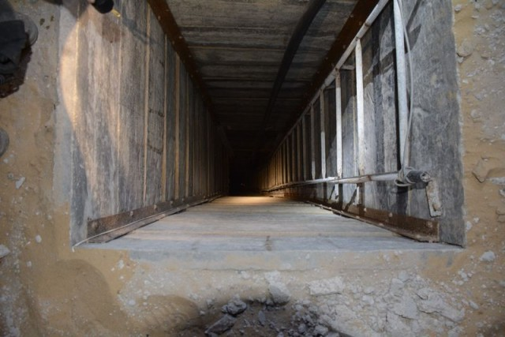
Access point to one of the tunnels
The tunnels openings sometimes lead beyond the Gaza border, into Israeli territory. Many tunnels have been found in close proximity to Israeli communities.
In three recent incidents, squads of Hamas terrorists infiltrated Israel through such terror tunnels. The latest incident took place on July 28 when terrorists infiltrated Israel via a tunnel near Nahal Oz. Their goal was to attack an Israeli community near the border. IDF soldiers thwarted the attack and killed one of the terrorists.
On July 17, heavily armed terrorists climbed out of a tunnel near the Israeli community of Sufa, a few kilometers from the Gaza border. Four days later, terrorists wearing full IDF uniforms infiltrated Israel through a different tunnel. IDF forces killed the terrorists and discovered that they were wearing suicide vests. Their goal was to massacre Israeli civilians.

[EMBEDDED VIDEO: http://humanrightsvoices.org/site/documents/?d=21817]

3. How can Hamas afford to build tunnels?
While new houses and other civilian structures go unbuilt, Hamas has invested millions of dollars and other resources in building and operating its massive tunnel network.
Every month, Israel transfers construction materials into Gaza [EDITOR’S NOTE: LINK GOES TO A DECEMBER 15, 2013 IDF BLOG ARTICLE ENTITLED “From Agriculture to Aid, Israel Cooperates with Gaza”] intended for civil projects. These materials are co-opted by Hamas for tunnel construction. Since January 2014, 4,680 trucks carrying 181 thousand tons of gravel, iron, cement, wood and other supplies have passed through the Kerem Shalom crossing into Gaza.
With these supplies, Hamas could have built houses, hospitals, schools and libraries. It could have built infrastructure to improve the quality of life for the residents of Gaza. Instead, it elected to expand its underground terrorist city.
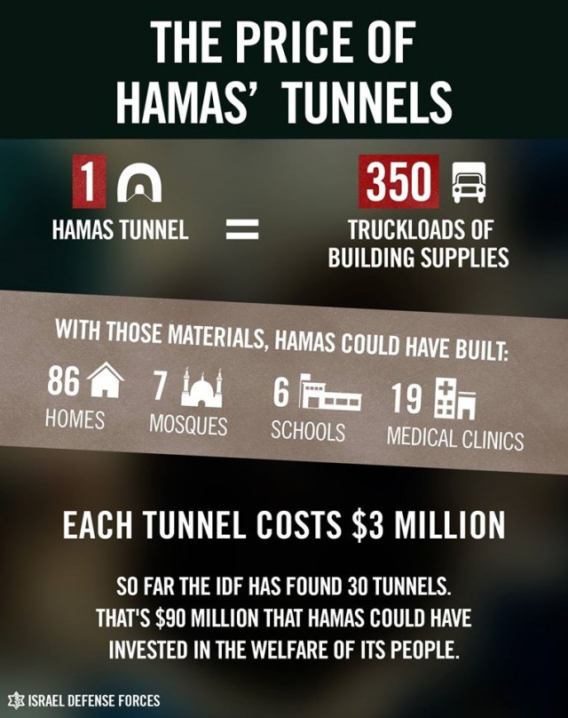

4. How does the IDF confront this threat?
IDF ground and aerial forces operating along the security fence and inside Gaza conduct meticulous searches for the tunnels and their access points. The tunnels are well hidden, often beneath civilian structures or open areas.
Each tunnel uncovered is carefully mapped and examined before its demolition.
[EMBEDDED VIDEO: http://humanrightsvoices.org/site/documents/?d=21909]

The IDF is committed to eliminating all threats aimed at harming Israeli civilians. The threats posed to Israelis by Hamas’ network of infiltration tunnels are unthinkable. That is why we will not stop in our mission to locate and neutralize them. Hamas, as the authority in the Gaza Strip, is accountable for all acts aimed at harming Israeli civilians and IDF soldiers.

