Caught: Hamas Reports Terrorist’s Death as a Civilian Casualty
IDF Blog
August 25, 2014
http://web.archive.org/web/20140831080026/http://www.idfblog.com/blog/2014/08/25/caught-hamas-reports-terrorists-death-civilian-casualty/

Media outlets have relied on Hamas’ statistics when reporting casualties in Gaza, but the terrorist group routinely exaggerates civilian deaths for propaganda purposes.
When IDF forces target terrorists in Gaza, Hamas leaders often conceal the deaths of its operatives. In many of these cases, the terrorist organization reports militant deaths as civilian casualties. This tactic has an obvious purpose: to attract international sympathy for Hamas while intensifying condemnation of Israel.
Hamas used this deceptive strategy on Saturday after the IDF targeted Mahmoud Osama Abbas. Hamas’ interior ministry Facebook page presented Osama Abbas as a civilian (in Arabic – مواطن), but a bit of research reveals that he was a senior terrorist in the Popular Front for the Liberation of Palestine (PFLP), a terrorist organization in Gaza. Images of Osama Abbas are publicly available on the organization’s website, which refers to him as a ground commander (in Arabic – قائد ميداني) who directed several attacks against Israel.
The Palestinian Interior Ministry recognizes Mahmoud Osama Abbas as “a civilian.”
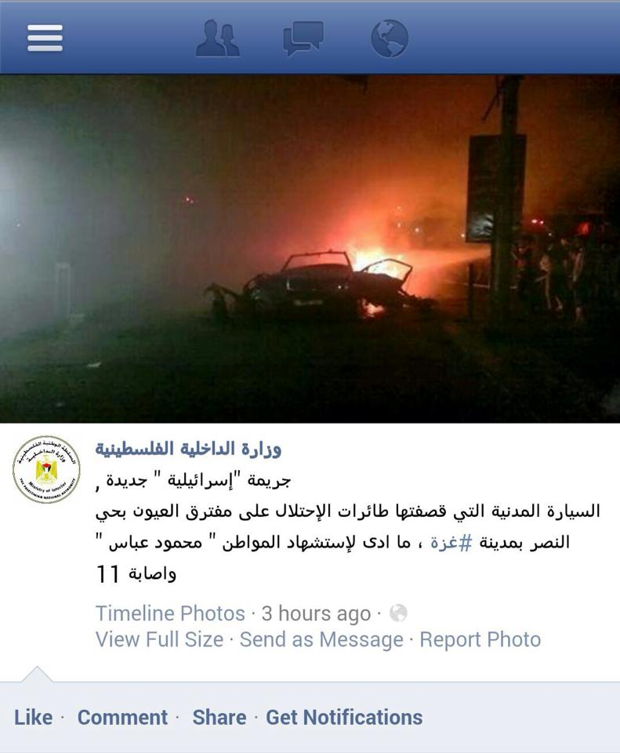

The Front for the Liberation of Palestine website laments the death of the “field commander” Osama Mohamed Abbas, meaning he was a terrorist.

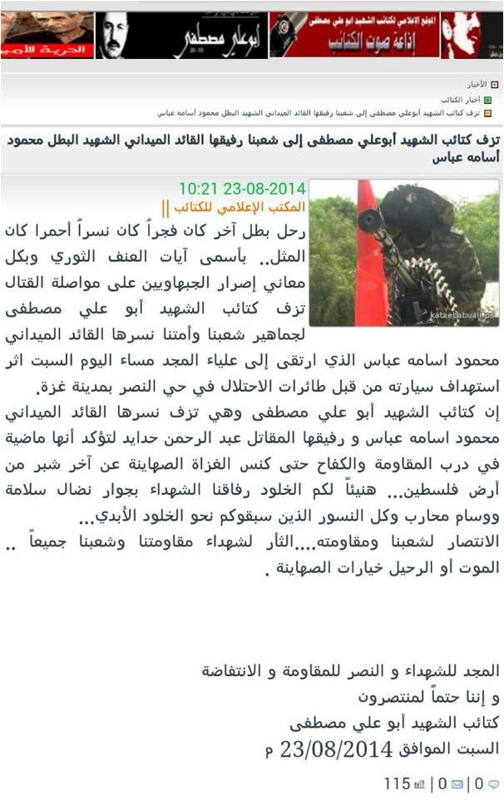

During the first weeks of Operation Protective Edge, the international media published figures on the number of civilian deaths provided by Hamas. Many journalists are beginning to question the reliability of this source. According to Anthony Reuben, [EDITOR’S NOTE: LINK GOES TO AN AUGUST 11, 2014 BBC NEWS ARTICLE ENTITLED “Caution needed with Gaza casualty figures“] head of statistics for BBC, “[i]t is hard to say with certainty at this stage how many of the dead in Gaza are civilians and how many were fighters… Some of the conclusions being drawn from [the data Hamas publishes] may be premature.”

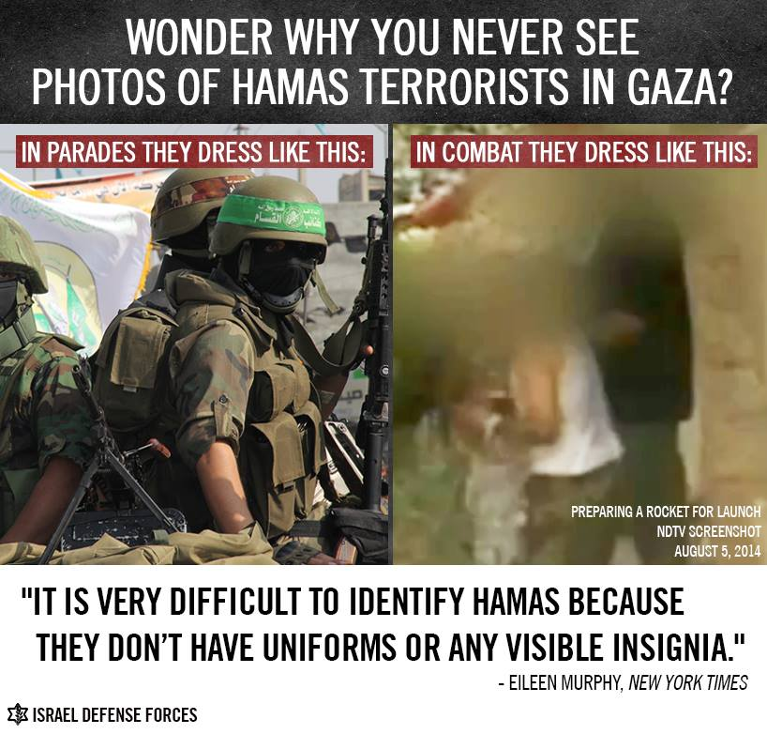

Captain Eytan Buchmann,an IDF spokesperson said that “the UN numbers being reported are, by and by large, based on the Gaza health ministry, a Hamas-run organization…When militants are brought to hospitals, they are brought in civilian clothing, obscuring terrorist affiliations.”

