Boycott HP Campaign proves BDS is booming
January 2, 2017
By Hasheemah Afaneh
Alternative Information Centre
http://www.alternativenews.org/index.php/features-02/311-boycott-hp-campaign-proves-bds-is-booming
Between November 25th and December 3rd of this year, the Global Week of Action against Hewlett-Packard (HP) was the most extensively coordinated boycott, divestment, and sanctions (BDS) action to take place.
According to the United Kingdom’s report, over 150 actions took place in 30 countries around the world. HP has been deemed as the “Polaroid of our times,” a slogan that refers to Polaroid’s role in the development of the passbook ID system during apartheid in South Africa. Eventually, Polaroid withdrew from South Africa in 1977, seven years after the campaign to boycott the company was initiated.
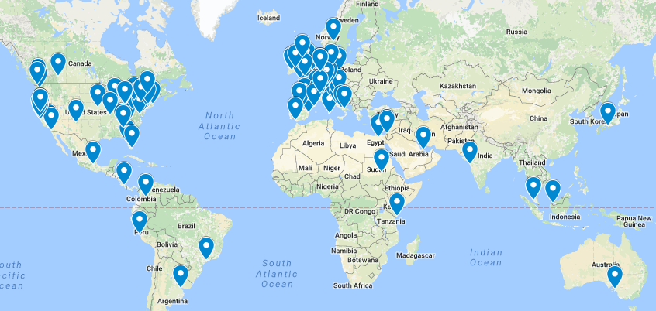
Locations of Boycott HP Campaign actions in 2016. Photo credit: US Campaign for Palestinian Rights.
HP operates in four main domains when it comes to the Israeli system of oppression. First, HP is the principle operator of the Basel system, a biometric system that is used to control the entrance of Palestinians whom are allowed in Israel through checkpoints. Second, HP profits pour into Israel’s ID card system that aims to differentiate between citizens of Israel and the rest. Third, HP plays a role in the siege on Gaza by delivering the information technology (IT) infrastructure to Israel’s navy as well as to the Israeli army in general. Fourth, HP provides services to two major Israeli settlements, Ariel and Modi’in Illit, supporting one of the major barriers for development among the Palestinian people. HP also provides services to the Israeli Prison System where many Palestinians are held under Administrative Detention. Ironically, HP claims to “unconditionally support human rights”.
In November 2015, HP split into HP Inc. for consumers and HP Enterprise for businesses and governments; however, both remain involved in Israel’s occupation of Palestine.
Garik Ruiz, the North America Advocacy Advisor for the Palestinian Boycott, Divestment, Sanctions (BDS) National Committee, talked to the Alternative Information Center about the BDS campaign against HP.
How does the boycott campaign against HP compliment BDS campaigns targeting other companies such as orange, G4S, etc.?
G.R.: HP companies are being targeted by the Palestinian-led international BDS movement because HP profits from Israeli violations of Palestinian human rights. HP technology is being used by Israel to enforce its military occupation, maintain its illegal settlements in the occupied Palestinian territory, besiege almost 2 million Palestinians in Gaza, as well as enforce an apartheid system within the state of Israel.
As with successful campaigns against other complicit corporations, such as Veolia, Orange and G4S, BDS is pressuring HP companies by advocating consumer boycotts as well as institutional divestment. The strategy is based on raising the reputational and financial price of HP’s support for Israel’s crimes and violations of international law to convince the company to quit these illegal projects.
Rising success often comes with backlash. What are the origins of the backlash against BDS and how is it affecting the movement?
G.R.: With the withdrawal from the Israeli economy of major international corporations such as Veolia (2015) and Orange (2016) after successful BDS campaigns, as well as the very recent sale of most of G4S’ (December, 2016) involvement with Israeli human rights abuses due to the ongoing G4S boycott campaign, corporations are starting to see that it is not only morally wrong to profit from Israel’s occupation and apartheid system but also that it is bad for business.
The growing impact and clout of the BDS movement, coupled with the McCarthyite war of repression against it by Israel and its allies are bringing BDS closer to the mainstream. We continue to build the movement at the grassroots level to pressure decision-makers to stop their complicity in Israel’s regime of occupation, settler-colonialism and apartheid, as was done in the struggle against apartheid South Africa.
How does the boycott of HP act as a tactic to push for an end to Israeli occupation in light of the increasing stubbornness of formal political avenues?
G.R.: After their resounding failure to slow down the impressive growth of BDS around the world, Israel’s far-right government, the most racist in its history, and Israel’s lobby groups around the world are desperately trying to conflate criticism of the racist and colonial policies and laws of the state of Israel with anti-Jewish racism and are backing anti-democratic legislation in North America and Europe to stifle BDS activists’ free speech rights.
The fact that BDS is anchored in the Universal Declaration of Human Rights, categorically and consistently rejects all forms of racism, including anti-Semitism, and enjoys enormous and growing support among Jewish millennials, especially in the US and UK, are not making Israel’s job easy at all, however. BDS targets complicity, not identity.
The recent embrace by Israel and the Israeli lobby in the US of openly racist, including anti-Jewish, figures chosen by US President-Elect Donald Trump for key positions in his cabinet, such as Steve Bannon, has exposed Israel’s hypocrisy.
BDS campaigns targeting HP and other apartheid profiteers do not rely on states but rather on the collective strength of human rights defenders around the globe.

