Announcing ADC’s 2016 Convention Panel: BDS Movement and First Amendment Rights
September 20, 2016
American-Arab Anti-Discrimination Committee
http://www.adc.org/2016/09/announcing-adcs-2016-convention-panel-bds-movement-and-first-amendment-rights/

As part of the upcoming Convention, ADC will be hosting a panel session on the Boycott, Divestment, Sanctions (BDS) movement for Palestinian freedom, justice, and equality.
The panel will discuss efforts to promote the BDS Movement and advocate for Palestinian human rights, including efforts on college campuses. Panelists will discuss the history of the right to boycott as a means to support social justice, as well as backlash that activists face when they engage in the movement. The panel will touch on First Amendment issues around BDS and legislation targeting the movement. Panelists will also discuss efforts such as Canary mission aimed at silencing supporters of Palestine and BDS.
This important discussion will include Josh Ruebner, Policy Director of the US Campaign to End the Israeli Occupation; Ms. Dalal Hillou, Palestinian-American Law Student at American University; and Attorney Abed Awad.
The session will take place on Friday, September 30, 2016 from 4:00 P.M. – 5:15 P.M. The ADC Convention will be held from September 29th – October 2nd, in Washington, D.C. To learn more about the Convention please visit convention.adc.org.
About the Panelists:
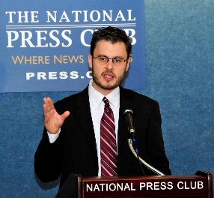
Josh Ruebner is the Policy Director of the US Campaign to End the Israeli Occupation, a national coalition of hundreds of organizations working to end U.S. support for Israel’s military occupation of the Palestinian West Bank, East Jerusalem, and Gaza Strip, and supporting a U.S. policy that upholds freedom, justice and equality. He is the author of “Shattered Hopes: Obama’s Failure to Broker Israeli-Palestinian Peace.”

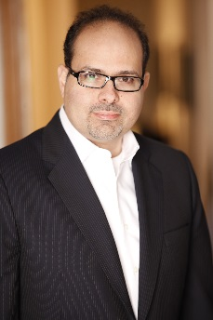
Abed Awad is an attorney practicing in the fields of general civil litigation and business advice, including complex matrimonial law, commercial law, Islamic law and international law. In addition to his Juris Doctorate, Mr. Awad holds a Masters in Near and Middle East Studies from the University of London. Mr. Awad was a leader in the fight against the Anti-BDS legislation in New Jersey and wrote several articles on the matter. As a frequent public speaker at bar associations, universities, conventions and political events, Mr. Awad lectures on subjects ranging from law, politics, gender, religion and culture internationally, with more than 200 television and radio appearances. Awad is an Adjunct Law Professor at Rutgers Law School, Newark and has taught at Pace Law School and Seton Hall Law School. Awad also has extensive experience in political campaigns. Mr. Awad was a co-founder of the Arab American democratic Caucus (NJ).

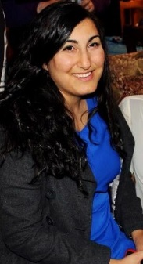
Dalal Hillou is a Palestinian-American from Georgia with a passion for law and social justice. She is currently a second-year law student at the American University Washington College of Law in Washington, DC. She was on the executive board for Athens for Justice in Palestine at the University of Georgia during her undergraduate career and worked in Haifa before attending law school. She worked as a Summer Associate in ADC’s Legal Department during the summer of 2016 as a participant in the Anthony Shadid Internship Program.
Click here to view the full 2016 ADC Convention Program.

