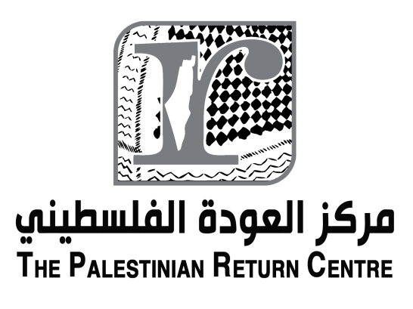
Dear Mr. President and members of the Council,
The Palestinian Return Centre would like to highlight that
In 2017, it is 100 years since the Balfour Declaration, 70 years since the UN Partition Plan, the Israeli occupation will enter its fiftieth year, and the closure/blockade of the Gaza Strip will enter its tenth year.
The Palestinian Return Centre (PRC) is concerned about the devastating failure of international community to exert real pressure on Israel, the occupying power, to bring its actions in line with its obligations under international humanitarian law and UN resolutions.
Inside the occupied territories Palestinian refugees continue to suffer from Israel’s illegal military occupation, colonial policies and apartheid regime. This is entrenching the prolonged exile of Palestine refugees, and their descendants, forcibly displaced after 1947 and intentionally denied the right to return as stated in UN resolution 194.
the delivery of basic services in Gaza, the West Bank can only be expected to become more pressing in 2017;however although humanitarian assistance is critical, no matter how robust, it is not solution to ending Israeli occupation, which is the root cause of the human rights violations
The Palestinian Return Centre reminds the Council that the concerted efforts aimed at the strategic fragmentation of the Palestinian people and normalizing Israel’s prolonged occupation and must be responded to with practical steps to ensure Palestinian access to human rights, fundamentally the right to self-determination.
States has states have a collective duty to ensure accountability, justice and equality. National governments should support boycott, divestment and sanctions activities and respond positively to calls for such initiatives. This is of utmost importance if the different actors are concerned about fulfilling their legal duty under international law.
I thank you

