How the AP Botched Its Investigation of Civilian Deaths in the Israel-Hamas War

March 10, 2015
By Richard Behar and Gary Weiss
Observer
http://observer.com/2015/03/how-the-ap-botched-its-investigation-of-civilian-deaths-in-the-israel-hamas-war/

UPDATE: There was no immediate reaction to the following story from the Associated Press, except for this: shortly after this article was published, the news service changed the captions of the photo slideshow to reflect that all eight photos were posed.

***

On February 13, 2015, the Associated Press published and distributed an article that stirred the conscience of the world. It gave its many readers—“AP news content is seen by half the world’s population,” according to the wire agency’s website—a disturbing picture of Israel as a serial violator of the norms of warfare, wantonly and indiscriminately slaughtering civilians during last summer’s war with Hamas in Gaza.

The AP had conducted what it called “the most painstaking attempt to date” to determine who was killed in Israeli strikes on houses in the war. The New York-based news agency examined 247 airstrikes on homes—interviewing witnesses, visiting attack sites and compiling a detailed casualty count. Its probe determined that out of 844 dead from those strikes, 508 (or just over 60 percent) were children, women and older men, “all presumed to be civilians.”

Hanan Ashrawi, executive committee member of the Palestine Liberation Organization, told the AP: “Either they [Israelis] have the worst army in the world that constantly misses targets and hits civilians, or they are deliberately killing civilians.” If most of those killed are civilians, she added, “You cannot call them collateral damage.”

The AP took it one step further, citing what it called “preliminary” UN figures that 66 percent of the overall Palestinian death toll during the war (not only from house strikes) was civilians.

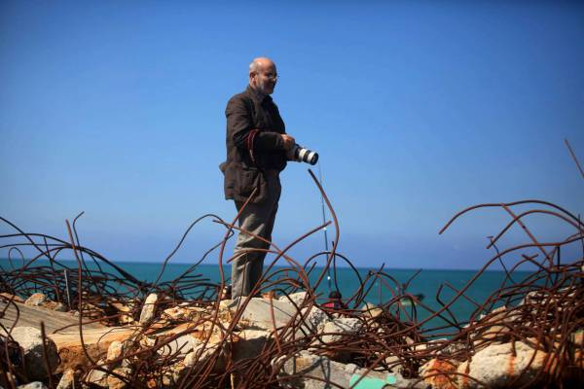
Portrait of AP photographer Adel Hana

There was some rebuttal from Israeli officials but the general approach of the article, which was illustrated with eight searing photographs, seemed designed to substantiate Ms. Ashrawi’s vehement comments. The AP found that children under 16 made up one-third of the total deaths, that in 83 strikes on houses (or what it calls “residential compounds”), three or more members of one family died, and that the killed included just “96 confirmed or suspected militants,” just more than 11 percent of the total (“though the actual number could be higher since armed groups have not released detailed casualty lists”).

It was the stuff of which journalism award submissions are made.
We strenuously sought the AP’s comment for this article. We sent follow-up
queries when there were responses, but our attempts to get the AP’s point of
view proved largely unsuccessful.

Publications, aggregation sites and broadcast outlets picking up the AP probe ranged from the New York Times to the Drudge Report and Al Jazeera America, from the Washington Post to ABC News (The AP provided subscribers with two versions of the article, a roughly 2,250-word story and one about half that size). The U.K.’s Daily Mail and The Independent both ran the piece, no doubt reinforcing the British public’s already dim view of Israel. Even Stars and Stripes, the newspaper for U.S. Armed Forces, ran the AP “exclusive.” The wide pickup was a coup for the oldest and most ubiquitous of wire services, which operates in more than 280 locations worldwide and counts 1,400 U.S. daily newspapers among its members, plus thousands of TV and radio broadcast members.

There is just one problem. The AP’s exclusive investigation was botched in just about every imaginable way.

We conducted an investigation of the AP investigation. We (the authors) have formed a nonprofit investigative project, The Mideast Reporter, that is going to do a lot of that kind of thing. We found that the news agency reached faulty conclusions based on selective information, cherry-picked quotes, and above all its “painstaking” survey was fundamentally flawed, and was set into motion by slanted, politically biased non-governmental organizations.

Some of it is Journalism 101 stuff, such as failing to write accurate headlines and failing to fully and fairly quote a principal source on a crucial issue. A lead photograph simultaneously exploited a 6-year-old child while inadequately identifying his father—a Hamas commander—as a “Hamas policeman.” And correcting captions violating its ethics rules only after we brought the issue to the AP’s attention—but limiting those corrections to an archive not usually accessed by the public, rather than the articles themselves.

A video segment, released concurrently, was even worse, and was structured almost as a kind of multimedia argument for bringing Israel to the International Criminal Court for war crimes, using as its principal source a fervent critic of Israel.

In its reporting, the AP disregarded its own code of ethics, as well as the Society of Professional Journalists’ Code of Ethics.

We strenuously sought the AP’s comment for this article. We sent follow-up queries when there were responses, but our attempts to get the AP’s point of view proved largely unsuccessful. Comment was sought from the three AP reporters who shared the byline on the Gaza air strikes examination, Karin Laub, Fares Akram and Mohammed Daraghmeh, as well as the Gaza-based staff photographer who produced the eight photographs, Adel Hana. None of the four would comment on the article (though in fairness, we were told that Mr. Hana’s grasp of English is limited). Questions were also submitted to Jerusalem bureau chief Josef Federman and Middle East region editor Dan Perry.

After receiving what he called “the necessary approvals,” Mr. Federman responded with a short statement that only partially addressed two of our 16 questions. (He offered to speak off-the-record about why AP would not respond to the others, but we declined the offer.) Follow-up questions on the photos were handled by Maya Alleruzzo, the AP’s Middle East regional photo editor, who issued brief responses that did not address crucial ethical issues—notably why the AP hasn’t told its subscribers that the photos were posed.

Responding appropriately to serious queries is not optional for the AP. It is a not-for-profit cooperative, owned by its media outlets, and it sets high ethical standards for itself. Its statement of “News Values and Principles,”says that questions about its reporting and any aspect of its work “should be taken seriously” by the wire service.

We approached our examination of the article wondering if the AP’s subscribers can trust this wire service in its reports from Gaza. Our conclusion is that they cannot.

The ‘Policeman’ Who Was a Terrorist

Let’s start at the top—literally: The photographs accompanying the February 13 article. AP ran eight, now available as a slideshow online.

The images are dramatic, showing survivors of Israeli air attacks walking or standing amid the ruins of what had been their homes. The lead photo (below) is especially heartrending. It shows a child standing amid the wreckage where his father, mother and two siblings were killed in an Israeli airstrike. The photo and its original caption, still unchanged at this writing, reads: “In this Tuesday, Nov. 25, 2014 photo, Khaled Malakeh, 6, stands on the rubble of his family house in the Zeitoun neighborhood in Gaza City, destroyed in an Israeli airstrike July 9. The attack killed his father, a Hamas policeman, his mother and two siblings. The sign in Arabic reads, ‘House of martyr Mostafa Jamal Malakeh (Abu Khaled).’ ”

The photo and its caption were were widely replicated by AP subscribers.
This photo is problematic from several perspectives. The first is that the caption is false.
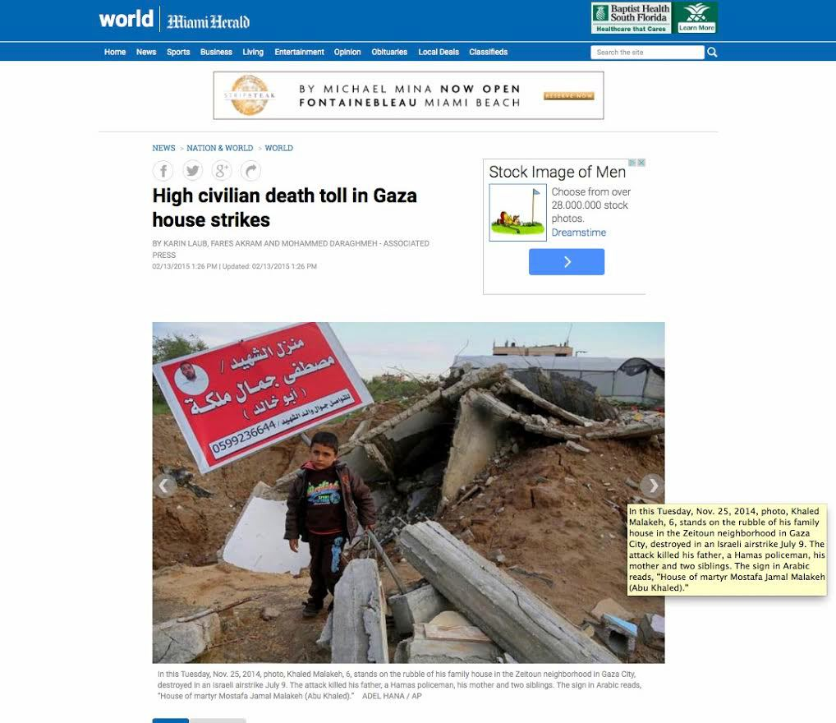
The AP article as published in the Miami Herald.

The word “policeman” conjures up images of a law enforcement officer, a civil servant, keeping the peace. But as the AP knew, or should have known, Hamas “policemen” frequently double as Hamas fighters for the terrorist group’s military wing, the Qassam Brigades. This has been widely reported. The Jerusalem Post pointed out in 2010 that “ahead of Operation Cast Lead in the Gaza Strip last year, the Hamas Interior Ministry formally incorporated a significant percentage of the police force into the Hamas military wing.” Hamas is designated as a terrorist organization by the U.S., the European Union, Australia, Canada, Japan and, more recently, Egypt—something nowhere noted in the article. AP policy is to refer to Hamas and similar groups as “militant groups,” not terrorists.

If the AP had wanted to find out if Mr. Malakeh was an exception to the rule, it had a number of options at its disposal. The Israeli armed forces is one source of information. Libby Weiss (no relation to one of the coauthors), head of the North American media desk for the Israel Defense Forces (IDF), told us that “Mostafa Jamal Malakeh, born in 1983, was part of the Hamas rocket apparatus in Zeitoun, and was responsible for firing rockets into various areas in Israel.”

Hamas is another source of information. We don’t know how Hamas would respond to such an inquiry, but we do know that it implicitly acknowledged that he was a fighter and not a civilian: His name does not appear on Gaza casualty lists, whether the ones in Arabic or the ones in English, such as one from the International Middle East Media Center. The latter includes Malakeh’s wife and one child (spelled “Malaka” on the list). The Observer was advised of the foregoing by another logical source to interview, Reuven Erlich, a retired IDF intelligence officer who now heads the Meir Amit Intelligence and Terrorism Information Center—an independent research institute that collects, studies and disseminates information about terrorists. Mr. Erlich points out that Hamas fighters such as Malakeh were omitted from casualty lists generated by Hamas-affiliated agencies, even though his wife and child were on such lists.

The AP knows about Mr. Erlich, and could have asked him about Malakeh, too. That’s because Erlich was briefly quoted in its article—quite a bit more on that later. Mr. Erlich told us that AP did not ask him about Malakeh in the hour he spent on the phone with its reporter.

Mr. Erlich confirmed for us that Malakeh was a Hamas fighter, and he also referred us to a YouTube memorial video, (above) which identifies the “policeman” as a local commander in the “Al-Zeitoun Battalions” of the Izz ad-Din al-Qassam Brigades. The Qassam Brigades are not a detective squad but the military wing of Hamas, which, along with terror groups under its auspices, had fired more than 8,000 rockets into Israel from 2005, when Israel evacuated from the Gaza Strip, until the launch of Israel’s counteroffensive last summer.

Had the AP reporters known about that memorial video, which featured the child, they might have noticed that Malakeh was shown shown brandishing not only a standard-release Kalashnikov rifle, but also an M-16 with telescopic sight, and a heavy machine gun. They would also have heard an Arabic song, accompanying the video, about Shaheed (holy-war martyrs) who sacrifice their lives for a place in paradise. The video also included a logo for the Qassam Brigades.

It seems odd that the AP would have let the glib description of Malakeh as a “Hamas policeman” be distributed to its subscribers and their readers without further checking. But the problem with the characterization of a Hamas commander as a civilian “policeman” goes beyond a faulty caption. It also raises a question that goes to the heart of the AP article: Did the news agency accurately distinguish between Hamas fighters and civilians? If it could miss Malakeh, how many more did it miss?
‘AP’s preference for the Palestinians isn’t a matter of anti-Semitism.
It’s a matter of favoring the side perceived as the underdog. The
assumption is that the Palestinians are telling the truth and the Israelis
are lying.’—Mark Lavie, former AP staffer

But the problem with this photo, and the other seven, does not end there. The photo’s use of a 6-year-old child, standing amid the ruins of the family home, draws a vociferously negative reaction from Dr. Madeline Levine, a child psychologist and author of See No Evil: A Guide to Protecting Our Children from Media Violence (1998). The photo, she says, “manipulates emotions … Should we do this with youngsters? Of course not, because they’re more vulnerable and the job is to protect them, not exploit them.” If the photo was posed—as admitted by the AP—“that’s pretty disgusting, because there are so many opportunities to make that point that don’t involve exploitation of a young child.”

Ms. Levine points out that the manipulation is twofold: “There is no easier way to manipulate an audience than around children suffering.” In her view, “you have to be clear that this is being used for particular purposes, and that’s not being made clear [with the AP photo]. So it’s both the exploitation of the child and that exploitation of the audience.” In an interview with Newsweek, a similar point was made by retired Col. Richard Kemp, the former commander of British troops in Afghanistan. “The Israelis are explaining it but many people don’t want to hear it,” Mr. Kemp told Newsweek last summer. “And no explanation counts for anything if you show me a photograph of a dead baby on a mortuary slab or four dead boys lying on the beach.”

Another photo shows Mohammed Al-Bayoumi “on the rubble of their family home in the Nusseirat refugee camp in the central Gaza Strip.” The house was attacked by Israel on July 31, says AP, killing “13 people from two families, including his son.” That is a tragedy. But the AP makes no effort to identify the fatalities. The Observer learned from Yossi Kuperwasser, who until recently was the director general of Israel’s Ministry of Strategic Affairs, that “no Al-Bayoumi male has been killed, according to Hamas and PA lists of casualties,” which seems to point to the son being a Hamas fighter. If he was a fighter, this information would have given a better idea of why Israel might have targeted the house, and perhaps also why any “roof knocks” might have been ignored.

Finally, all of the AP photographs were posed, without that fact being disclosed in captions, violating its own rules. The reason for the AP’s strict rules is obvious: Without such standards, news organizations can serve as willing or unwilling propaganda outlets. AP rules give subscribers and readers an assurance that photographs and captions tell the truth.
Staged photos violate an explicit provision of the AP statement of News Values and Principles under the section aptly titled “Fabrications”:
“We don’t stage or re-enact events for the camera or microphone … We do not ask people to pose for photos unless we are making a portrait and then we clearly state that in the caption.”

That’s standard operating procedure in photojournalism.

In response to our queries to the AP photographer, we received an email from Maya Alleruzzo, the wire service’s Middle East regional photo editor, in which she wrote:

“The photo you are referring to is a posed portrait of Khaled Malakeh, which accompanied several other portraits of Palestinians standing at the site of their destroyed home in Gaza. Under AP’s news values and principles, in a portrait setting it is permissible for the subject to pose for the camera. Our caption should have noted this was a posed portrait.”

They should have “noted this” but they didn’t. So why hadn’t it been fixed?
In response to a follow-up question, Ms. Alleruzzo acknowledged that all of the photos sent with the article were posed and that, “Although these photos conform with AP standards, we have gone into our archives and changed the captions to clarify that the subjects were posing.”

That caused confusion. Archives? The article had not been archived. As we pointed out, both articles, at least as of this writing, remain on the AP website. Further correspondence yielded the following:

“I have requested all of the captions changed that are available on the apimages.com site. This fix will ensure that later use of these images will have the updated captions. Some indicate that they are posing for a portrait and a few, where the person is walking or talking, indicate that they are visiting the site with an Associated Press photographer.”

Indeed, the eight photos accompanying the article were changed in reaction to our queries to reflect that they were posed—not in the photo array accompanying the article online, but on the “AP Images” archives, which is used mainly by publications licensing photos.

Why wasn’t a correction sent to all AP subscribers? Why wasn’t the caption issued, with an appropriate correction appended, in the slideshow that illustrates both versions of the article on the AP website?

Certainly corrections can be embarrassing, especially when they are sent out to hundreds of subscribers, and even more so when they, in turn, lead to hundreds of corrections—blaming the AP—throughout the world.
And that’s just the photos. We haven’t even gotten to the text. It doesn’t get any better. It gets a lot worse.

Lies and Statistics

How did the AP get the idea for this article? What was the process? One clue might be in a passage that was inexplicably dropped from a shorter version of the article, in which the AP says, “In the initial stages, the AP’s reporting was guided by Al Mezan Center for Human Rights, a Gaza human rights group, and the Israeli rights group, B’Tselem, which published partial findings on house strikes or provided names of families.”

We question why these two advocacy groups’ role in the article is described so vaguely, especially since both organizations have a widely known political agenda hostile to Israeli policies, and, in the case of Al Mezan, that hostility is especially broad and deep.

Al Mezan’s mission is to gather the raw materials needed to engage in what’s known as “lawfare” with Israel, bringing Israelis and the state itself to trial for “war crimes,” as it once attempted to do with former prime minister Ehud Barak in the wake of previous hostilities in Gaza.

Al Mezan’s objective, as can be seen by simply perusing its website, is to haul Israel before the International Court of Criminal Justice. It makes no effort to hide its agenda, but the AP took the liberty of doing so, making no reference to it. Al Mezan refers to the Israeli armed forces by the debasing term “Israel Occupation Forces,” something more befitting a hate-Israel blog than a dispassionate, unbiased “human rights group.” Its website is replete with accusations of “murder” by Israeli forces, and the overall impression it makes is of being a propaganda organ and not a compendium of reliable facts. According to the Jerusalem-based watchdog organization NGO Monitor, Al Mezan’s statistics on civilian casualties are “highly unreliable.”

B’Tselem—The Israeli Information Center for Human Rights in the Occupied Territories shares Al Mezan’s long history of anti-Israel bias. B’Tselem “has faced serious criticism for its misrepresentations of international law, inaccurate research, and skewed statistics,” reports NGO Monitor. In a recent article published by jns.org, Jonathan D. Halevi, a senior researcher on radical Islam at the Jerusalem Center for Public Affairs, an Israeli think tank, observes that Hagai El-Ad, B’Tselem’s executive director, “has repeatedly lashed out at the Israeli government and the senior command of the Israel Defense Forces, accusing them of deliberately committing large-scale war crimes in the Gaza Strip.”

The AP, of course, was fully within its rights to disregard criticism of Al Mezan and B’Tselem. But shouldn’t readers at least have known about criticism of its sources? In a brief statement to us, AP Jerusalem bureau chief Federman declined to elaborate on Al Mezan’s and B’Tselem’s role in its article, except to say that “we obtained lists of possible airstrikes on homes” from the “two human rights groups.”

That raises a question not addressed by Mr. Federman: Why weren’t the AP’s readers told that the AP delegated the crucial function of deciding whom to interview to groups that function as little more than Palestinian propaganda organs?

The AP’s use of these two groups was compounded by its removal of any reference to them in the shorter version of the article. Not describing the political agenda of these groups appears to violate the AP’s code of ethics, its statement of “News Values and Principles,” which includes the line, “Transparency is critical to our credibility with the public and our subscribers.”

Mr. Federman said the AP “was limited by a lack of cooperation from both sides. Hamas refused to provide identities of its members killed in the airstrikes, while the Israeli military refused to discuss any specific targets or say how many airstrikes on houses it carried out.”

Fair point. But there are independent military experts in Israel, with ties to the government, who could have shed some light on the subject—and on-the-record. And, as noted earlier, the AP went to two anti-Israel organizations, one of which is located in the Hamas-controlled Gaza strip. Did that have the practical effect of obtaining the list of supposed “targets” from Hamas? Certainly, it is hard to believe that Hamas would have allowed Al Mezan, even if it was inclined to do so, to provide information that deviated from a propaganda line endorsed not just by Hamas but by its rivals in the Palestinian Authority—that Israel deliberately targeted civilians.

Given its hostility to the “Israeli Occupation Forces,” could Al Mezan have been relied upon to distinguish between casualties by Israeli fire and casualties by Hamas fire? It’s been estimated by Eado Hecht, a defense analyst at the Begin-Sadat Center for Strategic Studies, a leading Israeli think tank, that approximately 2,500 Palestinian rockets and mortar bombs were fired deliberately or by mistake into Palestinian residential areas. The deliberate fire was made against Israeli soldiers in those areas, but allegedly without warning the local civilians to move out, as Israel typically did. Of the 247 houses struck in the AP’s report, how many were clearly struck by Israel and how many by Hamas fire? What role did Al Mezan have in distinguishing between Hamas and Israeli fire? Is it qualified to do so?

It was widely reported during the war that Hamas was engaged in intimidation of Western media outlets, to the point that it drew a protest from foreign correspondents residing in Israel—a group noted for its antagonistic relationship with the Israeli military. If the Western media was subjected to pressure, what about organizations residing in the Hamas-controlled territory? Or, given Al Mezan’s anti-Israel record, was pressure even necessary?

The Cherry-Picked Quotes

We were not permitted to speak with the AP reporters, but Reuven Erlich did, and it was not a good experience.

A few days before the AP article was published, one of its reporters, Karin Laub, telephoned Mr. Erlich of the Meir Amit Intelligence and Terrorism Information Center, which has documented in several of its own probes that the Hamas-generated numbers for Gaza civilian casualties are grossly inflated. The organization found that Hamas is obfuscating the actual lists and affiliations, partly because of objective technical difficulties (poor paperwork and a lack of access to some bodies), and as part of its propaganda campaign against Israel. Thus, Meir Amit’s experts are closely examining the deaths, one by one, and its final tally won’t be available for many months—if not years. For now, the ratio of civilian-to-terrorist deaths has been averaging roughly 1:1 in its reports.

Six weeks prior to the AP story, the center had published an update showing that a majority of the positively identified Gazan dead (55 percent) were fighters, while the rest were civilians. AP did not cite that report, which contradicts their reporting during the war, when the wire service routinely wrote that a majority of the Gazan fatalities were civilians.

Meir Amit reported that the status of 25 percent of fatalities (i.e. terrorist operatives or non-involved civilians) could not yet be determined, and the percentages will change over time as it analyzes more details. But if the trend from prior wars holds, the ratio will likely end up being at least 60:40—the latter being civilians—the reverse of the ratio in the AP article that comes from the UN. And where does the UN get its estimates from? Hamas. More on that later.
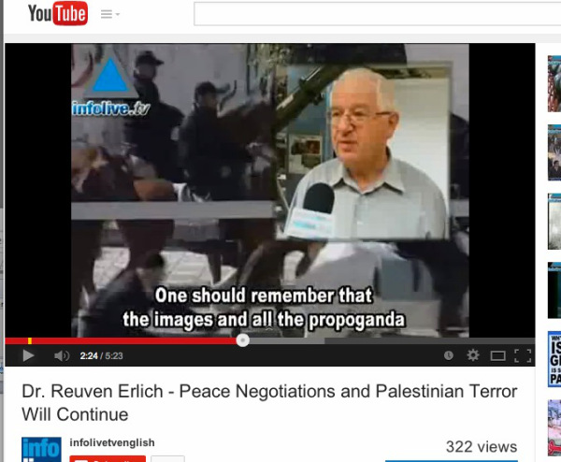
Reuven Erlich, who was interviewed by an AP reporter, calls its investigation “not serious.”

Mr. Erlich, who spoke to Ms. Laub for about an hour, recalls that she briefed him on the results of the AP’s work and seemed to have her mind already made up. He has reached that conclusion based not just on the phone conversation, in which she made her viewpoint clear, but that he was quoted selectively—and not on things that undermined her narrative.

She quoted him as saying that Hamas does not use women as fighters. That’s correct. He confirms that he said that. But he also said that Hamas recruits children as young as 15 years old—a fact that the AP neglected to publish. Assuming his account of the conversation is correct, why was Mr. Erlich considered quotable on women fighters but not on teenage fighters? The only reasonable explanation would be that it did not fit with the AP’s finding that “508 of the dead—just over 60 percent—were children, women and older men, all presumed to be civilians.” If teenage warriors are categorized as “fighters” rather than “children,” then the math underlying the AP “exclusive” disintegrates.

Mr. Erlich was paraphrased as saying that he “questioned the reliability of Gaza witnesses and said only military experts on the ground would be able to determine what happened in each strike.”

Objectivity requires a full and fair description of the other side of a story. The fragmentary paraphrase, cited above, doesn’t fit the bill. The AP’s Ms. Laub, Mr. Erlich recounted, “told me they spoke with neighbors, with Gazans, with so-and-so. And I told them that all the information from the Gaza Strip is Hamas-controlled and Hamas-oriented.” Also, he said, he pointed out to the AP reporter that “you cannot choose a number of air strikes and do a study about the air strikes, because you can never know in battle zones … whether these casualties were from Israeli air strikes or Hamas artillery or fighting there.”

The result, he remembers advising Ms. Laub, was that the AP’s entire methodology was fatally flawed—criticism not mentioned in the article. Mr. Erlich said that he has fought in the Gaza Strip, and that “you cannot take some cases and say for sure these are Israeli air strikes, the casualties because of Israeli airstrikes. These are stories. If you really want to know why they have been killed, you will have to send there a military delegation that will sit a year in the Gaza Strip and case by case will make a study.” The AP “exclusive,” he said, is “not serious.”

“Hamas controls the information,” he continued, “like in Northern Syria, ISIS controls the information. We are not playing in a yard of a democratic country [where] you can go and make your own investigation.”

Mr. Erlich’s comments are interesting because the AP counted among the civilian dead “males between the ages of 16 and 59 whose names did not appear in connection with militant groups on searches of websites or on street posters honoring fighters.” What the article did not mention, but what was perfectly obvious to even the most casual observer of the Gaza conflict, was that Hamas has turned civilian casualty statistics into a weapon of war, and routinely inflated the numbers. As reported last August in a Forbes article (by Richard Behar) entitled “Media Intifada,” the AP and other major media outlets (including The New York Times and Reuters) simply parroted the Hamas claim that most of the war dead were civilians.

So what was AP’s methodology for its current “examination” of the 247 airstrikes on houses? Mr. Federman won’t divulge that. What specific problems did they encounter that might have skewed their research? Ditto. But we do have a good idea of the kinds of things that were not included in its report.

Perhaps the most serious and disturbing omission from the AP article was this: It does not discuss, or even acknowledge, the issue of Hamas utilizing child soldiers. That would have seriously disrupted the narrative of the article by noting the possibility that some of the teenage casualties might have been combatants.
The AP’s statement of Values and Principles says, “We abhor
inaccuracies, carelessness, bias or distortions.” But given this
omission, it’s questionable whether this principle is put into
practice in its reporting from Gaza.

Again, all that the AP would have required was access to the Internet. In a report issued in September 2014—less than one month before the AP began its research—by the Meir Amit center, it was revealed that “boys aged 15 and 17 were integrated into the terrorist operative networks … Children and teenagers in Gaza’s educational system undergo basic military training in the schools and summer camps.” The report included photographs of child soldiers. It cited one instance in which a 9-year-old child was killed by IDF forces while “assisting his uncle, a senior Hamas operative.” Hamas deliberately falsified the age of the child, listing him as 24, reported Meir Amit, to conceal its use of children in combat. Moreover, the existence of such summer camps for kids was exposed by several news organizations, including AP rival Reuters, just prior to the start of last summer’s war. But none of this found its way into AP’s report.

The AP’s statement of Values and Principles says, “We abhor inaccuracies, carelessness, bias or distortions.” But given this omission, it’s questionable whether this principle is put into practice in its reporting from Gaza.

Also absent was historical perspective. Mr. Federman points out in his statement that “The story was accompanied by a sidebar, explaining that civilian deaths have been common in war throughout history.”

But this sidebar doesn’t do much to counter the anti-Israel slant of the article itself. Indeed, one might argue that it is inflammatory and unfair by saying that “Israel is far from the only country to have killed civilians during war. The list is long, from Dresden to Japan, from Grozny to Algeria.” Putting Israel in the same class as the Empire of Japan, which slaughtered millions of people in World War II, or the firebombing of Dresden, is outrageous. Indeed, a study by a working group affiliated with the American Public Health Association was published last June, one month before the Israel-Hamas war began, that puts things into a perspective that would have greatly benefited readers. The study cited widely circulated statistics that civilian casualties constituted 85% to 90% of the 248 armed conflicts in the world since the end of World War II. (In 2001, UN Secretary General Kofi Annan said the figure was 75%.).

But even if it had indeed provided needed historic perspective, it belonged in the main article.

What the AP needed to provide was any alternative to the Hamas perspective in its article. The AP could have done far more to depart from Hamas’ script. Indeed, another view was provided—but ignored.

The IDF’s lead international spokesman is Lt. Col. Peter Lerner, who says he spent an hour with Ms. Laub. The IDF also provided Ms. Laub with an hour-long background briefing by an Israeli military law expert. But “we did not see any influence of that [briefing] in the AP report,” Lt. Col. Lerner told the Observer. “Another core point,” he continued, “is that Hamas intentionally and deliberately concealed the identity and affiliation of their dead militants, depicting them as civilians to artificially inflate the civilian casualty figures. Their strategy was employed during and after [the war].

Such terrorists’ strategy aims to maximize public pressure on militaries.”
The AP did not include in its report that Hamas’ tactics were clear as far as back as July 8, the first day of the war, when its spokesperson, Sami Abu Zuhri, appeared on Al-Aqsa TV to call on Palestinian civilians to serve as human shields. “The people oppose the Israeli fighter planes with their bodies alone … We, the [Hamas] movement, call on our people to adopt this method to protect the Palestinian homes,” he declared. A week later, the Hamas Interior Ministry issued guidelines for whom it called its “activists” on social media: “Don’t forget to always add ‘innocent civilian’ or ‘innocent citizen’ in your description of those killed in Israeli attacks on Gaza …

Avoid publishing pictures of rockets fired into Israel from city centers…”
In August, the IDF announced it had discovered a Hamas urban-combat manual referring to civilians as helpful “pockets of resistance” that cause all kinds of problems for Israeli soldiers who Hamas acknowledges are trying to minimize civilian deaths. It also discusses the benefits for Hamas when civilian homes are destroyed. The AP never reported that in its “exclusive.” The AP certainly knows about the manual. Mr. Federman mentioned it in an AP story in September—after the war ended, and one full month after other media outlets reported about it.

To strengthen its argument, the AP reporters claimed that they “collected hundreds of death certificates—documents recognized by Israel as proof of mortality.” But Eado Hecht, the defense analyst from the Begin-Sadat Center for Strategic Studies, points out that death certificates are “not proof of the cause of death nor is it proof of who belongs to organizations and who does not.”

Reached after the AP article was published, Mr. Hecht was dismayed, but not surprised, by its inaccuracies and distortions. He pointed out that the AP is focused on a portion of the fatalities, those supposedly killed within houses, when a large volume of Palestinian mortars and rockets were fired at Palestinian residential areas by Hamas, deliberately or by mistake. Thus, he said, it is not clear how many of the casualties cited by the AP were a result of such “friendly fire.”

The AP article failed to note that all data emanating from Gaza on civilian and military casualties are controlled by Hamas. Kobi Michael, a senior research fellow with Israel’s Institute for National Security Studies, told us that the United Nations Relief and Works Agency (UNRWA) has very limited capabilities and it “can only have figures of its own from its clinics and shelters, all other figures are provided by Hamas.” He said, “As we knew in previous operations, Hamas lies and minimizes its casualties in order to score points in the international domain as well as in the domestic one—and to create the victory-and-achievement image. After Operation Cast Lead in 2008-2009, when Hamas declared about 49 casualties while Israel mentioned 709, a year or so later Hamas admitted that it lost between 600-700 of its fighters.” He believes that eventually the numbers will be very similar and maybe even higher—which likely means that at least 60 percent of Palestinian casualties are not innocent citizens.

Let’s Go To The Videotape

We’re saving the worst for last: The broadcast report. This was where the AP lost all pretense of fairness. It was more of a report on its own report than anything else. The broadcast was uploaded to YouTube, and was picked up by USA Today, MSN.com and Huffington Post, among other outlets. The segment made only a token attempt at balance, and quoted Human Rights Watch’s (HRW) senior researcher Bill Van Esveld saying that Israel had failed to properly investigate allegations of improper conduct in Gaza. The video concludes by saying that both Israel and Hamas are subject to prosecution by the International Criminal Court. But the message was plain: Israel, and Israel alone, is in serious legal jeopardy as a perpetrator of war crimes.

Mr. Van Esveld, like Al Mezan, is noted for his disdain for Israel, and his partiality toward its opponents. His Facebook page shows that he is a member of only two groups. One demands the release of a Palestinian allegedly kidnapped as part of a Mossad plot. The other, “The Popular Struggle Coordination Committee,” calls for boycotts against Israeli products.

Using Mr. Van Esveld to discuss the Israeli war against Hamas, notes Gerald Steinberg, head of the NGO Monitor, is akin to “asking a tobacco company for their view on whether smoking is hazardous to one’s health.”
NGO Monitor contends that its analyses “demonstrate that HRW disproportionately focuses on condemnations of Israel and that publications related to Israel often lack credibility.” In fact, HRW’s own founder, Robert S. Bernstein, severed his ties with the group because of what he felt was virulent anti-Israel bias.

Beyond the matter of balance, the video segment carried a headline and audio report that distorted even the print version of AP’s conclusions. The video carries a headline reading, “AP Investigates: Bulk of Gaza Deaths Civilians.” Put simply, AP ramped up its own findings with a video headline going way beyond its examination of civilian deaths from air strikes on “houses”—to civilian deaths caused by air strikes or ground battles on anything. Little wonder then that numerous media outlets adopted similar headlines for the print versions, as well. “AP Review: Israeli air strikes in Gaza killed mostly civilians,” announced Stars & Stripes. “AP report: Majority of Gaza war air strikes fatalities civilians” trumpeted Al Jazeera America. “Civilians bore brunt of Israeli strikes,” echoed the San Angelo Standard Times.

We’d like to believe that the AP pursued this article in good faith. But after seeing how Mr. Erlich was quoted in such a selective fashion, and reviewing how the AP stacked the deck in its article and video segment, that’s hard.
It gives us additional pause that one of the article’s authors is Fares Akram. In “Media Intifada,” it was described how Mr. Akram—formerly a New York Times’ Gaza-based reporter—once used Yasser Arafat as his profile photo on Facebook. In 2009, following an Israeli air strike that killed his father and a cousin, Mr. Akram wrote, “I am finding it hard to distinguish between what the Israelis call terrorists and the Israeli pilots and tank crews who are invading Gaza. What is the difference between the pilot who blew my father to pieces and the militant who fires a small rocket?”

Mr. Akram contends that there were no militants anywhere near the family farm at the time his father and cousin were killed: “The Israelis may say there were militants in the area of our farm, but I’ll never believe it.”
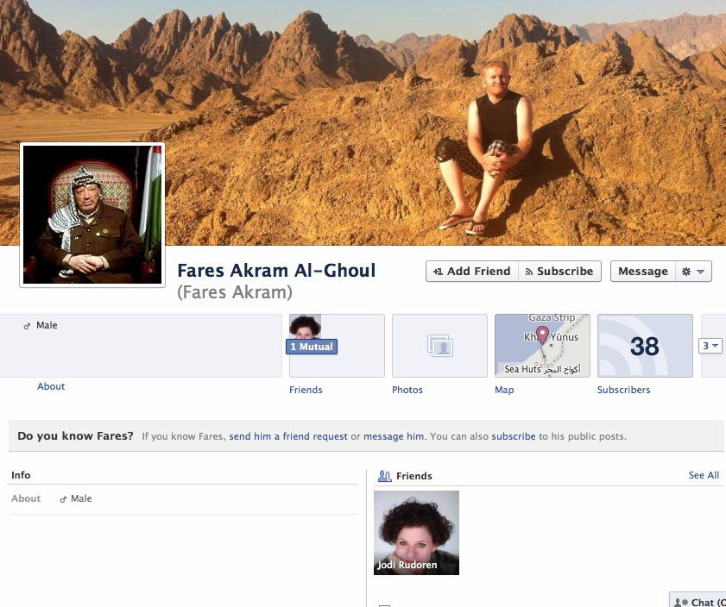
AP reporter Fares Akram once used an image of PLO head Yasser Arafat as his profile photo on Facebook.

While Mr. Akram is entitled to his personal opinions and to publish them on a personal blog, his writing raises questions about his impartiality. As Eado Hecht of the Begin-Sadat institute notes, “Akram has absolutely no way of knowing whether there were or were not Hamas fighters or fighters of other organizations in the vicinity of the farm at the time—they do not go around marking themselves with huge flags for all to see and some of their rocket launchers and permanent and temporary IEDs [Improvised Explosive Device] are dug into small pits so they won’t be seen till used.”

Moreover, Mr. Akram’s statement that there were “no militants” near the family farm is disputed by Israel. IDF spokesperson Weiss told the Observer that an investigation conducted by the Southern Command shows “that the target in question was identified as a Hamas observation post directing attacks at IDF forces and therefore it was imperative to operate against it. Being aware of Hamas’ mode of operation, the IDF planned the attack beforehand in order to minimize the damage to the noncombatant civilian population.” So we have to wonder, if the IDF is correct, why Mr. Akram would say that there were “no militants” in the vicinity if it was indeed a Hamas observation post? Mr. Akram says he’d “never believe” militants were in the area, but others may not be quite so incredulous.

The AP statement of Values and Principles contains no loophole or footnote exempting articles on Israel and Gaza. That this article saw the light of day at all represents what appears to be a systemic failure.
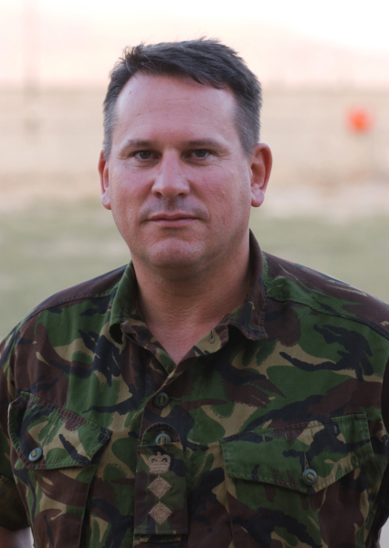
Col. Richard Kemp, a retired commander of British troops and a terrorism expert, called the AP report “shockingly biased.”

It might be a case of political bias. In an article in Tablet in August 2014, former AP journalist Matti Friedman painted a distressing picture of bias at AP’s Jerusalem bureau. “The Hamas charter, for example, calls not just for Israel’s destruction but for the murder of Jews and blames Jews for engineering the French and Russian revolutions and both world wars; the charter was never mentioned in print when I was at the AP,” wrote Mr. Friedman.

Another longtime former AP staffer in the Middle East, Mark Lavie, told us in an email, “AP’s preference for the Palestinians isn’t a matter of anti-Semitism. It’s a matter of favoring the side perceived as the underdog. The assumption is that the Palestinians are telling the truth and the Israelis are lying. Stories that don’t fit into that frame are less likely to be covered.”
We ran the AP article past Col. Richard Kemp, the former British commander of British troops in Afghanistan who has carefully studied Israeli tactics in Gaza. He sent us an email that said as follows:
This AP story is shockingly biased against the IDF … IDF has taken greater steps than any other army in the history of warfare to minimise harm to civilians in a combat zone … But media organizations, such as AP, politicians, UN leaders and human rights groups that falsely accuse Israel of war crimes, risk having blood on their own hands. These biased comments validate Hamas’s tactics and encourage terrorist groups around the world to continue and even intensify their violence.

The AP is by no means alone in doing bad work out of Gaza, and that’s bad not just for Israel, but for Gaza and—above all—AP subscribers and readers. Khaled Abu Toameh, a highly-regarded Arab-Israeli journalist (born in the West Bank), had this advice for foreign media in a 2009 article he wrote for The Gatestone Institute, a New York-based think tank, about turning a blind eye to Hamas atrocities: “Journalists who are afraid to report the truth should not be covering a conflict like the Israeli-Arab one. They should go back to their editors and demand that they be reassigned to cover sports or the environment. As long as such journalists continue to operate in the region, Hamas will feel safe to bomb as many mosques as it wants and to kill as many Palestinians as it wants.”

It would be an overgeneralization to say that the AP’s entire news report, or that its entire Middle Eastern coverage, is untrustworthy—though one does wonder whether this represents a more general problem at the wire service. Our reporting on this article does persuade us that the AP has disregarded its own standards too blatantly for it to be considered a fluke.
***
—with research assistance by Susan Radlauer

Richard Behar worked on the staffs of Forbes, Time and Fortune, for two decades and is writing a book about Bernard Madoff, to be published by Simon & Schuster. Gary Weiss is a former BusinessWeek investigative reporter and the author of three books, including Born to Steal: When the Mafia Hit Wall Street. They have commenced a nonprofit investigative reporting venture, The Mideast Reporter, focussing on the Israeli-Palestinian conflict and related issues.
Correction: Due to an editing error, a photo in the print edition of the New York Observer of Mostafa Jamal Malakeh, a Hamas fighter killed in Gaza, misidentified him as Khaled Malakeh.

