UPDATE: Hamas Executes 21 Arabs in Gaza

August 22, 2014
By Shalom Bear
Jewish Press
http://www.jewishpress.com/news/breaking-news/hamas-executes-11-arabs-in-gaza-warning-graphic-photo/2014/08/22/

Please see important update at the end of the article regarding the photos originally published in this article.
The Islamic terror organization, Hamas, publicly executed 11 Gazans in Gaza City on Friday morning at 10am.
UPDATE 2:15pm: 7 more Gazans were executed on Friday afternoon. We just learned that 3 Gazans were executed yesterday. for a total of 21 Gazans executed by Hamas in the past 24 hours.
The 11 executed Arabs were accused of treason by Hamas. A Hamas security official claims the 11 had been tried in a Hamas court.
Hamas accused them of trying to overthrow Hamas by collaborating with Israel.
Hamas has warned Gazans to not publicize the names of the executed, as presumably they want to include them in the list of people killed in Operation Protective Edge. Their bodies were moved to Shifa hospital after the executions.
Hamas is currently running an internal operation to seek out and execute every Gazan they suspect is trying to overthrow Hamas or collaborate with Israel, which of course is a good cover for killing off any political opponents.
On Friday afternoon, Hamas executed an additional 7 Gazans outside the Omari Mosque after prayers.
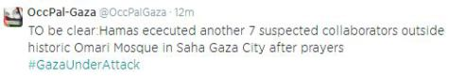
It’s important to note, that unlike ISIS, Hamas did not behead their victims when killing them. They shot some.
Apparently to some, this is a very important distinction.
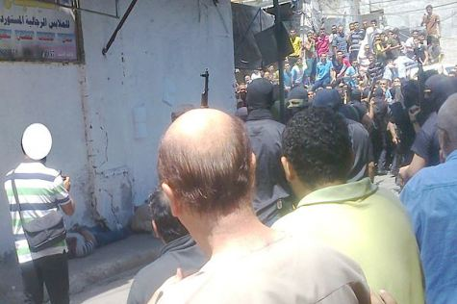
It is believed that this is a photo from the Friday afternoon execution outside a Gazan mosque. Source: Yoni Alper / Terror Watch
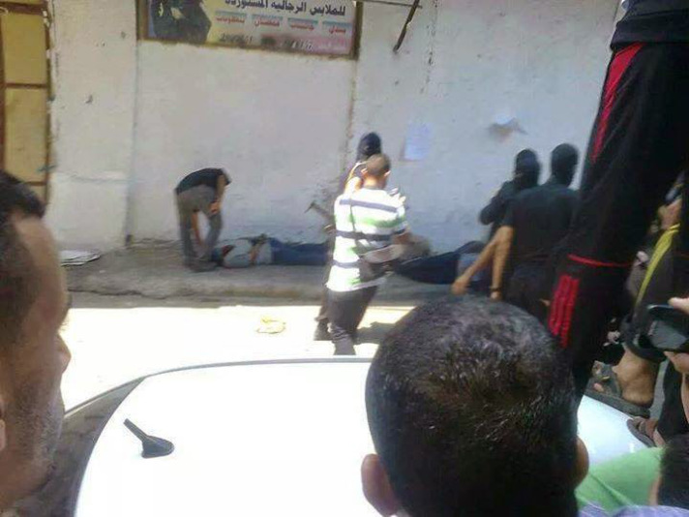It is believed that this is a photo from the Friday afternoon execution outside a Gazan mosque.

CORRECTION AND UPDATE The photos originally posted here originated from various Hamas supporter and affiliate site and pages.
We have removed them for the following reasons:
1) Photo was from an earlier execution, apparently by Hamas in Gaza, but a few years ago.
2) Photo was from a 2006 execution by Islamic Jihad in Jenin (Shomron).
3) Photo was an execution from a different Islamic conflict.
We thank our readers for helping us clarify the source of the photos, and to ensure the accuracy of our reports.

