**Poverty and racism: multidimensionality and implications for social policy**

Marcelo Paixão[1]

*(in memorian of Azoilda Loretto)*

This text was written to be presented in the Inter-Governmental Working Group to Follow-up Durban about the issue of racism and poverty

Geneva; October, 12nd and 13th, 2015.

**1. Introduction**

This text aims at addressing some reflections about the problem of racism and its relation to poverty in Brazil. We know that this version will be far from of definitive or complete. But we hope that it can advance some concerns about the intersection between these important issues as well as its effect on the public policies.

For several years, or decades, the most theoretical contributions to the problem of the poverty dealt with it as a simple problem of lack monetary resources by some families to get the minimum level of material goods, such as nurture or others basic needs. This approach leaded to public policy choices based on cash-transfers for those who were considered eligible to earn these funds[2]. However, nowadays, after a plenty of anti-poverty policies around the world, we are able to enlarge this conception, trying to incorporate into the analysis a more comprehensive approach, whether in this theoretical aspects, or in its normative terms.

Further, our main concern in this text will be how to include the problem of the ethnic and racial inequality, at least partially caused from the ethnocentrism and racism, into the social policy to combat poverty. Again, for several years, or decades, the main interpretations about ethnic and racial inequalities, at least in the Latin American region, were based on the *class approach*. As such, they understood that these injustices did not dialogue with the problem of the ethnic and racial relation. Or, in others words, this approach believe that some social problems of groups like Afro-descendant and Indigenous population are caused because they are mainly poor.

One of the main contributions to this debate came from the *marginality theory*. As such, the backdrop of the ethnic and racial inequality in Latin Americans nations would be their historical roots (slavery or servile society) and the current difficulties of these ones to modernize and become a *true* capitalist society. So, through the modernization process, some social structures, as well as inter-personal practices and behaviors, considered reminiscences of the colonial past, could be, finally, overcome. Accordingly, after those, the ethnic and racial inequality in the Latin American countries would be solved (Fernandes, 1971; Germani, 1980)[3].

A second way of interpretation to the problem of the ethnic and racial inequality in the Latin American region comes from the *Human Capital theory*. To this approach the cause of inequalities would verge from the uneven level of educational endowment of the individuals and its effects over the free market. So, the main option of public policy would be addressing policies to overcome the problem of accessing the educational system. As such, the ethnic and racial inequality would be solved for itself, or, in other words without taking into account the prejudice and discriminatory practices against Indigenous or Afro-descendant individuals. It is worthy to note that this theoretical conception is strongly pervasive nowadays, mainly inside the main multilateral institutions around the world (Marques *et allii*, 2007; Ñopo, 2012).

Actually, we believe that the set of these interpretations was rigorous and well framed. As such they are intrinsically valid. Nevertheless, on the other hand, we think that the main interpretations for the problem of the social, ethnic and racial injustice in Latin America share the same epistemological limit. They have been unable to cope with the problem of the racism and the ethnocentrism beyond as a superficial phenomenon of the social order.

In other worlds, in our point of view, racism and ethnocentrism are variables that bequeath social inequalities against social groups victimized from discriminatory practices. In short: in the current Latin American societies those who are Afro-descendant and Indigenous are not well treated because they are simply poor. Rather, they are poor because they Afro-descendant and Indigenous! So, in assuming this perspective, we must finally understand how several discriminatory practices present within the society produce, whether poverty, or the necessity of public policies to address it.

Relatedly to this approach we will be lead to incorporate in our analysis a multidimensional level of understanding.

In this brief reflection we will divide this paper into more two parts. In the second one, we will see some aspects of the current stage of the racial inequality in Brazil and how these ones overlapped the problem of the poverty in its multidimensional levels.

Brazil hosts the main Afro-descendant population around the world. In the same way, recently Brazil became well know around the world for his comprehensive policies for combating the poverty. So we could expect that the racial inequality had dropped in Brazil in the recent period and it actually did. But, we must recognize that this process have not been so straightforward or smooth as someone could expect. To accomplish this discussion we will take into account these accordingly variables: i) Human Development; ii) Cash-Transfer Programs to combat the poverty; iii) Violence indicators; iv) Labor market; v) Educational indicators; vi) Access to the political power.

Finally, in the last section, we will make some final remarks about this discussion and indicate eight lessons that we can take from the Brazilian experience of combating poverty and its relation with the racial inequality.

**2. Poverty and racial inequality: the Brazilian case**[4] [5]

The Latin American region is sorrowfully known to be one of the most uneven around the globe. Since the colonial past, this history has been indelibly characterized for the presence of the slave or servile forms of compulsory labor of Indigenous people and Afro-descendants. Since the independence in the 19th century and the process of modernization during the 20th century, the Latin American elites revealed a strong resistance in incorporating the offspring of these populations in their *National Imagination*,and so, denied to recognize them as a collective subject of rights (Graham, ed. 2006 [1990], Telles; Perla team, 2014). Nevertheless, as we have already commented, conversely, the main approach of understanding the Latin American inequality tended to overlook this aspect, adopting other ways of interpretation that overemphasize (or even only emphasize) the class aspect.

Nevertheless, since 1980s decade several new contributions have been coming into the debate, revealing the complex net involving the class and ethnic-racial relations in the Latin American region. We can assume that one of the main contributions to the debate have come just from Brazil (Telles, 2004).

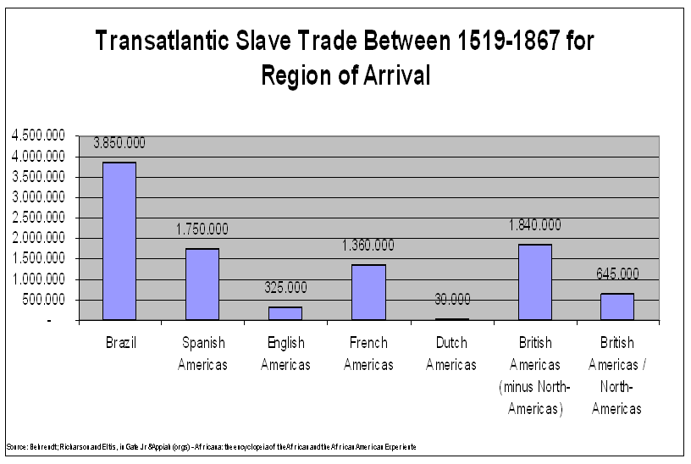

First of all, the Brazilian experience is important in our analysis due the historical presence of the Afro-descendant in the all country. It is estimated that between 16th and 19th centuries, about 3,8 millions slavered people reached the Brazilian shore. It would correspond at least to 40% of the total Africans slavered those were hijacked and brought into the Americas hemisphere.

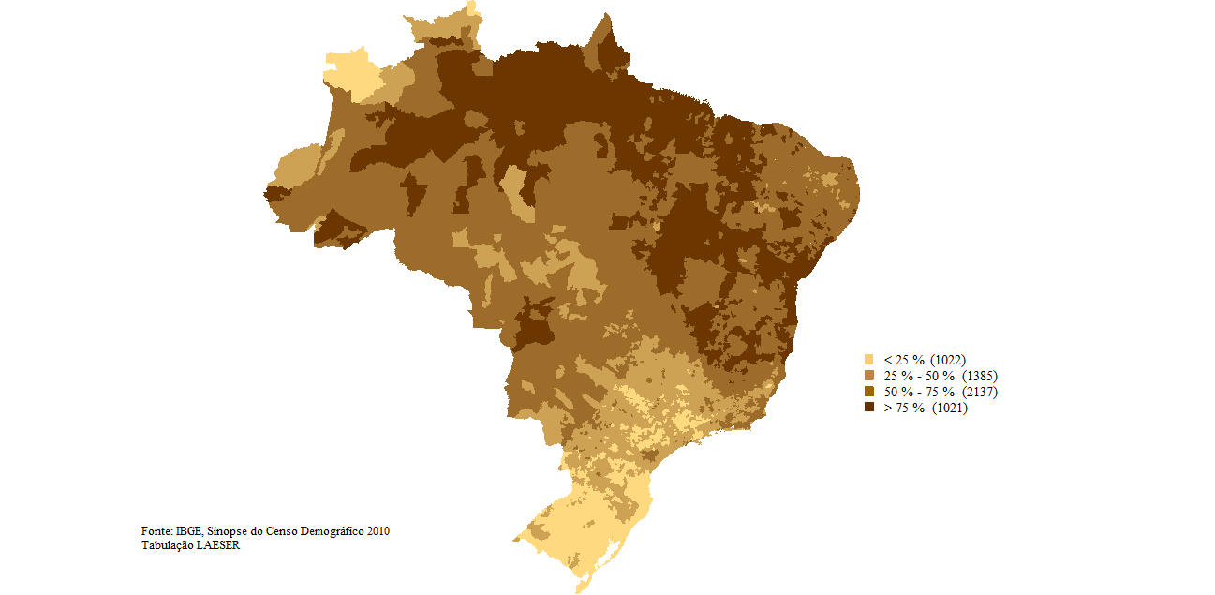

Nevertheless the remotest history, in accordance to last demographic Census (2010), Brazil nowadays host about 100 millions Afro-descendant people (considering those who declared themself as Black or Brown to the Census interviewers)[6]. This number is about 50 millions more than those of the Afro-American population. Brazil, actually, has the second biggest Afro-descendant population in the word, just after Nigeria. The racial makeup of Brazil is about 51% of Black and Brown altogether. Almost 20% of the Brazilian municipalities have more than 75% Black and Brown in their racial markup, and about 57% of those have more than 50%. So, this country is the only one in the Latin America (we are not including the Caribbean region) whose the majority of the population is Afro-descendant, in accordance to the Census data.

Notwithstanding the demographic data, the Afro-descendant presence inside Brazil is strongly pervasive in the realm of culture, religion, behaviors and several other form of national identity. However, despite of these, when we disaggregate the statistics for color or race it is easy to see the presence of deep level of racial inequalities inside the country.

**2.1. Human Development**

Human Index Development (HDI) is a synthetic index based on three sorts of variables: income, education and health. It is strongly rooted on the theoretical contribution of Amartya Sen (1999) and his canonic concept of *functionality*. This last is framed on the conception of *capability* that can be defined for the possibility that individuals have (or does not have) to undergo his or her life coherently to their wishes and personal appraisal of a *good life to be lived*. That is why so, as many as the material aspects (to get money, purchase power, etc.), the concept *functionality* includes personal assets like access to culture and to good conditions of personal health.

The Human Development Index (HDI) has been built framed on the conception of *functionality* and its multidimensional aspect (Sen, *op cit*). So, instead of classifying the development of the countries only based on income, the HDI incorporates two other ones variables: average of education and life expectancy at birth. So, after gathering these three indicators into the same one, the HDI is applied by the United Nations to classify level of development of the all countries of the world.

Although we know that HDI not imply a direct measurement of poverty, we can utilize it as a multidimensional indicator to assess the ethnic and racial inequality.



In 2010 the Brazilian´s HDI was 0,730 and this country sorted in the 85o position in the United National Development Program (UNDP) ranking. If the same country were inhabited just for white people he would increase his position to 66o position. If Brazil were inhabited only for Afro-descendant the rank of the country would drop to 103o position. Relatedly, in 2010, the HDI ranking distance between Brazilians whites and Afro-descendant would 37 positions.

In other words, based on the Amartya Sen approach, we may assume that the racial inequality is a way of *des-functionality* against his main victims, like Afro-descendants (and Indigenous as well)

**2.2. Cash-Transfer Programs to combat the poverty and violence indicators**

In this section we will analyze the evolution of the poverty among the Brazilian population (2003-2013) and the effects of some social programs to address this problem in Brazil. We will be using two different source of statistical information, one coming from Brazilian Institute of Geography and Statistics (IBGE) and the second one from Social Development Ministry (MDS).

From 2003 to 2013, the percentage of the population below the Poverty Line in Brazil intensively dropped. So, in that first year the relative presence of the poor was 25.8% of the population, whereas in the last one the same percentage had fallen to 9.8%. This trend repeated to each color or race group, whether for those were whites (from 16.2% to 9.8%), or those were Afro-descendants (from 36.4% to 13.1%).

In part, this recent advances in the poverty reduction was produced from the main cash-transfer policy in Brazil (or even in the world), called *Programa Bolsa-Família*. This Program provides financial aid to poor and indigent Brazilian families on condition that their children attend school and are vaccinated.

**Population under the Poverty Line, accordingly the Program Brazil without Misery, by color or race, Brazil, 2003-2013 (in %)**

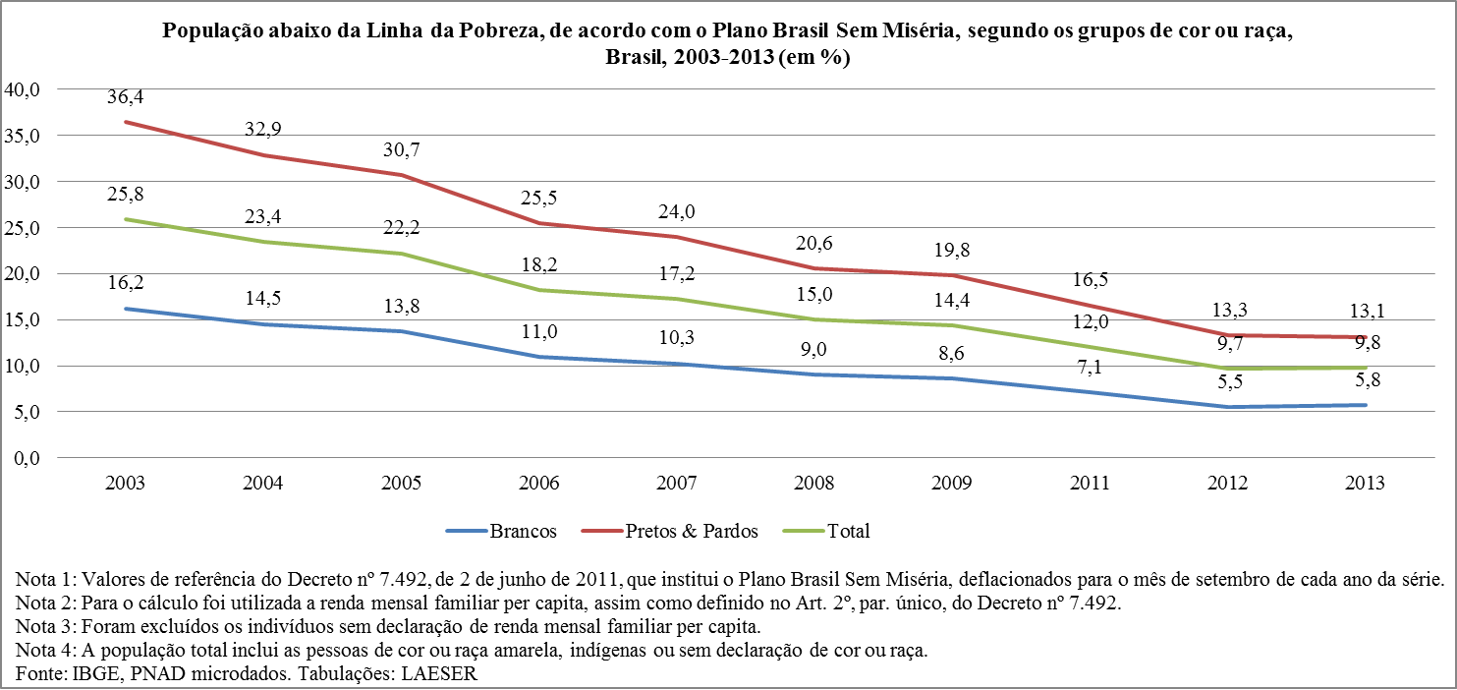

**Afrodescendant and white families receiving Bolsa Família, Brazil, February 2009 (in % of the total the families)**

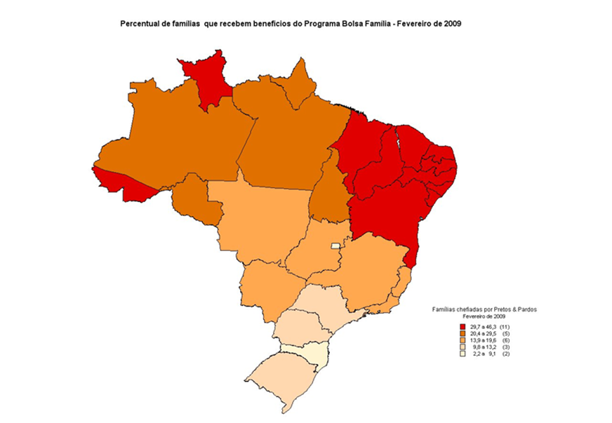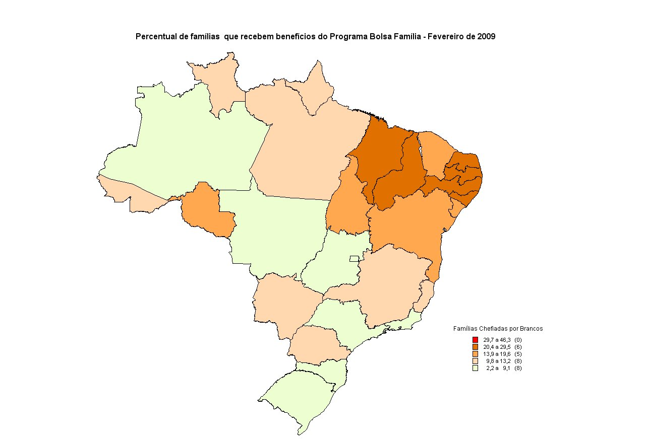

In the end of 2000 decade, almost 11 million families received some grant from that program. It is worthy to note that among them there were about 7,3 million Afro-descendants families receiving *Bolsa Família*. This number corresponded to 66.4% of all the beneficiaries. In the poorest Brazilian States (in general located in Northeast region), the percentage of Afro-descendant families those who received some support from this cash-transfer program ranged from 30% to 46%. The percentage of white families those who received the same benefit ever has been so expressive as the Afro-descendent ones. In all 26 Brazilian States, as well as in Brasilia, the percentages of Afro-descendants families who received cash-transfer program were bigger than those white families (see the contrast of color in the two maps above).

Actually, it is not easy to monitor a social program so comprehensive like *Bolsa-Família*. The variables at stake are several and the final outcome may be stage for many controversial. Even considering that the rate of poverty inside the Afro-descendant population in 2013 was more than twice than those white population (and just 3 percentage points below of the same data for those whites ten years before); if the main objective of some cash-transfer program is to reduce the poverty, so we do not have any doubt that the *Bolsa Família* reached an extraordinary success.

But, if instead of reducing the number of peoples with insufficient amount of money to get by, we pursue a more comprehensive outcome, maybe we can be lead to relativize some aspects of this final account.

**2.2. Violence indicators**

Between 1980 and 2012, the total number of homicides committed in Brazil increased from 13,910 to 56,337. This data revels that this country is so violent. But it is worthy to note that this violence is undeniable featured with the racial inequality.

In 2012 the probability of Afro-descendant man to be murdered was 128% higher than those of white man. Ten years before, in 2002, this difference was 63%. So this data reveals not just that the violence increased in the recent time, but that this is linked to the deepening of the racial inequality, mainly among young Afro-descendant male between 18 to 24 years old. Why did it happen? Or better, why does it still happen?

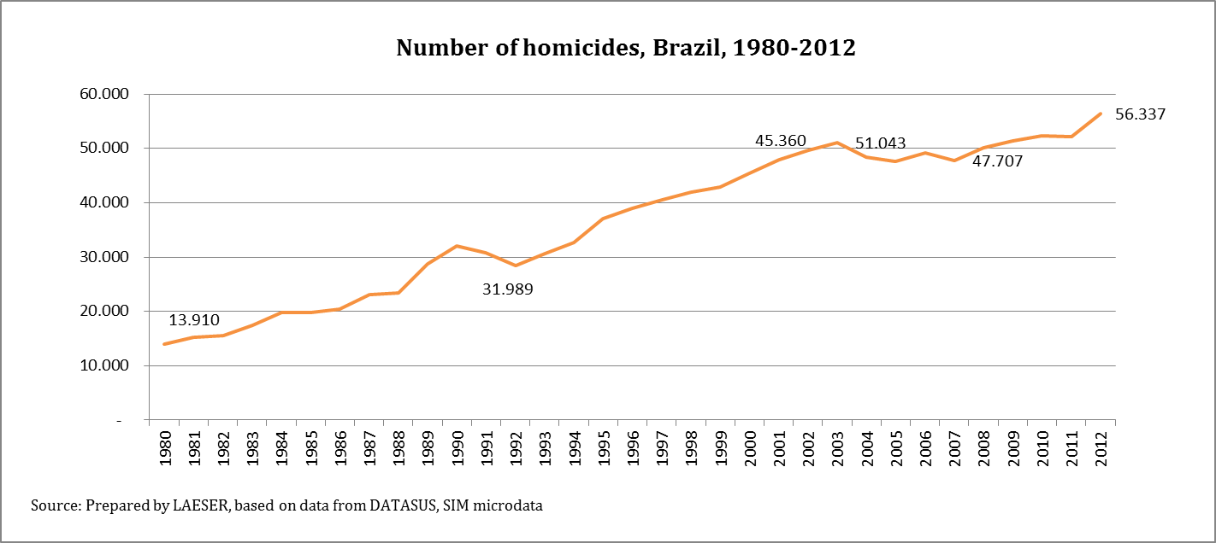

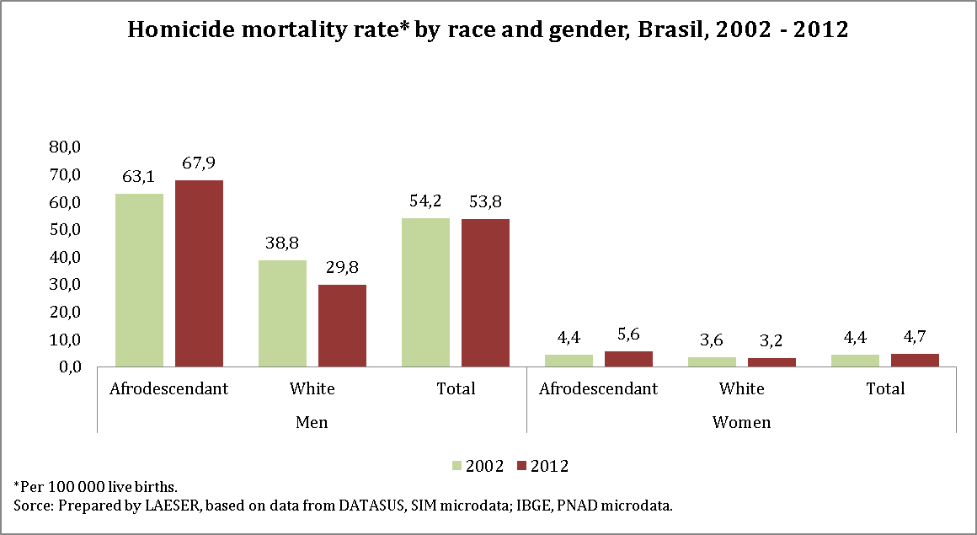

Nevertheless the brutality of these numbers, we think that the most impressive fact is that the homicide numbers in Brazil kept growing even after the beginning of the *Bolsa-Família*. We are highlighting this fact because it may contradict some voices that purely identify an association between the levels of the poverty and the violence. Rather, this correspondence was not present in the recent history of Brazil.

**2.3. Class structure and labor market**

Brazil is known around the world for his deep level of social inequality. Using the official sources we can see the share of inhabitants into deciles (equal number of inhabitants by deciles, ranked in accordance from the poorest to the richest). In doing so, we realize the closed relation between the class, gender and color or racial line in Brazil.

Actually, the graph below is very rich in details and it will not be possible to make a deep comment about these. But, in short, from this one, we see that the Afro-descendants represent 25% within the 10°decile (the poorest), and 70,3% within the 1° decile (the richest). The most striking is that up to 5o decil (poorest), the mode of the distribution was exactly the Afro-descendant woman.

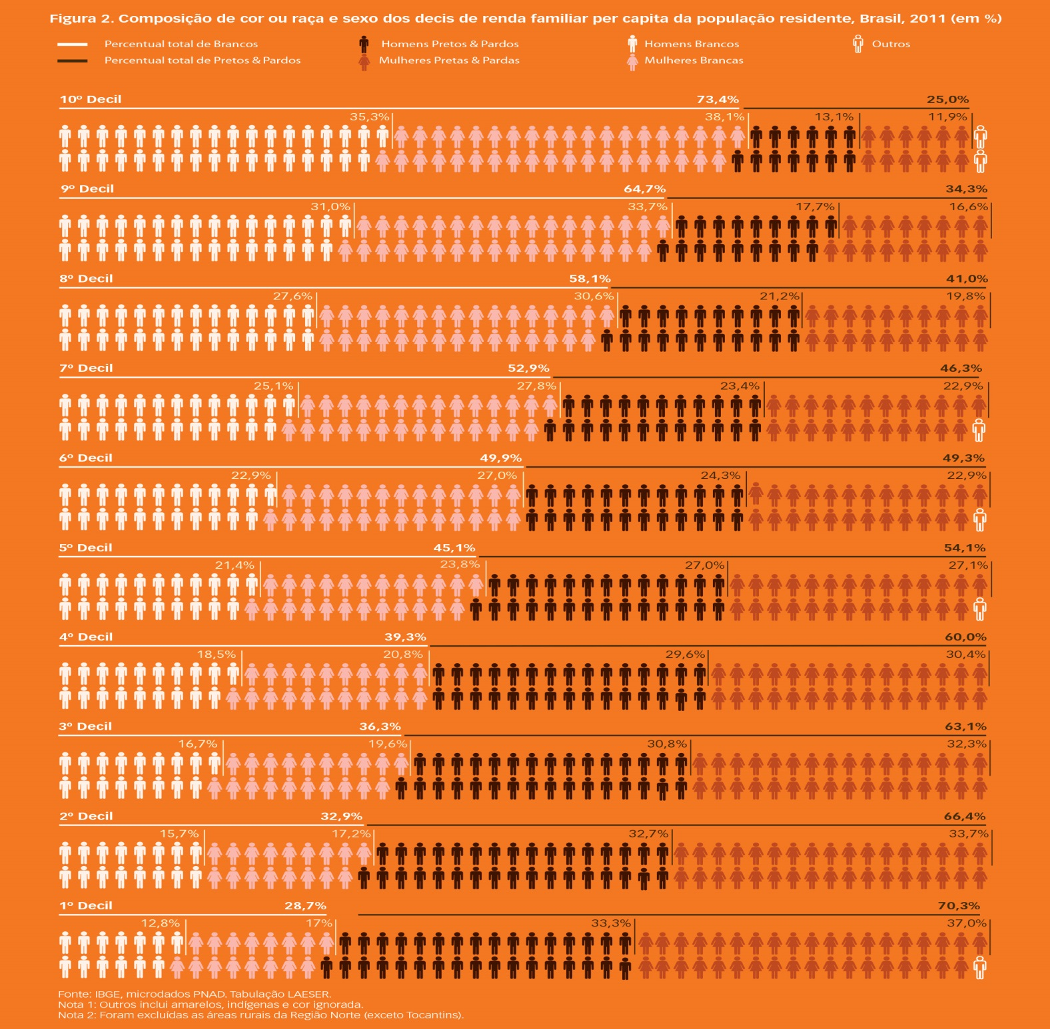

When we study poverty it is also important to include in the analysis the labor market structure. To the big majority of the families the main source of the monetary funds usually comes from the wages, salaries and incomes earned in some occupational activity. Also, the labor market includes some parallel dimensions, mainly the social prestige of individuals and families in the society as whole. It is because the set of occupational activities necessarily will include whether the status attached to each occupation; or correspondents levels of responsibility, command and access to some professional associations and trade unions (Weber, 2009).

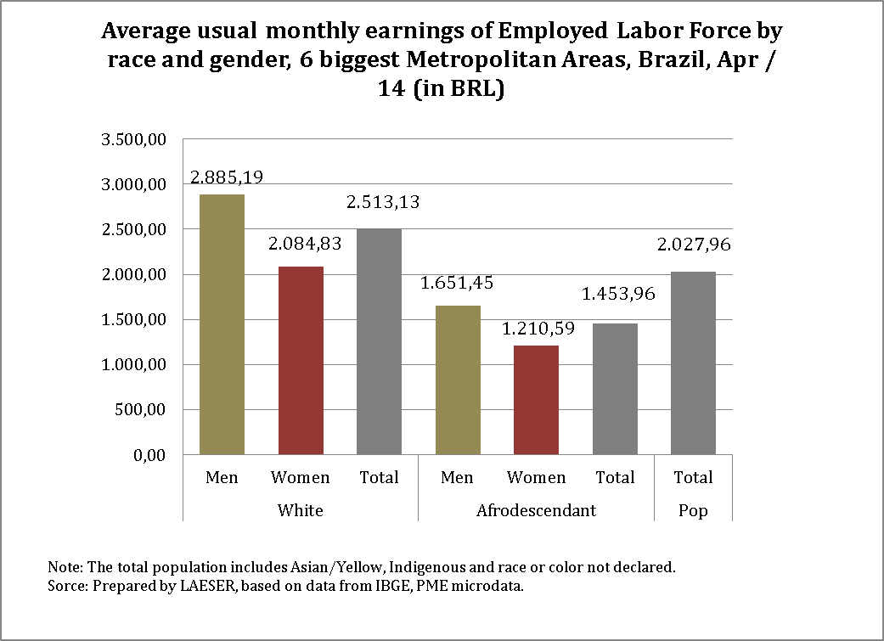

In the beginning of 2014, in the 6 biggest Brazilian Metropolitan Areas, the white man earned about R$ 2,9 thousands. This amount was 38% than those white female, 75% than those an Afro-descendant male and 138% bigger than those an Afro-descendant female. In this same period, the earnings of both sexes whites employed labor force were 73% higher than Afro-descendant ones

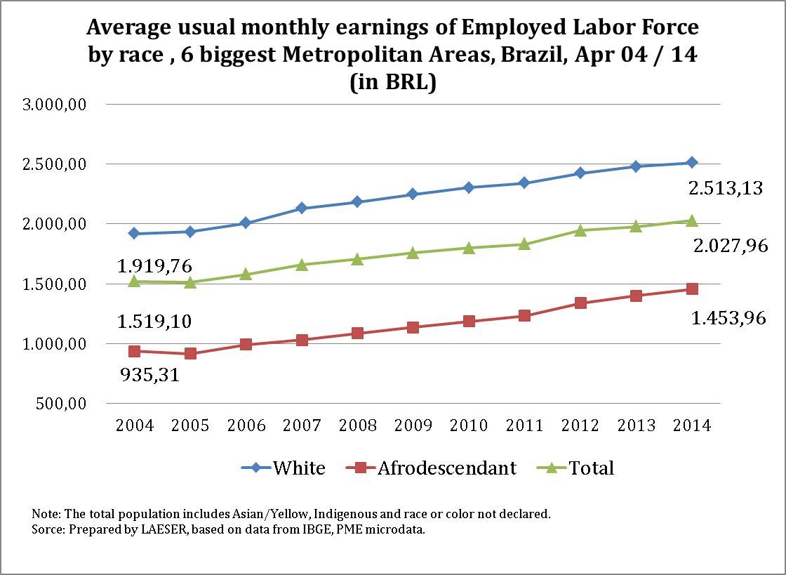

On the other hand, between 2004 and 2014, the earnings of Afro-descendant labor force increased 55%. In the same period, the increase of the white group was 31%. So, in the last decade the racial inequality of labor income decreased in Brazil.

There are many variables that could be utilized to explain the reason of this trend into the reduction of the income racial inequality in the Brazilian labor market. For one hand, in its structural aspect, we could include the recent transformations (at least since 1990s) of the Brazilian economy toward whether his re-primarization (raw material exportation-based), or the opening of the domestic market to foreign competition. In both case, we can hypothesis that the male whites workers – traditionally the most privileges in the labor market - might have suffered the main effects of the globalization. But, it is also arguably that some institutional decisions made by the Brazilian government helped to the recent reduction of the racial inequality in the labor market, mainly the valuation policy of minimum wage, whose amount is decided by the policy makers. Between 2003 and 2014 the minimum wage real valuation in Brazil was about 75%. In 2000, about 1/3 of Afro-descendant labor market receive just this amount (the whites workers those received the same level of earing was less than 20%) (Paixão *et alli*, forthcoming). So, this aspect could help us to understand what have being happening during this recent time.

Some voices could claim that the minimum wage valuation is a typical universal policy and for this reason such orientation is more efficient to reducing the racial inequality. About this topic, we would like to address two comments.

First of all, it is important to see that if it is true that the recent valuation of minimum wage was important to diminish the racial inequality, on the other hand, it is also important to notice the limits of this kind of policy. The real amount of the labors earn does not depend just on its nominal value. We need to include the purchase power, and this one is determined too by the inflation rate, as well as other economic variables like the employ level and economic growth rate. So, even we can recognize the importance of some universal policies to reduce the racial inequality, we must recognize at the same time their limits. The acceleration of the inflation or unemployment rate can put under risks some recent conquests.

The second aspect of this question is about the role of affirmative action in the labor market as a path of reducing the racial inequality. Rather than simply adopt the income average as a way to calculate the racial inequality in the labor market (or in the social structure as whole) we should include others important structural variables like the kind of employ and occupation usually undertaken for each racial group.

Accordingly the 2010 Census, the percentage of Afro-descendant working as lawyers was 24.5%; physicians, 23.5 and engineers, 23.1%. In the same year the presence of this group in the Economically Active Population (EAP) was about 50%. Others sources indicate that the relative share of Afro-descendant working as manager, supervisors or chairs of the biggest Brazilian company was about 5% (Instituto Ethos, 2010). Actually, in recent days we do not have yet plenty of public or private experiences of affirmative action to Afro-descendants in the labor market to give as example.

Anyway, in our point of view, the problem of the racial inequality in the Brazilian social structure, as well as in the labor market, are not just linked to this structural aspect. It seems to be associated to the presence of the racial discrimination in the labor market. Without taking into account this aspect we are skeptical that it will be possible to give large steps to address the problem of the racial inequality in the Brazilian labor market.

**2.4. Educational indicators**

In the last decades the Brazilian government´s effort to universalize the access to the basic level of education were worthy. For example, in 1988, the relative numbers of children between 7 to 14 years old who dropped out the school was about 15%. Twenty years later, in 2008, this percentage fell to 2%. Among the young between 15 to 17 years old this relative number was less expressive, but even so it was noticeable. Between 1988 and 2008, from 45% to 15%.

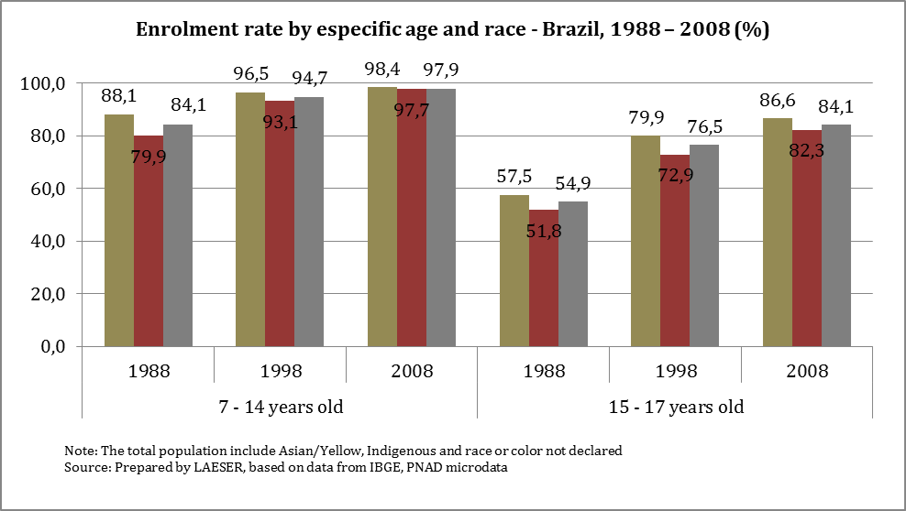

Accordingly, during the same period, the racial inequality of education decreased intensively. So, among those who were between 7 to 14 years old the difference among whites and Afro-descendant dropped from 8 percentages point (pp.), in 1988, to 0.2 pp., in 2008. Between those were between 15 to 17 years old the same difference went down, from 5.3 pp., in 1988, to 4.3, in 2008.

Although this evolution has seemed to be so strikingly, we must pay attention to other indicator about the same issue. The rate level of children and young in determined age who were at the same time in the school and in the expected grade (we will call this indicator as adequacy rate).

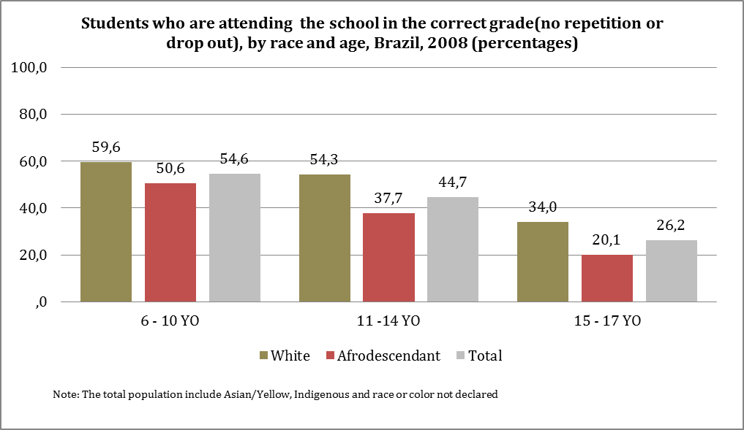

In Brazil we expect that a child of 6 years old attend the first year of the fundamental level and so on up to 14 years old when we expect that this one attend the 9th year. In the high school we expect that a young of 15 years old attend the 1st year of this level of schooling and so.

In 2008 the relative presence of children between 6 to 10 years old attending the expected year of school was 54.6%. These relative numbers dropped to 44.7% among those were between 11 to 14 years old; and into just 26.2! among there were between 15 to 17 years old. These indicators prevent us to be so optimist as we could be after analyzing only the enrollment rate.

In all brackets of age we watch racial inequalities in the adequacy rate. So we do not need to make any specific comment about these in each range. Nevertheless, it is worthy to note that, in 2008, among Afro-descendants children and young those were between 6 to 10 years old, the percentage was 50.6%; between 11 to 14 years old, 37.3%; and between 15 to 17 years old, only 20.1%.

So, we believe that we can get another lesson from this indicator and its trends. Absolutely, it is very important to guarantee the access to the children and young to the school. But it is also true that we need to guarantee the school quality and capability of preparing the students to get outstanding attainment. Also, when we reflect about the racial inequality, more than treat the all students as if they are as shapeless mass, the policy markers should pay attention to their differences and difficulties to improve their attainments. And it includes the method that each school will have to address the problem of the racism in the school environment and its negative effects.

**2.5. Access to the political power**

Since the beginning of this article we are trying to adopt a multidimensional approach to debate the relation between the poverty and the racial inequality. As such, we will include into our reflection the political aspect of the poverty. We will use as an example the outcomes of the last Brazilian election to the National Deputies Chamber.



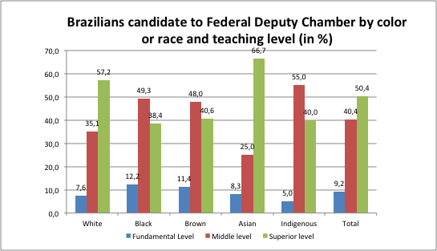

In the most recent Brazilian poll, accomplished in 2014, among the 517 Federal Deputies elected, the percentage of those were white man was 72% and the percentage white woman was 8%. So, this color or racial group, who perform about 48% of the Brazilian population, got elected 80% of the Brazilian national congress. In the other hand, those were Afro-descendants got elected only 20.1% of the Federal Chamber. The Afro-descendant woman just 2%!

Actually, the politician in Brazil has as specific gender, color or race and level of education. So, more than 50% of the total candidates had up to high school level. More than the half had superior level (among those were whites this percentage was close to 60%).

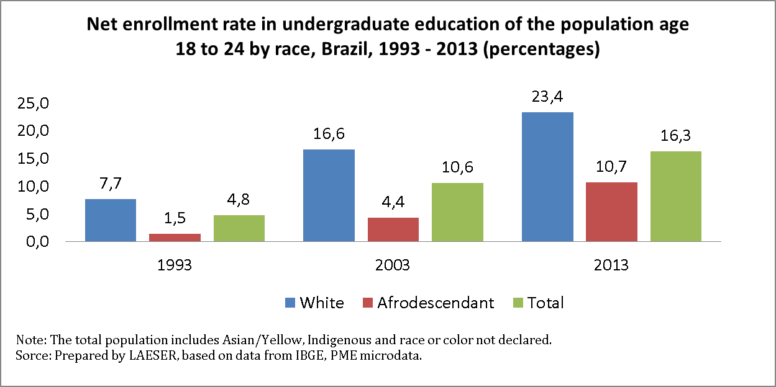

Finally, when we see the net enrollment rate among Afro-descendants in the undergraduate education (between 18 to 24 years old) we notice that, in 2013, less than 11% was attending this level of schooling. Among those were whites this proportion was more than twice.

Naturally, we would have a lot of questions to comment about these social, racial and gender profiles of the political participation in the Brazilian political life. For reason of space we will not able to do this, although it seems evident that as less the presence of some specific group within the political system as little will be their capability to be influent over the policy and policies makers. As such, inevitably, their problems, demands and claims will tend to be downplayed by the political system, if not, simply, hidden or forgotten. Like it seems to be in Brazil.

**4. Final remarks**

In this text we tried to debate the relation between the poverty and the ethnic and racial inequality, whether in terms of it conceptual aspect, or in terms of the normative one and its implication to the social policy. We are definitively sure that these words was only a generic reflection, but we also believe that we can use this current reflection at least to produce new paths of a most profound document about this issue in the future.

Nevertheless, from the indicators commented at the long at this text, we expect to have got some lessons from the Brazilian recent experiences about programs of combating the poverty. We will list it below framed on eight *lessons*.

*First lesson:*

From the *Bolsa-Família* experience we recognize that a cash-transfer program can reduce the material level of poverty and the poverty among the historically discriminated group depending on their scope, level of comprehensiveness and amount transferred to the target population.

*Second lesson:*

The anti-poverty program will be able to be better succeeded in reducing racial inequality if it is linked to pro-poor economic growth model. However, if this program is limited only to improve the purchase power of some target–group, this one may be vulnerable to suffer a retreat when the economy and institutional context come into worsening.

*Third lesson:*

All anti-poverty programs should include in their scope the objective to help to overcome the ethnic and racial inequality. As such, they need to recognize the specificities of each group of the society and their specific needs and difficulties to be overcame.

*Fourth lesson:*

The anti-poverty program to historical discriminated group will be better succeeded if they are be able to change the structural presence of these group in the social pyramid at least in terms of education, labor market and to the political empowerment.

*Fifth lesson:*

The anti-poverty program based on cash-transfer never should be charged if they do not solve some parallel social problems like violence, education, health or labor market quality. But it will be impossible to monitor it without using these more comprehensive, or multidimensional criteria. As such, the matter that *Programa Bolsa-Família* in Brazil arose and thrived at the same time in which the violence rate growth (and the racial inequality in this indicator as well) prevents us to recognize it as well succeeded.

*Sixth lesson:*

To combat the material poverty is very important, but it is not an objective for itself. We must recognize other forms of poverty based on political, symbolic and sociocultural aspect. Using these whole variables, maybe even in the context of income increasing the poverty may be growing at the same time. *Quilombola* or Indigenous traditional communities expelled from their land, for example. This population will be ouster to the city, their monetary income will increase there, but even so they can be poorer than in the past.

*Seventh lesson:*

When we build an anti-poverty strategy we must pay attention to the level of diversity among historically discriminated group in terms of gender, age, sexual orientation, cultural affiliation among others possible variables.

*Eight lesson:*

The cash-transfer program will be most well succeeded if it is able to bequeath structural changes in the insertion of historically discriminated group into the social pyramid. From the recent trends of educational indicators in Brazil we can see that so important to universalize the enrolment rate, is to guarantee correspondent level of quality and actions of combating racial inequality into the school environment.

*Ninth lesson:*

It will be almost impossible to combat the poverty and overcome ethnic and racial inequalities without having tolls of monitoring these policies. That is why it is so important that the countries produce good statistics and include the ethnic and racial categories inside it.

*(Austin-EUA, Paris-France, fall 2015)*

**5. Bibliography quoted**

Behrendt, S. – Transatlantic slave trade. In Appiah, K; Gattes Jr, Henry – **Africana: the encyclopedia of the african and african american experience. [s.l.] Basic Civitas Book., 1999 (pp. 1865-1877)**

Esping-Andersen, G. – **The three worlds of the Welfare State**. Princeton, NJ: Princeton University Press, 1990

Ferranti, D.; Perry, G.; Ferreira, F.; Walton, M.. **Inequality in Latin America: breaking with history?.** Washington D.C. The World Bank, 2004

Fernandes, F. **The Negro in Brazilian society**. New York: Columbia University Press, 1969. (Chapter 2, pp. 55-130; if possible, please read Chapter 3, pp. 131-186)

Gino G. **Marginality**. New Brunswick, N.J.: Transaction Books, 1980. (Part II, pp. 49-90)

Graham, R. (ed.) – **The idea of race in Latin American, 1870-1940**. Austin, Texas: Texas University Press, 2006 [1990]

Friedman, M. – **Capitalism and freedom**. Chicago / London: Chicago University Press, 2002 [1962]

Hasenbalg, C. “Race and socioeconomic inequalities in Brazil”. In: Pierre-Michel Fontaine (Editor). **Race, class, and power in Brazil**. Los Angeles: Center for Afro-American Studies, University of California, 1985

Instituto Ethos - **Perfil Social, Racial e de Gênero das 500 Maiores Empresas do Brasil e Suas Ações Afirmativas, 2010.** In www3.ethos.org.br

LAESER / UFRJ - **Tempo em Curso: Publicação eletrônica mensal sobre as desigualdades de cor ou raça e gênero no mercado de trabalho metropolitano brasileiro - Especial Eleições 2014: A cor ou raça d@s deputad@s federais eleit@s**, Ano VI; Vol. 6; no 10, Outubro, 2014.

Marques, G.; Chong, A.; Duryea, S.; Mazza, J.; Ñopo, H. (coords.) – **Outsiders? The changing patterns of exclusion in Latin American and Caribbean**. Washington D.C: Inter-American Development Bank, 2008

Nobles, Melissa. **Shades of citizenship: Race and the census in modern politics**. Stanford, CA: Stanford University Press, 2000

Ñopo, H. – **New centuries, old disparities: gender and ethnic earnings gaps in Latin American and the Caribbean**. Washington D.C.: IDB, 2012,

Paixão, M. – **500 anos de solidão: estudos sobre as desigualdades raciais no Brasil**. Curitba: Appris, 2013

Paixão, M.; Rossetto, I. - Levantamento das fontes de dados estatísticos sobre a variável cor ou raça no Brasil contemporâneo: terminologias classificatórias, qualidade das bases de dados e implicações para as políticas públicas. In: **Anais do 35º Encontro Anual da ANPOCS**, Caxambu (MG), 2011.

Paixao, M.; Rossetto, I.; Monçores, E.; Carvalho, E. – **Relatório anual das desigualdades raciais no Brasil, vol 3**. Forthcoming.

Pierson, Donald. **Negroes in Brazil; a study of race contact at Bahia**. Chicago, Illinois: The University of Chicago Press, 1967 (Chapter XI, pp. 321-350)

Sen, A. – Development as freedom. New York: Alfred A. Knopf, 1999.

Telles, E.. **Race in another America: the significance of skin color in Brazil**. Princeton / Oxford: Princeton University Press, 2006 (chapters 5 and 6, pp. 107-172)

Telles, E; PERLA research team - **Pigmentocracies: ethnicity, race, and color in Latin America**. Chapel Hill, NC: University of North Carolina Press, 2014

Pierson, D. - **Negroes in Brazil: a study of race contact at Bahia**. Chicago, Illinois: The University of Chicago Press, 1967

Wagley, C. - **Race and class in rural Brazil**. Paris: UNESCO, 1952.

Weber, Max. “Class, status and Party”. In: **From Max Weber: essays in sociology**. New York: Routledge, 2009

1. Associate Professor, University of Texas at Austin, marcelopaixao@utexas.edu
2. We know that in 2nd Post-War experience of public policies around the developed countries had several specificities. Esping-Andersen (1990) would classify these differences through the level of *de-commodification* of the labor market. Nevertheless, since 1960s authors like Friedman (2002 [1962]) suggested cash-transfer policies would be the best solution to combat the poverty based on principles of efficiency of public expenditure, as well as reduction of the bureaucracy of State. With some variances this conception was fundamentally adopted from multilateral institution like Word Bank and Inter-American Development Bank (IDB) and recently in several countries of Latin America, mainly in Brazil (Ferranti el allii, 2004).
3. It will be almost impossible to debate the history of the racial relations in Brazil without taking into account the influence of the Brazilian sociologist Gilberto Freyre. So, during the 20th century, the idea that Brazil sheltered a *racial democracy* (in other word, a country where the racial groups are used to lived harmoniously together) was so pervasive not just in its cultural aspects, but, also in the economics and political realm. It is also important to recognize important contributions to the debate of racial inequality in Brazil like Pierson (1967 [1942]) and Wagley (ed., 1952). These set of authors also believed that the problem of the racial inequality in Brazil were not created from prejudicial practices against blacks, but due class discriminations. Although there are a plenty of differences between Freyre, Pierson and Wagley and the marginality theory it is undeniable that they converge in the sense that the ethnic and racial problem in Brazil were produced from class inequalities.
4. Since the beginning we must apologize because due statistic significance we were now be able to include in our analysis the data of the Brazilian Indigenous population.
5. The social indicators presented in this section have been produced based on the LAESER/UFRJ database collection.
6. In Brazil, since the colonial period, the ethnic-racial markup of population is based on the color criteria: white, black, yellow (Asian) and brown. It is worthy to note the Indigenous category was included just in 1991 Census. So since then, the IBGE (statistical institution of Brazilian government) interviewers ask for “which is your personal color or race”. To understand the history of the racial statistics in Brazil see Nobles 2000, Paixão, Rossetto, 2011; Paixão; 2013).