On Afghanistan, UN Says There Never Was a Super-Envoy, UK Cites Misunderstanding of Talks with Taliban
By Matthew Russell Lee
March 26, 2008
The Inner City Press
Original Source: http://www.innercitypress.com/un1afghan032608.html
UNITED NATIONS, March 26 -- As up to 40% of aid money to Afghanistan is repatriated to donor nations or never leaves their borders, the UN's role in the country is riddled with misunderstandings and, according to the UN spokesperson, "press myths." Wednesday at UN headquarters, Inner City Press asked Ban-Ki-moon's spokesperson Michele Montas for any UN reaction to reports of aid diversion for and non-delivery to Afghanistan. While expressing "concern," Ms. Montas said there would be no comment on "that NGO position." Inner City Press asked if aid waste might have been the type of issue that the "super-envoy" proposed by the UN (as well as UK and United States), but rejected by President Karzai, might have addressed. "There was never a question of a super envoy," Ms. Montas said. "That was a press myth. There was going to be an envoy, and he is there now." Video here, from Minute 18:56. When Inner City Press asked if the position's powers were in any way reduced from what was first proposed, Montas said no, "this is the same mandate that had been talked about."
This may come as a surprise to those in or who cover Kabul, given reports about President Karzai's veto of Paddy Ashdown and clipping the wings of the mandate. Relatedly, Karzai expelled from Afghanistan the UN's Melvyn Patterson and EU's Michael Semple, for allegedly carrying money to negotiate with the Taliban. On March 20, Inner City Press asked UK Ambassador John Sawers about the two men and their status. Amb. Sawers said there are been a lot of "misunderstanding" about the two men's roles, that what they had done had been "fully briefed to the Afghan authorities.. everyone who needed to know," and that the UK hopes they can soon return to the country. Video here, from Minute 4:55.
But what seems clear is that while the UN's post-Ashdown, "non-super" envoy Kai Eide may for example be authorized to speak with Iran, he cannot speak with the Taliban. This despite the UN's position that it speaks to anyone, to get its work done. The UN is misunderstood, yes. But often it has only or mostly itself to blame.
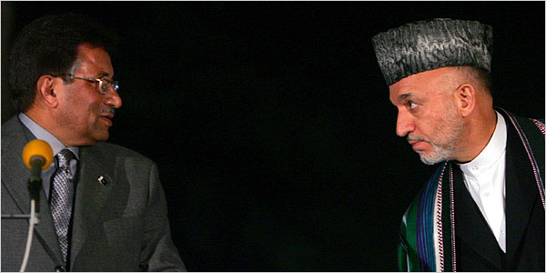
Hamid Karzai and Pervez Musharraf in stare-down, two expelled diplomats and super-envoy not shown
On Afghanistan's neighbor to the east, Ban Ki-moon on Wednesday spoke with Pakistan's new prime minister, including about a request for a UN investigation of the murder of Benazir Bhutto. Ban's spokesperson Michele Montas said that in the call, it was said that the next step is an act of parliament in Pakistan. Any request, she said, will be passed on to the Security Council. But while the setting up of a tribunal, like the one in The Hague for Hariri, would require Security Council action, is there nothing in the nature of investigative help that the Secretariat could consider giving without Council action being required? For example, if the UN helps to investigate a crash, does that require Council consideration and approval?
Speaking of crashes, Inner City Press on Wednesday asked Ms. Montas about two separate crashes: one in November 2007 in Liberia, and another, just-happened, in Darfur, Sudan. While Ms. Montas said she had addressed the Darfur crash, that appears to be in reference to attacks on UN (World Food Program) drivers. The crash was by the UN, into a bus, killing civilians. Ms. Montas said she would seek and provide more information about the crash in Darfur, and Inner City Press has asked the UN Mission in Liberia and its Office of Legal Affairs about the other claim. Watch this site.

