In Nepal, Another Death Tied to Downing of UN Copter, ID and Term of Contractor Still Withheld
By Matthew Russell Lee
March 10, 2008
The Inner City Press
Original Source: http://www.innercitypress.com/un6nepal031008.html
UNITED NATIONS, March 10 -- While the UN Mission in Nepal only had a mandate of one year, it reportedly entered into a three year contract for helicopter services with Vertical T, a Russian firm to which the UN has given over $127 million in business, it emerged on Monday. A week ago, Inner City Press asked the UN in New York to disclose the identity of its contractor for the helicopter downed on March 3, killing ten. The UN has yet to provide the name.
On March 7, the UN told Inner City Press it apologized for an "altercation" with media in Nepal, claiming this was only to prevent filming of dead bodies. The UN subsequently bought advertising in media throughout Nepal to deliver this apology -- or, as local sources say, to try to buy off the journalists' associations which had criticized the UN's behavior. A local paper reports that following the alleged suicide of the Russian engineer associated with the helicopter, UNMIN personnel arrived to seal off the dead engineer's apartment: "a foreigner sporting identity cards of UNMIN... visited the house and instructed security guards not to let any one in except UNMIN staff and the police personnel." Questions are multiplying, and from the UN Spokesperson's office, there have been no answers forthcoming.
Early on March 10, Inner City Press asked the UN Spokesperson's Office to comment on a local story which reported that "Vertical T was contracted for hiring two helicopters, which were flown in from Entebbe in Uganda to Nepal in April 2007, incurring a substantial transportation cost. Then, inexplicably, the two choppers were flown out of Nepal in December 2007 to Khartoum in Sudan, adding to the expenses. Around that time, two more choppers were brought to Nepal from another Russian company, Aviacon Zitotrance."
More than 12 hours later, the UN Spokesperson's office had not provided any response, despite the fact that procurement information is available at UN Headquarters in New York. Inner City Press' research reveals that Aviacon Zitotrance is an operator of IL-76s, which can transport helicopters (but which does not usually operate them). Aviacon Zitotrance also has contracts in the UN system with, among others, the World Food Program.
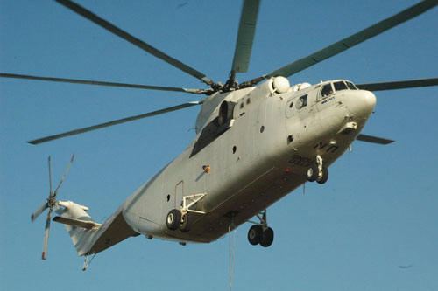
Vertical (or Vertikal) T in action
News analysis: the ten, now eleven, deaths are tragic. The dead are not served by silence, much less cover-up. There is no reason that the UN in New York cannot disclose to which company they had given the Nepal helicopter contract, and for how long. In fact, Inner City Press has asked, early Monday, what happened to the confiscated footage of the crash site. The inquiry will continue. Watch this site.

