US, EU Ask UN to Consider New Burma Sanctions

26 September, 2007
VOA News
Original Source: http://voanews.com/english/2007-09-26-voa40.cfm

The United States and the European Union have asked the United Nations Security Council to consider placing additional sanctions on Burma.
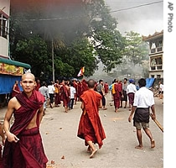
Buddhist monks take to the streets of Rangoon, Burma, 26 Sep 2007
Following a meeting Wednesday on the sidelines of the U.N. General Assembly in New York, EU and U.S. ministers released a joint statement. In it, they called on Burma to stop using violence against protesters and to open dialogue with pro-democracy leaders.
The U.N. Security Council is scheduled to meet this afternoon to discuss the crisis in Burma.
Ahead of the meeting, U.N. Secretary-General Ban Ki-moon announced that he will send special envoy Ibrahim Gambari to Burma on an urgent mission to look into the situation. Mr. Ban urged Burmese leaders to use the utmost restraint toward peaceful protesters.
U.S. and European leaders Wednesday called on China to use its influence to press Burma's military regime to open a dialogue with opponents.
Chinese officials said Tuesday that China would stay out of Burma's affairs. But reports suggest China may be engaging in quiet behind-the-scenes diplomacy.
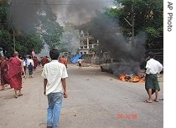
In this photo released by the Democratic Voice of Burma, fires burn on streets of Rangoon as demonstrators and Buddhist monks take to the streets, 25 Sept 2007
Also Wednesday, U.N. human rights chief Louise Arbour urged Burma's government to abide by international laws allowing peaceful expression of dissent.
French President Nicolas Sarkozy joined other world leaders in condemning the crackdown. Following a meeting Wednesday with Burmese opposition politicians, Mr. Sarkozy urged French firms, including oil giant Total, to refrain from making new investments in Burma.
Earlier, France's European Affairs Minister Jean-Pierre Jouyet urged the European Union to impose stronger sanctions on Burma's government.
A U.S. House of Representatives Foreign Affairs Committee approved a resolution Wednesday calling for the immediate and unconditional release of opposition leader Aung San Suu Kyi.
On Tuesday, the United States announced new sanctions against Burma's generals, their supporters and families.
Italy's prime minister, Romano Prodi, called on the EU to hold an urgent meeting on the situation in Burma.
The EU earlier warned it would "reinforce and strengthen its sanctions" if the protests are put down by force.
But Russia, a veto-wielding permanent member of U.N. Security Council, took a different position on the protests. The Russian Foreign Ministry called interference in Burma's internal affairs counterproductive.
Some information for this report was provided by AFP, AP and Reuters

