Palestinian UN diplomat caught on tape glorifying children's rock throwing
Palestinian Media Watch
By: Itamar Marcus & Nan Jacques Zilberdik
February 20, 2018
http://www.palwatch.org/main.aspx?fi=157&doc_id=25080

A recording surfaced last week of a Palestinian diplomat, Abdallah Abushawesh, member of the Palestinian Authority delegation to the UN, telling a group of students from Canada: "We are very clever and very expert at throwing the stones," as well as: "We are very proud that we are stone throwers. I'm one of them." Following is a transcript of the recording:

"We are very clever and very expert at throwing the stones. We are very proud to do that. We will not stop to learn our kids. We are very proud to say that every catching a Palestinian throwing a stone we go to the jail. We are very proud that we are stone throwers. I'm one of them. Now I became a little bit older, but I still resist in the name of my kids."
[Ynet, Feb. 13, 2018]

It does not come as a surprise that a Palestinian UN diplomat openly praises rock throwing. Palestinian Media Watch has documented that the PA and Fatah openly encourage rock throwing. For example, a poem in a Palestinian youth magazine partially funded by the PA teaches children that throwing rocks at Jews is something mandated by Muhammad, Islam's Prophet.

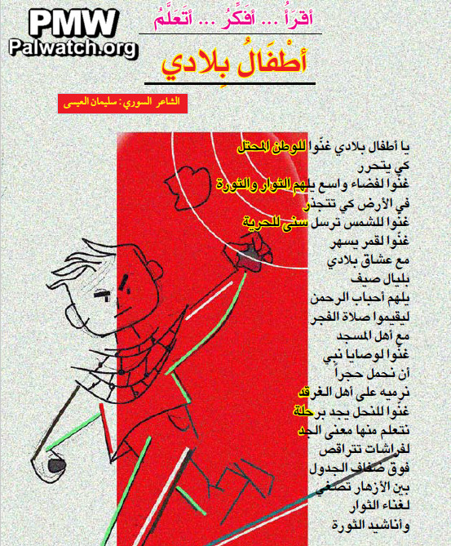

The following lines were part of the poem printed in the magazine's October 2017 issue together with the image above of a kid throwing rocks:

"O children of my country, sing to the occupied homeland so it will be liberated...
Sing by the order of Prophet [Muhammad] that we carry a rock
that we will throw at the people of the Gharqad [tree]"
[Zayzafuna, October 2017]

That Jews are the intended target is clear from the reference to the Gharqad tree - "the tree of the Jews." According to Muslim tradition Jews will try to hide behind the Gharqad tree when the Muslims come to kill them on Judgment Day.

Abbas' Fatah Movement published a guide to rock throwing for kids on its Twitter account last December:

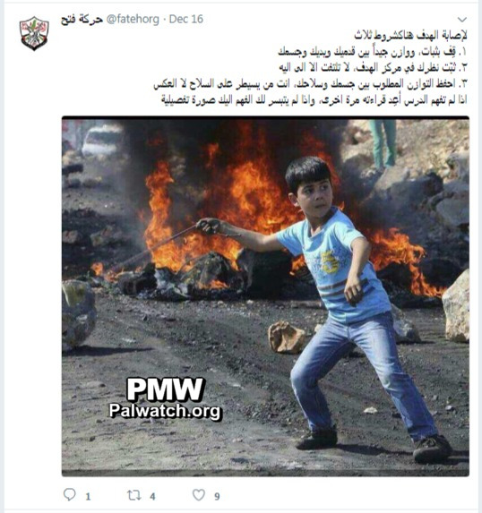
Posted text:
"In order to hit the target, there are three conditions:
1. Stand stably and balance your legs, arms, and body well
2. Focus your gaze on the center of the target, and do not look at anything else
3. Keep the desired balance between your body and your weapon; you are the one that controls the weapon, and not the other way around
If you did not understand this, read it again, and if you still have not understood, here is an example picture for you"
[Official Fatah Twitter account,
Dec. 16, 2017]

Earlier this month, in a debate in British Parliament, MP Joan Ryan used PMW exposures to criticize the PA and Fatah for educating Palestinian children to violence, and included Fatah's guide to rock throwing among her examples.

Fatah often promotes stone throwing to youth. The following images show young Palestinian rioters slinging rocks, accompanied by encouraging text:

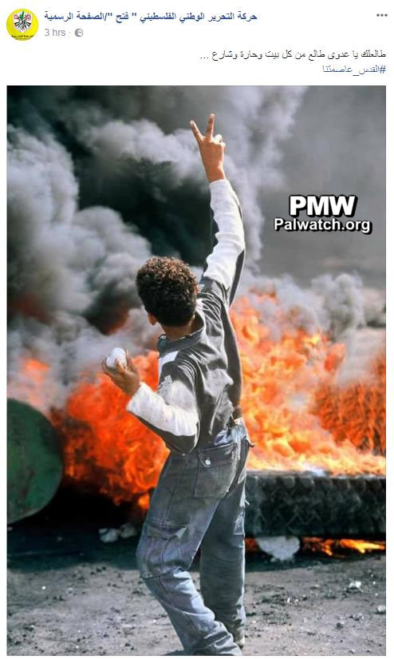
Posted text: "I am coming towards you, my enemy, from every home, neighborhood, and street
#Jerusalem_is_our_capital"

[Official Fatah Facebook page,
Dec. 11, 2017]

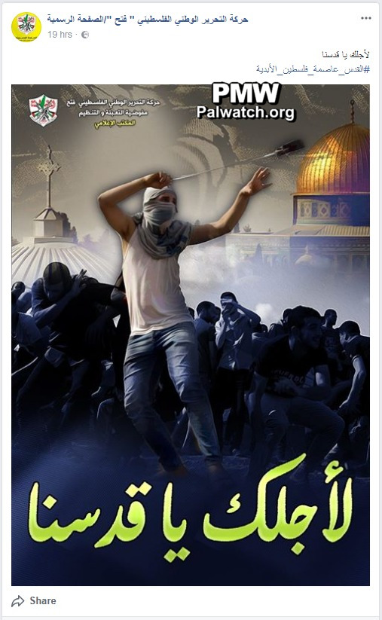
Posted text:
"For you, O our Jerusalem
#Jerusalem_the_eterna
l_capital_of_Palestine"
Text on image: "For you, O our Jerusalem"

[Official Fatah Facebook page, Dec. 12, 2017]

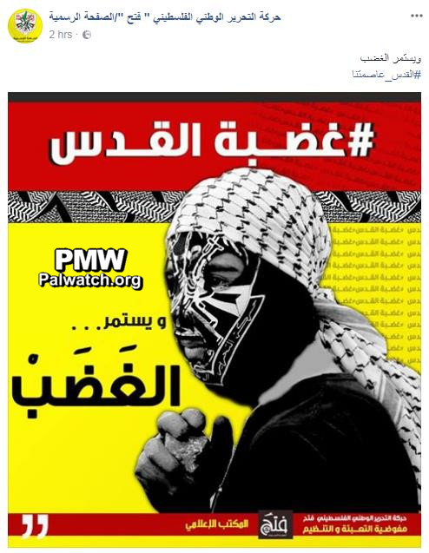
Posted text:
"The rage continues
#Jerusalem_is_our_capital"

Text on image:
"#The_rage_of_Jerusalem
The rage continues"
In the bottom of the image is written "The Fatah Movement Mobilization and Organization Commission."
[Official Fatah Facebook page, Dec. 11, 2017]

