Anti-Semitism, Brought to You by the

United Nations

September 7, 2016

By Anne Bayefsky

National Review

http://www.nationalreview.com/article/439760/anti-semitism-united-nations-supports-hate-groups-calling-israels-destruction?mc_cid=41719ae812&mc_eid=0ffd120ac2

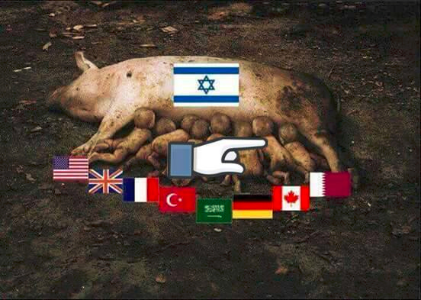

UN-accredited Palestine Solidarity Campaign – Thailand (May 10, 2016)
The United Nations was founded as a global pact among states, but over the decades in the name of transparency and to further the aim of globalization, it has opened its doors to more than 6,150 non-governmental organizations (NGOs). While governments wring their hands over incitement to terror and dangerous uses of social media, they ignore the alarming focal point within arms’ reach: the United Nations. An examination of U.N. NGOs reveals that the U.N. has handed a global megaphone to groups spreading hatred and inciting terror from the world stage. In short, the so-called representatives of “civil society” aren’t so civil after all.
In theory, the U.N. has processes for accreditation that share a common requirement: respect for the purposes and principles of the organization. In order to qualify for accreditation, NGOs must operate in conformity with, or promote, the U.N Charter. They must affirm “faith in fundamental human rights, in the dignity and worth of the human person, in the equal rights of men and women and of nations large and small.”
In practice, NGOs have been welcomed into the world of international diplomacy and have gained access to international media platforms while they are simultaneously betraying the core U.N mission by advocating terror and intolerance.
Most striking for an organization founded on the ashes of the Holocaust, U.N.-accredited NGOs play a central role in promoting modern anti-Semitism and encouraging the destruction of the Jewish state.
The benefits of U.N.-accreditation for NGOs are tangible and significant: the ability to sponsor speakers, mount exhibits, and screen films in the same U.N. facilities that house an international press corps; the right to speak at U.N. meetings and have their words translated and broadcast via U.N. webcasts worldwide; the capacity to publish written statements and have them disseminated by the U.N.; the opportunity to attend negotiating sessions and to influence the world’s diplomats. U.N. websites even link directly to selected NGO websites, greatly enhancing their traffic and messaging.
Scattered around the U.N. system are a few disclaimers of responsibility for the content of NGO events and websites. But NGO events on U.N. premises are permitted only after detailed applications and approval by U.N. representatives. NGO website links are selectively posted on U.N. sites by U.N. officials. And NGOs are regularly singled out for coveted speaking gigs by U.N. representatives. U.N. selection and approval procedures, from accreditation on, belie claims that U.N. officials and envoys are ignorant of the purposes and content of the NGOs they choose.
In May 2016, many of the world’s major NGOs complained that the accreditation processes were unfair because applications were being thwarted by certain member states for fear of empowering critics of these states. And, indeed, many of the states running the U.N. accreditation processes -- such as China, Cuba, Iran, Russia, and Sudan -- inhibit free speech and curtail the freedom of association in their own backyards. At the same time, these nations use their powers on the U.N. NGO Committee to protect themselves in the international arena.
But the NGOs busy clamoring for more access to the U.N. are seeking the privileges without the responsibilities. They have no intention of policing themselves. On the contrary, the common mantra among NGOs is that they promote “the voices of the victims” -- where victimhood is self-defined, regardless of the legitimacy of the claims. The reality is that U.N. member states are not only delaying or denying accreditation to the right NGOs; they are accrediting the wrong NGOs: the terrorist advocates, the haters, the anti-Semites.
Here is a selection of the output from U.N-accredited NGOs, their websites, their social-media accounts, their written and oral statements at the U.N. -- all easily accessible online in 2016.
- “Zionism, with its inhumane ethnic, racist principles, with its devilish schemes which generate chaos all over the world, with its dangerous plans to dominate...with its beastly octopus which has almost a decisive role in directing the policies of the greatest countries in the world...” — the International Organization for the Elimination of All Forms of Racial Discrimination

- “Terrorism is a political term used by the colonizer to discredit those who resist...Armed resistance was used in...the French resistance against the Nazis, and even in the Nazi concentration camps, or, more famously, in the Warsaw Ghetto. Palestinian resistance arises out of a similarly oppressive situation.” — If Americans Knew

- “The main obstacle to the advancement of Zionism is the heroic daily resistance of the Palestinians, manifested in the recent ‘youth intifada.’...Zionism instrumentalizes the memory of the Holocaust as a tool to legitimize war crimes...We must expose the fallacy of partition and the two-state solution.” — Alternatives, Action, and Communication Network for International Development

- “Never forget or forgive! We will fight until total liberation of #Palestine from the River to the Sea! #Nakba67” — Al-Awda, The Palestine Right to Return Coalition

- “I saw how the settlements are spreading everywhere like spores inhabited by pervert vagabonds who came from everywhere around the world to occupy this land.” — Arab Commission for Human Rights

- “The most important feeling is when you feel your soul and the souls of the people you love are so cheap, and your suffering and your blood so cheap, and there is only one blood and soul that is holy, which is Israeli Jews, you just lose your mind.” — United Nations Information System on the Question of Palestine (UNISPAL) entry on the Palestinian Centre for Human Rights

- “This year uncovered, for the first time, the practice of extracting human organs from killed Palestinians whose bodies were in the hands of Israeli forces and the sale of these organs.” — The International Organization for the Elimination of All Forms of Racial Discrimination

- “Zionist ideology is the driving force behind the ongoing Palestinian reality of apartheid.” — BADIL Resource Center for Palestinian Residency and Refugee Rights

- “To boost Israeli arms sales, Palestinian families have suffered three onslaughts of ‘systematic genocide’ wars in six years.” — Third World Network
The use and abuse of the United Nations to broadcast and support modern antisemitism and its lethal consequences is part of a burgeoning global network of incitement to violent extremism. The democratic states that control U.N. purse strings have the power and the duty to stop it.

