Preliminary, Partial Examination of The Names Of Palestinians Killed In Operation Protective Edge And Analysis of The Ratio Between Terrorist Operatives and Non-Involved Civilians Killed In Error

July 28, 2014
Meir Amit Intelligence and Terrorism Information Center http://www.terrorism-info.org.il/en/article/20687

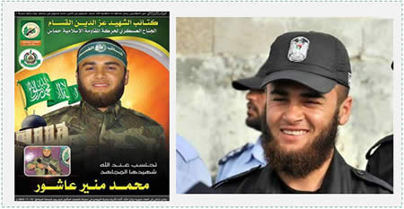 Dual identity of a dead operative in the Izz al-Din al-Qassam Brigades. Left: Death notice for Mohammed Mounir Ashour posted by the Izz al-Din al-Qassam Brigades (paldf.net, July 11, 2014).Right: Mohammed Mounir Ashour in a Palestinian police uniform.
Main Findings
1. Below are the findings of a preliminary, partial list of Palestinians killed in Operation Protective Edge.^{[1]} The goal is to ascertain the identity of terrorist operatives and non-involved citizens, and to examine the ratio between them.
2. We have examined the first 150 names of Palestinians killed between July 7 and July 12, 2014, which appeared on the list of those killed issued by the Palestinian Health Ministry in Gaza (see Appendix C). To this list the ITIC added the names of six terrorist operatives who were killed on those dates but were not included on the Health Ministry’s list, or who were killed and whose names were added later. Conversely, we removed the names of three dead, whose identity is still unknown, and the name of a terrorist operative who, it turned out, was wounded and whose name appeared on the mortality list by mistake.
3. Out of the names of 152 individuals who were killed, that were examined by the ITIC, 71 were identified as terror operatives and 81 as non-involved civilians. The percentage of terrorist operatives among all those examined is 46.7%, while the percentage of non-involved citizens is 53.3%. This ratio may vary as the ITIC continues to examine the names of those killed in Operation Protective Edge.

Methodological Notes
4. In its study, the ITIC examined 150 names of the first individuals who were killed, which appeared on the lists issued by the Palestinian Health Ministry in the Gaza Strip. These lists include the names of Palestinians killed between July 7, 2014, the day that the Palestinians consider to be the day that the operation began, and July 12, 2014. This is only a preliminary, partial list with regard to the number of those killed, as according to reports issued by the Health Ministry, the Palestinian death toll has now reached 1,035 (on the morning of July 28, 2014).^{[2]}
5. The analysis of the first 150 names again indicated a number of deficiencies on the list issued by the Health Ministry, the likes of which we also encountered after Operation Pillar of Defense.^{[3]} It is our impression that the list published by the Health Ministry was prepared hastily, and corrections appeared on lists published later. The details about those killed are incomplete (which makes them difficult to identify) and we suspect that they include duplicate names and/or names of civilians who were not necessarily killed by the IDF. Moreover, the list does not distinguish between non-involved civilians and terrorist operatives, and refers to all those killed as “shahids” (martyrs).
6. These deficiencies, in our opinion, are not accidental but are part of Hamas’s policy of concealment and deception (see below), shared by the Hamas-controlled Health Ministry in the Gaza Strip. Hamas’s policy is designed to create an image of a large number of civilians who were killed, to strengthen the image that Israel is carrying out a “massacre” of civilians and to create an ostensibly factual infrastructure for a political, propaganda and legal campaign against Israel during Operation Protective Edge and on the day after. However, despite the deficiencies, these reports by the Health Ministry are the only systematic source of information regarding the names of the dead, so we had to rely on it.
7. In order to cope with the fundamental deficiencies, we examined each of the 150 names of the first casualties appearing on the Health Ministry’s list on an individual basis. The ITIC’s analysis of the names is based on a variety of information, sourced primarily from social networks and websites of various organizations, especially Hamas and PIJ.We also used information from other media outlets, both Palestinian and Arab. In order to complement or validate some of the names, we used information originating from Israeli security sources.
Details of the Findings
8. Based on our analysis of the first 150 names on the Health Ministry’s list, we reached the following findings:
A. We identified 66 names of Palestinians killed as terrorist operatives (for details about them see table in Appendix A). In addition, we identified six terrorist operatives killed during the period that the Health Ministry’s list refers to. Four of them do not appear on the list and two others appeared on later lists. Another terrorist operative turned out to be injured and not killed.Hence the total number of terrorist operatives is 71.
B. Of the 71 names of terrorist operatives that we identified, we found 38 photos of operatives – i.e., more than half of the dead operatives who were identified (for photos of operatives, see Appendix B).
C. We identified 81 names as non-involved civilians.
D. Three names of dead Palestinians have not yet been identified. It is not yet possible to determine whether they were terrorist operatives or non-involved civilians.
9. Below is a breakdown of 71 terrorist operatives identified by the ITIC, by organizational affiliation:
A. 35Hamas / Izz al-Din al-Qassam Brigades operatives
B. 21PIJ / Al-Quds Battalions operatives
C. Sixoperatives of Fatah terrorist networks (Abu al-Rish Battalions; Abd al-Qader al-Husseini Battalions)
D. Fourmembers of an independent terrorist network called Al-Mujahedin Battalions^{[4]}
E. Threeoperatives affiliated with the Salafist-jihadis (two members of a network named Saif al-Islam Battalions[5] and an extremist Salafist preacher).
F. One PFLP military operative.
G. One military operative of a terrorist network by the name of Al-Ahrar.^{[6]}
10. In our assessment, the interim findings of the segmentation of names of the dead reflect the relative weight of the various terrorist organizations involved in the fighting: the figures illustrate the centrality of Hamas in the fighting and the important role played by the PIJ. Special attention should also be paid to the relatively large number of terrorist operatives belonging to networks based on former Fatah operatives and on operatives from a terrorist network by the name of Al-Mujahedin Battalions. The number of operatives from other terrorist groups is small and, in our assessment, this also reflects their minor military importance.
Dual Identity
11. The names that we examined included those of six terrorist operatives with a dual identity, i.e., those serving concurrently in terrorist organizations and in the Palestinian security forces in the Gaza Strip. All six who were identified were operatives in Hamas’s Izz al-Din al-Qassam Brigades. Three of them also served in the national security forces of the Palestinian Interior Ministry in the Gaza Strip and three of them served in the Palestinian police.After their deaths, dual death notices were published by the Izz al-Din al-Qassam Brigades and by the police, Interior Ministry and security forces.
12. Dual identity of terrorist operatives, especially in Hamas, is widespread and is well known to us from Operation Cast Lead and Operation Pillar of Defense. Dual identity allows Hamas to employ many military operatives in the security forces, give their activity governmental legitimacy, and pay them salaries intended for members of the security forces in the Gaza Strip.

Terrorists with dual identity^{[7]}
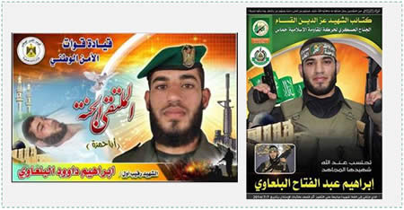 Left: Death notice of Ibrahim al-Balawi from the National Security Forces Headquarters (Facebook page of the National Security Forces in the Gaza Strip, July 8, 2014). Right: Death notice of Ibrahim Abd al-Fattah al-Balawi, issued by the Izz al-Din al-Qassam Brigades (No. 43 in the table in Appendix B).
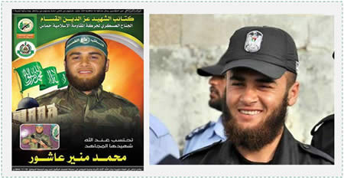 Left: Death notice of Mohammed Mounir Ashour posted by the Izz al-Din al-Qassam Brigades (paldf.net, July 11, 2014). Right: Mohammed Mounir Ashour in a Palestinian police uniform (No. 92 in the table in Appendix B).
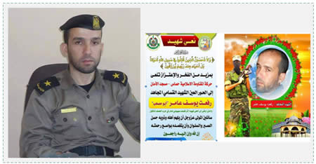
Left: Rif’at Yusuf Aamer in the uniform of the Interior Ministry in the Gaza Strip (muslm.org). Right: Death notice of Rif’at Yusuf Aamer in Facebook, posted by the Izz al-Din al-Qassam Brigades (No. 127 in the table in Appendix B).
Hamas’s policy of concealment and deception
13. In our analysis of the identity of the Palestinians killed, we encountered many difficultiesarising from the policy of concealment and deception of Hamas and the government ministries controlled by it (the Health Ministry, the Interior Ministry). In the present conflict, as during previous operations, Hamas and these ministries are again refraining from publishing reliable figures about terrorist operatives killed, with the intention of not harming the image of their “victory.” At the same time, Hamas seeks to increase the number of civilian dead in an effort to disparage Israel and to apply propagandist political and legal pressure on it during the fighting and on the day after. Palestinian human rights organizations based in the Gaza Strip, mainly PCHR and the Al-Mezan Center, which played an important role in conveying false information to the Goldstone Commission, are an integral part of this policy and are preparing for legal and propaganda campaigns against Israel after the operation.
14. Hamas’s policy of concealment of is manifested, inter alia, in refraining from publishing complete, detailed and systematic information on the names of the organization’s terrorist operatives killed in Operation Protective Edge. It also appears that Hamas refrains from providing the Palestinian Health Ministry with information about some operatives who were killed. This is done with the goal of helping to create the image that civilians are getting killed in the Gaza Strip, not terrorist operatives. For instance, guidelines for social networking activists in the Gaza Strip, published by the Hamas-controlled Interior Ministry a few days after the start of Operation Protective Edge, state, among other things, that every Palestinian killed should be described as an “innocent citizen” (these two words appeared in English in the Arabic-language guidelines). It also states that the number of fatalities among women and children should be emphasized (YouTube video, July 10, 2014).
The problem with assessments from UN sources and human rights organizations about the ratio of civilians killed
15. According to data published by UN and human rights organizations, the ratio of civilians among the fatalities in Operation Protective Edge is between 70% and 80%.^{[8]}
16. We believe these figures are not reliable, and that the ratio of civilian fatalities is significantly biased upward in order to defame Israel. This is because these figures are not based on a detailed analysis of the names of the Palestinians killed but rather on manipulative and biased information, originating from Hamas, Hamas’s ministries operating in the Gaza Strip, and human rights organizations based in the Gaza Strip that serve the Hamas propaganda network.^{[9]} Our initial findings and the lessons learned from our analysis of the names of those killed during Operation Cast Lead[^{10]} may support this assessment.

Close

Fighting Terrorism Shaheeds Civilians Hamas Palestinian Islamic Jihad The Israeli-Palestinian Conflict
Full Document in PDF Format
^{[1]}Hamas calls Operation Protective Edge Al-’Asf al-Ma’kul - the Eaten Chaff Campaign. This is a term from the Quran (Surat al-Fil, Verse 5). ‘Asf is the grain that remains after the harvest, which the wind blows, chaff that is used as fodder for sheep and cattle. Al-’Asf al-Ma’kul is the chaff that the animal eats and crushes in its mouth. In the context of the verse from the Quran, it is Allah who dealt a severe blow to the enemies who fought against the residents of Mecca in the year of the Prophet Muhammad’s birth, and figuratively crushed them into crumbs. The image is that this campaign will crush Israel. ^{[2]}The figure is taken from the Twitter page of Dr. Ashraf al-Qudra, spokesman for the Palestinian Health Ministry in the Gaza Strip. ^{[3]}See the ITIC Information Bulletin from December 16, 2012: “Analysis of the Ratio between the Names of Terrorist Operatives Killed during Operation Pillar of Defense and Civilians Killed in Error.” ^{[4]}Al-Mujahedin Battalions- an independent terrorist network in the Gaza Strip, based on former Fatah operatives, now radical Islamist. ^{[5]}Saif al-Islam Battalions -a Salafist-jihadi network in the Gaza Strip, which is a secessionist faction of Fatah’s Abu Rish Battalions. ^{[6]}Al-Ahrar movement - a terrorist network in the Gaza Strip, established in 2007 and based on Fatah operatives, now affiliated with Hamas. ^{[7]} These are examples that arose in our analysis of the first 150 names on the list published by the Palestinian Health Ministry. ^{[8]}In her speech at the Supreme Council for Human Rights in Geneva, United Nations High Commissioner for Human Rights Navi Pillay noted that according to UN figures, about 74% of those killed during the operation were civilians. ^{[9]}The most prominent of these organizations is the Palestinian Center for Human Rights (PCHR) operating in the Gaza Strip, which played an important role in conveying false and misleading information to the Goldstone Commission and is extremely active in the lawfare campaign being waged against Israel around the world. ^{[10]}The findings of the study carried out by Israel’s defense establishment after Operation Cast Lead showed that at least 60% of all those killed in the operation were operatives in the military and security forces of Hamas and other terrorist organizations. Conversely, data supplied by Palestinian human rights organizations, whose findings were adopted by the report in practice, stated that only 20% of those killed were “combatants” (i.e., terrorist operatives). For a detailed analysis on this issue, see the document published by the ITIC on March 10, 2010: “Hamas and the Terrorist Threat from the Gaza Strip. The Main Findings of the Goldstone Report Versus the Factual Findings”, Part Two.

