UN appeals to the world to fund the PA’s “Pay for Slay” policy
December 18, 2018
By Maurice Hirsch and Nan Jacques Zilberdik
Palestinian Media Watch
https://www.palwatch.org/main.aspx?fi=157&doc_id=26878

Yesterday, the United Nations Office for the Coordination of Humanitarian Affairs (UNOCHA) and the Palestinian Authority (PA) issued a joint statement in which they launched a US$350 million appeal to "address critical humanitarian needs of Palestinians." In the appeal, they called "upon the international donors' community to help us in securing the requested funds for 2019 in order to maintain the humanitarian interventions."
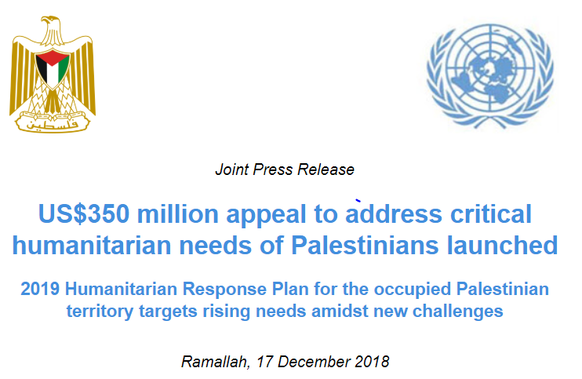
Significantly, the sum that the UN and the PA are asking the international community to donate - $350 million dollars - is equivalent to the $355 million dollars the PA allocated in its 2018 budget to fund its payments rewarding terror. This includes payments to terrorist prisoners, released terrorist prisoners, and to the families of the so-called "Martyrs" which includes terrorists killed while carrying out attacks, including suicide bombers.
Instead of the UN asking donor countries to contribute $350 million to provide for Palestinian humanitarian needs, the UN should be joining the unequivocal call from many governments that the PA immediately stop squandering the $355 million dollars of its own funds on its "Pay for Slay" policy that incentivizes and rewards terrorism, and instead spend that money on needy Palestinians.
Were the UN to adopt this basic and elementary moral requirement, it would strengthen the international forces that are mobilizing against the PA's terror support.
Abolishing the "Pay for Slay" policy would re-open the door for the PA to receive the approximately $215 million dollars of US aid to the PA withheld by the Taylor Force Act. Abolishing the PA's "Pay for Slay" policy would also avert the imminent deduction by Israel of the PA's expenditure on the salary program from the tax revenues Israel collects and transfers to the PA. Moreover, it would ensure that the PA would not lose its Australian funding and part of its funding from The Netherlands.
As more international donors withdraw their funding due to the PA's insistence on paying salaries to terrorists, it is obvious that the so-called Palestinian "humanitarian" crisis is a self-imposed crisis, created by the PA and its leaders.
While the leaders of the PA have repeatedly made their moral bankruptcy crystal clear by saying that even if they only have one penny left in the bank, they will spend it on the terrorists before any other Palestinians, it is altogether unclear why the UN's OCHA has decided that it is appropriate to assist the PA in raising the funds it needs to support its pugnacious policy of financially rewarding terrorists.
As if the payment of these terrorist salaries wasn't enough, the PA spends money on terrorists in yet additional ways. One of them is building houses for terrorists.
As a deterrent it is Israeli policy in certain cases to demolish houses of terrorists.
It is PA policy to spend money on rebuilding such houses.
PA Chairman Abbas has just given orders to rebuild the home of the family of terror mom Um Nasser Abu Hmeid. Abu Hmeid is the mother of 4 convicted terrorist murderers who are serving 18 life sentences combined; another terrorist son whom the PA refers to as a "Martyr" after he was killed while resisting arrest after he murdered a member of the Israeli security forces. The Abu Hmeid family's house was demolished on Dec. 15, 2018, after a sixth son, now standing trial, admitted to the murder of Israeli staff-sergeant Ronen Lyubarsky. The family of Abu Hmeid has been paid over $1 million dollars as part of the PA's "Pay for Slay" policy just because of the attacks and murders committed by the sons.

Now the PA will spend money on rebuilding their house on orders from Abbas:

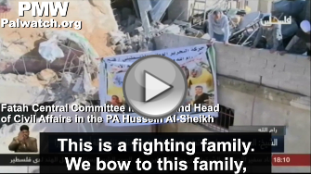 | 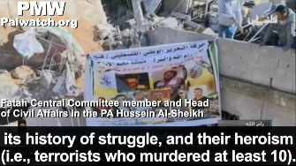
Fatah Central Committee member and Head of Civil Affairs in the PA Hussein Al-Sheikh: “President Abbas has given direct orders this morning [Dec. 15, 2018] to quickly and immediately rebuild the home of the Abu Hmeid family. This is a fighting family. We bow to this family, its history of struggle, and their heroism (i.e., terrorists who murdered at least 10). Therefore, the minimum that can be provided to this family is to stand by it and immediately rebuild its demolished home.”
[Official PA TV News, Dec. 15, 2018]

Forcing the PA to spend its own funds on the "critical humanitarian needs" of the Palestinians rather than using them to incentivize and reward terrorism, will both promote peace and help ween the Palestinians from their self imposed reliance on international aid. In contrast, requesting the international community to step in and fund the humanitarian needs of the Palestinians, allows the PA to continue to waste its own resources on programs that distance peace and deepen the dependence of the Palestinians on aid.
Um Nasser Abu Hmeid (Um Yusuf Abu Hmeid/Latifa Abu Hmeid) - Palestinian woman who is famous and admired in the Palestinian Authority for being the mother of 4 terrorist prisoners serving multiple life sentences, another terrorist who admitted to murdering an Israeli soldier, and another terrorist son whom the PA refers to as a "Martyr." Abu Hmeid is also called Khansa of Palestine, a name that refers to the woman Al-Khansa in the earliest period of Islam who sent her four sons to battle and rejoiced when they all died as Martyrs. Abu Hmeid was honored by the PA in 2010 and in 2015, and was chosen in 2011 to launch the PA's statehood campaign with the UN.
Her terrorist sons are: Islam Yusuf Abu Hmeid, who admitted to murdering 1 on May 24, 2018, and is on trial (as of Dec. 18, 2018); Muhammad Abu Hmeid, who is serving 2 life sentences and 30 years for involvement in terror attacks; Nasser Abu Hmeid, who is serving 7 life sentences and 50 years for murdering 7 Israeli civilians and 12 attempted murders; Nasr Abu Hmeid, who is serving 5 life sentences for involvement in two terror attacks in which 4 were murdered and arms dealing; Sharif Abu Hmeid, who is serving 4 life sentences for involvement in terror attacks in which 4 were murdered; Abd Al-Mun'im Muhammad Yusuf Naji Abu Hmeid, who murdered 1 on Feb. 13, 1994, and was killed by Israeli military undercover agents on May 31, 1994.

